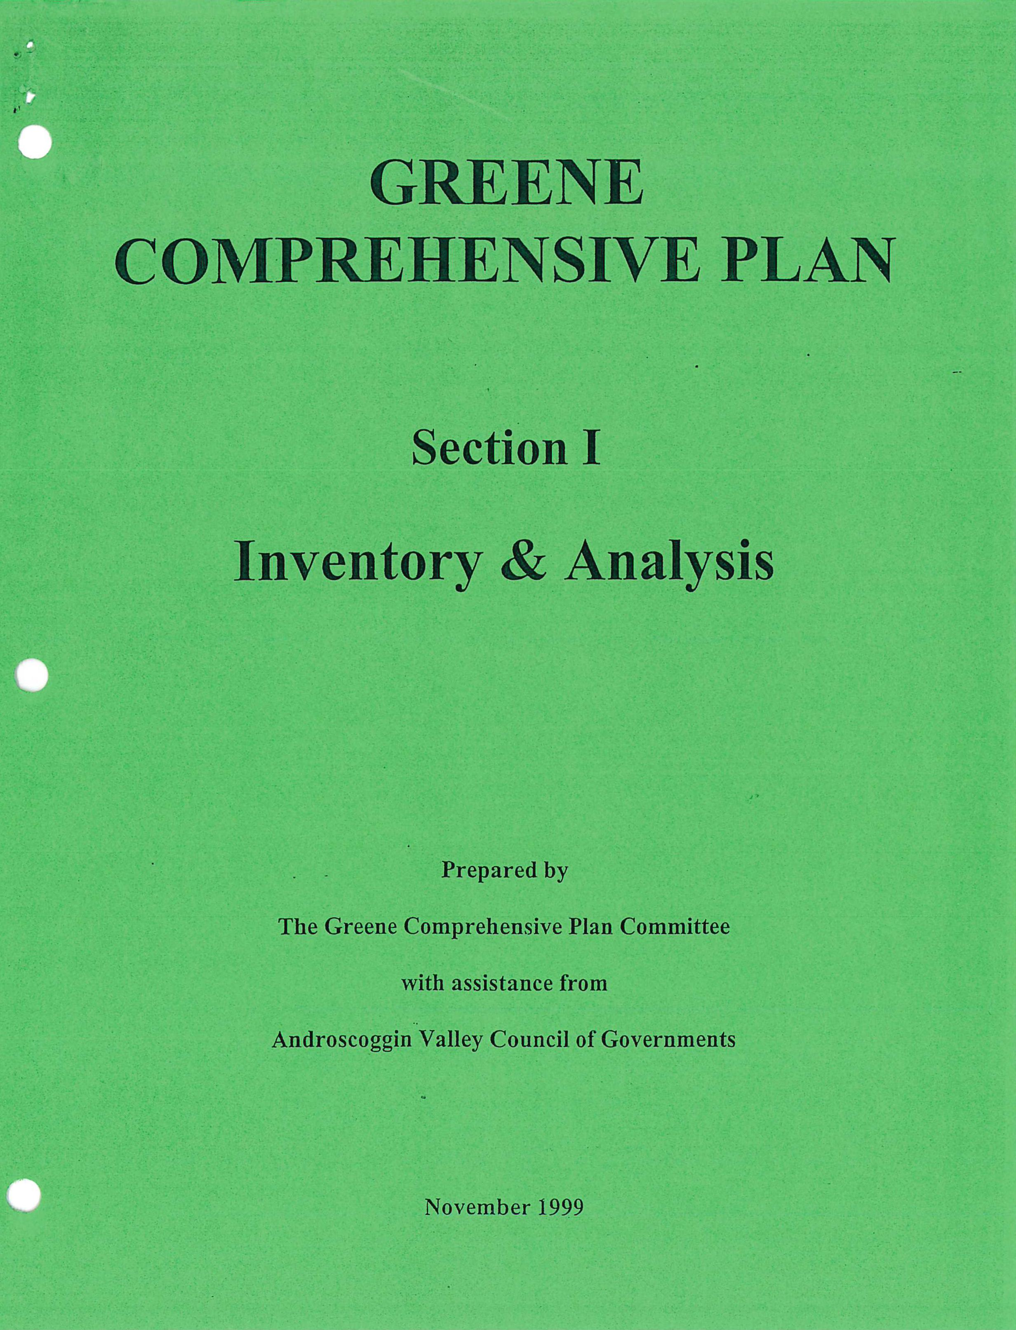
Inventory & Analysis
GREENE
COMPREHENSIVE PLAN
Prepared by
The Greene Comprehensive Plan Committee
with assistance from
Androscoggin Valley Council of Governments
Section I
November 1999

The Comprehensive Plan, presented in two sections—the Inventory & Analysis and Goals, Policies, & strategies—should serve as a guide for the community and town officials as they make decisions about the future of Greene. The Plan suggests general directions, recognizing the specific details will require further efforts. The Plan should be considered a living document meaning that it will require review and revisions as Greene changes over time.

The Plan is not a zoning ordinance and the future land use map is not a zoning map. The Plan is, however, intended to guide future changes in the Town's land use regulations so that they will reflect the goals and polices of this Plan. Similarly, the discussions of capital needs and spending priorities are intended as general guides, not specific proposals.
This Plan is the result of the efforts of the Comprehensive Plan Committee and the citizens of Greene that provided ideas during the planning process.

TABLE OF CONTENTS
Summary
Introduction
Historical and Archaeological Resources
Planning Considerations
Population
Planning Considerations
Economy ii
Planning Considerations ii
Housing ii
Planning Considerations iii
Public Services and Facilities iii
Planning Considerations iii
Outdoor Recreation Resources iv
Planning Considerations iv
Transportation iv
Planning Considerations iv
Natural Resources
Planning Considerations
Land Use/Utilization vi
Planning Considerations vi
Fiscal Capacity vii
Interlocal Planning Considerations vii
HISTORIC AND ARCHAEOLOGICAL RESOURCES 1
Findings 1
Introduction 1
Historic Resources 2
Archaeological Resources 3
POPULATION CHARACTERISTICS 5
Findings 5
Introduction 5
Population Growth 5
Seasonal Population 7
Age Distribution 7
Education Levels 7
Income Characteristics 8
Median Household Income 9
Employment 10
General Housing Characteristics 11
Household Size 12
Projected Year-Round Population 13

ECONOMY 15
Findings 15
Economic History 15
Regional Economic Perspective 15
Location of Employment 17
Greene's Economy 18
Labor Force 19
Major Employers 21
Economic Expectations 21
HOUSING CHARACTERISTICS 23
Findings 23
Introduction 23
Housing/Growth Trends - 1980-1990 23
Type of Dwelling Unit 24
Owner/Renter Patterns 25
Vacancy Rates 26
Housing Conditions 26
Housing Trends - 1990-1998 27
Affordability of Housing 28
Future Housing Demand 30
PUBLIC FACILITIES AND SERVICES 33
Findings 33
Introduction 33
Fire Department 33
Emergency Rescue 34
Police Protection 34
Public Works Department 35
Solid Waste 35
Town Government 35
Municipally Owned Buildings 36
Educational Facilities 36
Health Care Facilities 37
Utilities/Communications 37
TRANSPORTATION 39
Findings 39
Introduction 39
Roadway Conditions 40
Roadway Capacity 41
Motor Vehicle Accident Data 41
Railroads 41

OUTDOOR RECREATION RESOURCES 45
Findings 45
Introduction 45
Public Recreation Areas and Facilities 45
Private Recreation Facilities 46
Snowmobile Trail System 46
Important Hunting and Fishing Areas 46
Recreation Facility Needs Analysis 46
NATURAL RESOURCES 49
Findings 49
Topography 49
Soils 50
Prime Farmland Soils 53
Wetlands 53
Surface Waters 53
Androscoggin River 53
The Dead River 57
Streams and Brooks 58
Drainage Areas 58
Greene's Lakes 58
Allen Pond 58
B erry Pond 59
Daggett Bog 59
Deane Pond 59
Little Sabattus 59
Sabattus Pond 59
Lake Watersheds and Water Quality 63
Ground Water 64
Sand and Gravel Aquifers 64
Bedrock Aquifers 65
Floodplains 66
Forest Resources 66
Wildlife Habitat 71
Unique Natural Areas 71
Scenic Resources 72
LAND USE/UTILIZATION 75
Findings 75
Introduction 75
Forest Land 75
Agricultural Land Use 76
Village Land Use 76
Residential Land Use 76
Village Residential 77
Subdivision Residential 77

Scattered Residential 78
Seasonal Residential 78
Commercial Land Use 78
Industrial/Manufacturing Land Use 83
Development/Land Use Trends 83
Comprehensive Plan and Land Use Ordinances 83
Ordinance Effectiveness 84
FISCAL CAPACITY 85
Findings 85
Introduction 85
Revenue 85
Expenditures 87
Capital Projects Fund 88
Municipal Debt 88
Fiscal Capacity 89

INTRODUCTION
The comprehensive planning process needs to be based on an accurate and comprehensive understanding of the community. In planning terms, the "community" means its people, infrastructure, services, and natural features. To provide that factual information base, the Comprehensive Plan Committee, with assistance from Androscoggin Valley Council of Governments, collected, organized, and analyzed information about Greene. Areas considered in the inventory and analysis elements related to population, economy, housing, transportation, natural resources, historic, cultural, and archaeological resources, land use and development patterns, outdoor recreation, public facilities, and fiscal capacity.
The information to prepare the inventory and analysis came from several sources. Individual committee members collected information only available in Greene. Other information came from state and federal sources. State agencies provided information on the location of wildlife habitat, traffic volumes, traffic accidents and lake and pond phosphorus loads. Much of the characteristics concerning Greene's population information was obtained from the U.S. Department of Commerce 1990 Census. While this information was somewhat dated, it was the best readily available for the comprehensive plan.
The inventory and analysis also made several forecasts for the 10-year planning period. These included year-round population growth and year-round housing demand. Such forecasts were based on past trends and acceptable forecasting techniques.
The inventory and analysis are intended to be a snapshot of Greene based on the best information available in 1998. Communities are dynamic places, and thus, the inventory and analysis may not reflect all community characteristics at time of the adoption of the plan or five years from adoption. However, it presented a reliable picture of Greene and provided the necessary direction for the Comprehensive Plan Committee to identify issues and implications and formulate town goals and policies.

GREENE COMPREHENSIVE PLAN
INVENTORY AND ANALYSIS
Summary
Introduction
The inventory and analysis element of the comprehensive plan assesses information and characteristics of the community. Population trends, local and regional economy, housing characteristics, transportation systems, public facilities, recreation, natural resources, agricultural and forestry resources, historic and archaeological resources, land uses and the Town's fiscal capacity were reviewed. The following summary presents the major findings of the inventory portion of the plan. In addition, it identifies the significant issues and planning considerations.
Historical and Archaeological Resources
Greene's history is strongly tied to an agricultural based economy. Several important historic buildings and sites have been identified in the comprehensive plan.
Archaeological resources are physical remains of the past, mostly commonly buried in the ground or very difficult to see on the surface. Although no prehistoric sites have been documented within Greene, they are likely to exist along the banks of the Androscoggin River.
Planning Considerations
- Significant historic buildings and sites are not protected from change.
- The Town currently has no safeguards to assure that significant archaeological resources are not lost.
Population
Greene's population grew from 3,037 in 1980 to an estimated 3,950 in 1996. This rate of growth has been greater than most communities. It is expected that Greene's population will grow to approximately 4,800 people by the year 2009.
Planning Considerations
- Expanded and new municipal services such as schools, recreation opportunities, fire, police, and emergency medical services, solid waste disposal and highways will be required as the result of population growth.

- Demands for services such as stores, banking and other services associated with growing, medium sized communities will increase.
- In-migration will be an important component of population growth. Economy
Greene, like many New England towns, witnessed its economy flourish during the mid to late 1800s. Before Greene prospered as a small industrial center, it was primarily an agricultural community. During the mid 1800s, Greene had four saw mills, three grist mills, a shingle mill, and four stores. More recently, the Town has experienced growth of service-related businesses located primarily along Route 202 responding to Greene's growing population.
Greene's labor force has increased significantly since 1993 (12%) reflective of the Town's growing population. Total consumer sales increased by 92% between 1991 and 1997 which was greater than all surrounding communities.
The Town's workers are dependent upon employment outside Greene with 75% leaving the Town for their place of employment. Lewiston/Auburn serves as the primary employment center for the Town's labor force.
It is expected that the dependence upon Lewiston/Auburn as an employment center for Greene's residents will continue. It is also expected that a demand for additional service-related
businesses will occur due to the Town's increasing population.
Planning Considerations
- Future demands for local services will provide for a small increase in local employment opportunities.
- Efforts need to be directed towards increased local employment opportunities.
- The dependence upon Greene's labor force for employment outside of Greene will continue.
Housing
Greene has had a large increase in new housing units between 1990 and 1998; some 235 new units were added.
The traditional stick built home comprises the greatest share (72%) of the total year-round housing stock. However, between 1980 and 1990, the mobile or manufactured home has acquired a greater share. The number of mobile homes increased by 145% in the period. Multifamily housing is limited in Greene.

11

Greene's housing costs have remained stable in recent years. The average sale price of a home in Greene over the past five years has been $81,500.
Based upon expected population growth and maintaining a vacancy rate that allows flexibility in housing choices, some 250 new dwellings will be needed to house Greene's population in 2009.
Planning Considerations
- Greene will continue to experience a greater increase in housing development than surrounding communities.
- Some 250 new housing units are expected over the next ten years.
- Rental housing is limited in Greene.
Public Services and Facilities
Greene's public facilities and services are limited. However, they have to date generally met the demands of the citizens. Expanded or new municipal facilities will be needed within the next ten years.
Greene, along with Leeds and Turner, form SAD #52. With the population growth of all three district towns, facility needs have been a major issue. Although there have been physical expansions in Leeds and Turner, additional space is needed in Greene. With current enrollment levels, additional expansions will be needed in the near future.
The Town's road system demands a major portion of the Town's budget for summer and winter maintenance. Continued growth will demand increased expenditures for its roadway system.
Planning Considerations
- Population growth will demand new or expanded public safety services including fire, police and emergency medical services.
- A new fire station is needed.
- Increased population and service demands have created the need for more municipal office space.
- Additional population and their philosophy of public services will create new demands to deliver municipal services.
- Greater public involvement is needed in the governmental affairs of Greene.
- A demand for municipal recreation facilities exists and will increase.
- Additional library space is needed.

Outdoor Recreation Resources
Recreation opportunities both organized and unstructured are important elements of Greene's quality of life. Municipal organized recreational activities are directed by the Greene Athletic Association and Conservation Commission. The Athletic Association is overseen by a board of directors and offers organized sports activities in baseball, basketball, cheering, field hockey, ice hockey, soccer, softball, and t-ball. The Conservation Commission maintains, improves and develops the town's outdoor recreation areas.
Planning Considerations
- Expanded and/or new recreation programs are needed for Greene's residents. This demand will increase as the population increases.
- Changing land use and land ownership patterns may reduce some traditional outdoor recreation activities such as hunting and hiking.
Transportation
Greene has approximately 52 miles of totally town-maintained roads. Road conditions, as rated by the Road Commissioner, revealed that 25 miles are considered good, 27 miles in fair condition, and 10 miles in poor condition.
Route 202 is the major travel route through Greene. It averages approximately 11,000 vehicles per day.
Planning Considerations
- Expanded new growth will create additional public roads.
- A significant portion (58%) of the total town road mileage in Greene has been rated in fair or poor condition.
- Increased traffic may degrade roads already in poor condition; in particular, Sawyer Road: should a new turnpike exit be constructed in Sabattus.
- Route 202 is a major travel corridor. New and expanded commercial development accessed by Route 202 will create traffic conflicts.
- New development along or served by substandard roads will create a more immediate need for upgrading.

iv

Natural Resources
The natural resources base of a community plays an important role in overall community development. Natural resources can enhance or limit growth potential of a community and are significant factors in the planning of a community's future. Various natural resources also enhance the quality of life within the community.
Greene's natural resources played a major role in the Town's historic development. While natural resources have declined in the importance to the local economy, they are significant components in Greene's character.
Because Greene relies upon subsurface disposal systems for all sewage disposal, soils are important to current and future environmentally safe development. Based upon soil potential ratings for low density residential development, some 20% of the town's land area has a high development potential. Thirty percent has a low rating and 50% has a rating of medium.
Greene's surface waters include the Androscoggin and Dead Rivers, six great ponds totally or partially located in Greene, and a number of streams and brooks. These surface waters are used primarily for recreation with the Androscoggin River - an important power generating and recreation river.
All the ponds in Greene have the highest water classification under the State Surface Water Classification System. Sabattus Pond is shared with the Towns of Sabattus and Wales and with existing development within its watershed has experienced degradation with an ongoing remedial program.
The mixture of woodlands, fields, and wetlands provide significant habitat for wildlife. A number of deer wintering areas and high value waterfowl breeding and nesting areas are found throughout the community.
Planning Considerations
- Currently and in the future, all sewage disposal in Greene will be via subsurface sewage disposal systems. Use of unsuitable soils or excessive densities may cause contamination and health problems.
- Wetland areas are multi-functional natural resources. The degradation of their values will leave lasting impacts.
- The Androscoggin River and its shorelands in Greene are significant natural areas. These development values and natural resource values may conflict in the future.
- Wildlife is an important resource within Greene. Habitat loss could greatly reduce wildlife's presence.
- All drinking water in Greene is obtained from ground water. Contamination of this resource will cause costly solutions.

- The greatest threats to surface water quality is from erosion and sedimentation.
- Various types of land use activities and development within the watersheds of ponds can greatly impact surface water quality.
- The Androscoggin River and shorelands have significant recreation potential. Land Use/Utilization
Greene has a land area of approximately 36 square miles--the majority of which is forested. Forest or woodlands cover the majority of land surface in Greene. It is estimated that some 19,000 acres are covered by trees of various species and stages of maturity. Over the past 20 years, agricultural land in Greene has decreased significantly due to abandonment or development. It is estimated that some 700 acres are used for agricultural purposes today.
Residential development patterns in Greene have been the major factor in the change of Town's character of the past ten years. The majority of the Town's new residential units has been scattered along existing town roads. Between 1988 & 1998, there have been 17 subdivisions approved with a total of 115 lots.
Commercial land use is scattered throughout the community; however, the majority is located along Route 202.
Since 1970, the most significant trend in development patterns in Greene has been scattered residential development adjacent to existing public roads. Numerous factors can contribute to this development trend. However, the result has been the stringing of residential development along many of the town roads.
Planning Considerations
- Large lot residential development throughout the town will consume significant land areas, reduce open space and create residential strip development.
- The majority of Greene's roads are in fair to poor condition. Residential development on or served by these roads will require their upgrading.
- Current land use regulations aid in perpetuating strip residential development.
- A shift from agricultural land use to residential will greatly impact the traditional character of Greene.
The intermixing of potentially conflicting land uses is possible in Greene.
- Continued traditional commercial development along Route 202 may lead to a commercial strip.
- Future land use activities and development may reduce scenic views.

vi

Fiscal Capacity
A community's fiscal capacity refers to its ability to meet current and future public expenditure needs. The inventory element of the plan has identified various public expenditure needs and there will be others not identified in the Plan. Greene's largest source of revenue is the property tax. Other significant sources of revenue are from excise tax and state revenue sharing.
- The major reoccurring expenditures are for education, highways, administration and county taxes.
- At the end of 1997, Greene had no municipal debt. The Town has significant borrowing power.
Interlocal Planning Considerations
Greene shares several common natural resources and common planning concerns with adjacent communities. Planning should be undertaken to coordinate with adjacent communities and, where feasible, to develop common programs. The major interlocal planning considerations are as follows:
- A portion of Allen Ponds' and Sabattus' watersheds are located in Greene and shared by several other communities.
- Androscoggin River Corridor shared with Livermore, Turner, Leeds, Auburn, and Lewiston.
- Compatible land use: Wales, Sabattus, Monmouth and Leeds.
- Economic development.
- Continued rapid population growth in the three communities that comprise SAD #52 will create a need for educational facility expansions.

vii

. viii

HISTORIC AND ARCHAEOLOGICAL RESOURCES
Findings
- :* Greene's contains many locally important sites and structures. No comprehensive survey, of historic resources has been conducted in Greene.

Introduction
The Greene of today was first originally a part of Lewiston Plantation. In 1775, a pioneer by the name of Benjamin Ellingwood built a log cabin, cleared some land and planted his crops on a slight elevation northwest from the Mrs. Arthur Knowles residence, thus making himself the first settler in the boundaries of the town. In that same year, he sold his cabin and improvements to Benjamin Merrill and moved to Gray. Benjamin Merrill brought his wife and children here from North Yarmouth and they are credited with being the first permanent settlers. Other pioneers quickly acquired lots of land and settled. Thus, began the growth of the Town.
By 1788, the Town had reached a population of 500 and desired to be incorporated so it could control its own affairs. A petition for incorporation to become a town named Greenland was submitted to the General Court of the Commonwealth of Massachusetts. In the same year, the petition was approved with the Town being named Greene in honor of General Nathanael Greene who was one of the best officers under General Washington in the Revolutionary War.
Greene was primarily an agricultural town but prospered as a large industrial center in the early to mid 1800s having four saw mills, three grist mills, and shingle mill, four stores, a fullen mill with dye works. The Androscoggin and Kennebec Railroad, after being completed in 1849, brought outside trade to the area. The station at the Center became one of the busiest rural stations on the line with shipments of lumber, boxes, barrels, apples, milk, eggs, and other produce.
With the turn of the 20th century came a decline in population and many small industries as people moved to the cities for jobs. With industrial development prospering in the cities, commercial enterprises also disappeared from the Town. As a result, the Town became basically an area of general farming.
The history of Greene is much like that of other towns in New England where its pioneers had a strong faith, broad vision and showed great concern for the home, church, school, and community.
1

Historic Resources
Greene does not contain any sites on the National Register of Historic Places or sites listed on the Maine Historic Resources inventory. Several buildings and sites have locally significant values and include the following. The Historical Society maintains a more comprehensive listing.
Table I-1
Historic Buildings and Sites
Greene, Maine
Sprague's Mill site is where the town's first saw mill was and soon after, 1795, a grist mill.
The stones from this mill are now on the Hobart lawn. Mr. Sprague baked brick and built the house where Clayton Bubier now lives.
Spoffard Brook, at the foot of Daggett Hill, is the site of the second grist mill and saw mill in town. One of the mill stones found by Wilbrod Veilleux is on the house lawn.
The outlet to Allen Pond is the site of the shingle mill where the first shingles were sawed in Maine.
Also the site of the first grist mill, fulling mill, and dye works known as Crocker's Mills.
Cattle Pound on Barrel Shop Road. The site of the first pound was on the east side of the road and the first Baptist Church was at the rear.
Area around Greene Depot--Railroad Depot, Sawyer Store, Blacksmith Shoppe, Coburn
Mill, Gamage place, and others--also the site of the stone quarry and where water was gotten for the railroad.
The Fire House, part of which was Patten School.
Grange Hall, Baptist Church, Morse Library, old town house and Universalist Church.
Ruth Wood's home was that of W. L. Mower who wrote the history of Greene.
The present home of John Prescott was a stage stop and tavern for many years.
Sawyer Memorial.
The home of Doris Hodgkins, Greene Village, was once a store.
Howard Johnson's home was a store west of Gamage Place before it was moved to the present location.
The end of the road past Annie Gagne's home, off River Road, connected with the ferry to cross the Androscoggin River.
Longview Heights was the site of the Town Farm.
Lane Road School.

River Road School.
Morse School.
Greene Corner School.
Glen Rock Spring.
Maine Meadow is the site where a steam locomotive was located when the railroad was being built.
In addition to the above, other historic resources include the many early stone walls and residences that may be more than 100 years old.
Archaeological Resources
Archaeological resources are physical remains of the past, most commonly buried in the ground or very difficult to see on the surface. Archaeological sites are defined as prehistoric or historic. Prehistoric sites are those areas where remains are found that were deposited thousands of years before written records began in the United States. These sites are the only source of information about prehistory. More recent archaeological or historic sites are those sites which occurred after written records began.
In Maine, archaeological sites are most commonly found within 25 yards of an existing or former shoreline. These areas provided good locations for boat access and camp locations. Although some 4,500 archaeological sites have been identified in Maine, there may be an additional 12,000 sites to be discovered.
The Maine Historic Preservation Commission reports one prehistoric archaeological site not deemed to be significant along the Androscoggin River and multi sites at the north end of Sabattus Pond. The banks of the Androscoggin River have been surveyed for archaeological sites in conjunction with Central Maine Power Company's hydroelectric relicensing. No professional survey for historic archaeological site has been conducted in Greene. The Maine Historic Preservation Commission recommends future field work focus on sites relating to the first wave of Anglo-American settlement beginning in the 1770s.

3

4

POPULATION CHARACTERISTICS
Findings
- It is estimated that population increased by 290 or 8% between 1990 and 1996.

- In-migration has been an important factor in population growth between 1990 and 1996.
- Estimated population growth between 1990 and 1996 has been greater than all surrounding communities except Turner.
- Greene's 2009 population will approach 5,000.
Introduction
The following presents an overview of recent population trends in Greene and surrounding communities. An examination of past population trends and characteristics is extremely important in understanding anticipated future population growth over the next ten years. Population information strengthens the capability of Town officials to prepare for future growth and the impact it may have on municipal services and land use.
Population Growth
As reported in the 1990 U.S. Census, Greene's year-round population was 3,661 which
represented an increase of 21% over the 1980 population. This was a much greater growth rate than Androscoggin County, but similar to several surrounding towns including Leeds and Turner.
It is estimated that between 1990 and 1996, Greene's year-round population increased by approximately 300 people, or 8%. This rate of population increase was greater than all surrounding communities other than Turner. Greene's population growth between 1990 and 1996 was the result of a natural increase of 164 and in-migration of 130.
5

Table 1-2
Population Trends
1980-1996
 | Greene. | , Lewiston | ' Sabattus | ' Wales | , :Leeds. | : Auburn '. | - Turner | - Monmouth.
1980 | 3,037 | 40,481 | 3,081 | 862 | 1,463 | 23,123 | 3,539 | 2,888
1990 | 3,661 | 39,757 | 3,696 | 1,223 | 1,669 | 24,309 | 4,315 | 3,353
1996 | 3,955 | 36,326 | 3,823 | 1,283 | 1,793 | 22,437 | 4,708 | 3,498
% Change
1980-1990 | 21 | -2 | 20 | 42 | 14 | 5 | 22 | 16
1990-1996 | 8 | -9 | 3 | 5 | 7 | -8 | 9 | 4

Sources: 1980, 1990 U.S. Censuses of Population
1996 Estimate developed by Maine Department of Human Services
Natural increase is the change in population as a result of the number of births less deaths in a given year. This information is useful because it provides insight regarding migration into Greene. From this information, it can be generalized that almost half of the population growth between 1990 and 1996 was the result of in-migration.
Table 1-3
Natural Population Increase
1990-1996
 | Births | Deaths | Natural Increase
1990 | 36 | 11 | 25
1991 | 51 | 25 | 26
1992 | 36 | 12 | 24
1993 | 44 | 24 | 20
1994 | 51 | 32 | 19
1995 | 31 | 15 | 16
1996 | 46 | 22 | 24
1997 | 42 | 16 | 26
TOTALS | 337 | 157 | 180
Source: Town of Greene Annual Reports
6

Seasonal Population
The Public Affairs Research Center of Bowdoin College estimated in 1972 that Greene's 1970 peak seasonal population was approximately 1,000 people greater than that of the year-round population. Current estimates of seasonal population are somewhat lower than that 1970 estimate. Assuming some 90 seasonal dwellings and 65 commercial campsites with four persons at each seasonal dwelling and campsite, it is estimated Greene's peak seasonal population would increase by some 620 persons. Peak seasonal population occurs in the summer months.
Greene's seasonal population is not a significant planning consideration.
Age Distribution
Table 1-4 shows the distribution of persons by age living in Greene in 1990. It shows Greene having a higher percentage of persons in the 18-44 and 45-64 age groups than Androscoggin County.
Table 1-4
Age Distribution
1990
Source: 1980 Census

droscOggin County
ktENE.

Age |  | OA,
Under 5 | 269 | 7 | 7,768 | 7
5 - 17 | 792 | 22 | 23,783 | 23
18 -44 | 1,632 | 45 | 44,640 | 42
45 - 64 | 673 | 18 | 14,943 | 14
65 and over | 295 | 8 | 14,125 | 13
TOTALS | 3,661 |  | 105,259

Education Levels
Based on the 1990 Census, Greene's population had similar education levels as those of Androscoggin County and the State. Table 1-5 indicates that 78% of Greene's population 25 years of age and older had completed at least four years of high school. This compares to 72% of the county's population and 79% of the State's population.

7

Table 1-5
Education Levels, 1990
(Persons 25 years and older)
Source: 1990 Census
Income Characteristics

236
14
10
9
Less than 9th grade
70,153
9,485
12
12
277
14
9-12 grade, no diploma
9,364
98,307
16
14
15
305
Some college, no diploma
9,574
127,799
6
7
8
192
Associate Degree
4,043
54,928
184
8
l 3
9
Bachelor's Degree
5,815
100,788
Graduate or Professional Degree
6
85
4
2,567
4
48,564
TOTALS
795,613
66,785
2,303
Elementary
High School Graduate
1,024
25,937
295,074
44
39
37
Table 1-6 indicates the 1989 household income levels for Greene, Androscoggin County, and the State. The largest percentage of households (21%), in Greene, reported incomes between $35,000 and $50,000 in 1989. This was somewhat higher than Androscoggin and the State of Maine. The percentage of households in Greene and earning less than $10,000 was significantly less than the County and State while the percentage earning more than $50,000 was significantly greater.

8

Table 1-6
Household Income Levels
1989
Source: 1990 Census

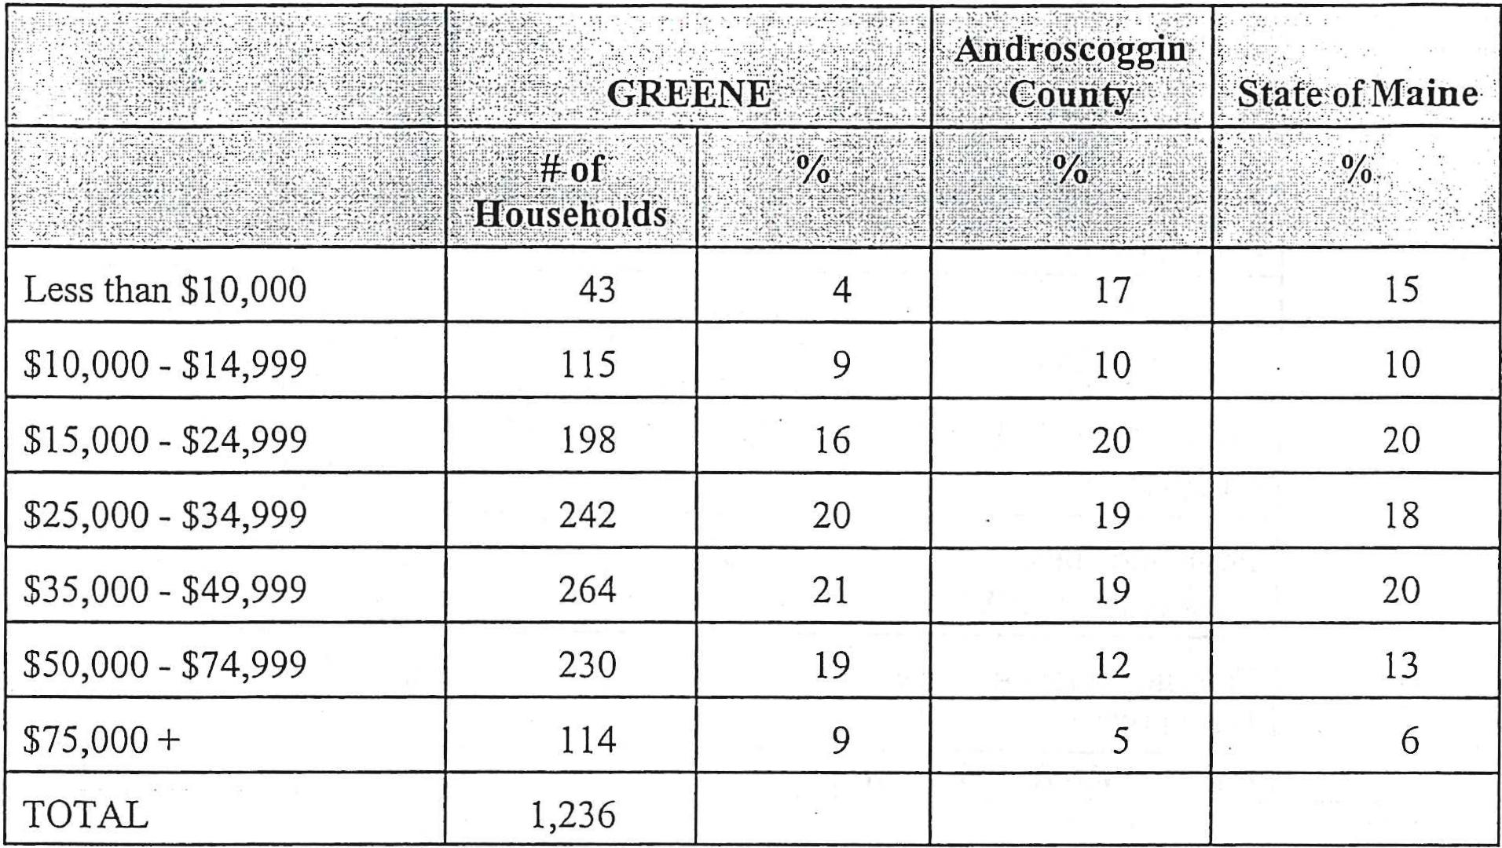
4
15
17
10
9
10
43
115
Less than $10,000
$10,000 - $14,999
264
21
19
20
$35,000 - $49,999
230
19
12
13
$50,000 - $74,999
$75,000 +
114
9
5
6
TOTAL
1,236
Androscoggrn
cou.)#y-:
State-of Maine
16
20
20
18
19
20
$15,000 - $24,999
198
Median Household Income
Per capita income for Greene residents was greater than the County but below the State in 1989. The table also shows that Greene's 1989 household income was approximately $6,000 greater than the county and $5,000 greater than the State.

9

Table 1-7
General Income Characteristics
1979 - 1989
. | - GREENE | Androscoggin  bounty | State of Maine
Per capita income (1979) | $5,980 | $5,631 | $5,766
Per capita income (1989) | $12,677 | $12,397 | $12,957
Median household  income (1979) | $16,803 | $13,524 | $13,186
Median household  income (1989) | $32,897 | $26,979 | $27,854
Population below poverty level (1989) | 9% | 11% | 11%
Families below poverty level (1989) | ₅% | 9% | 8%

Source: 1986 & 1990 Census
Employment
Greene residents had similar occupations as the residents of Androscoggin County and the State in 1990. The leading occupations in all three regions were in manufacturing. This is a shift from 1980 when employment in the manufacture of non-durable goods was the greatest.

10

Table 1-8
Employment by Occupation
1990
 | GREENE |  | Androseoggin,  County |  | State of Maine
 | # | V | # | ; % | # | %
Agriculture, Forestry, | 32 | 2 | 878 | 2 | 16,262 | 3
Fishing, Mining
Construction | 150 | 8 | 3,501 | 7 | 42,026 | 7
Manufacturing:
Durable Goods | 253 | 13 | 5,956 | 12 | 54,741 | 10
Non-Durable Goods | 261 | 14 | 6,870 | 14 | 57,890 | 10
Transportation | 53 | 3 | 1,421 | 3 | 19,567 | 3
Communications, Public | 52 | 3 | 1,054 | 2 | 12,716 | 2
Utilities
Wholesale Trade | 26 | 1 | 1,941 | 4 | 20,818 | 4
Retail Trade | 347 | 18 | 9,418 | 19 | 105,312 | 18
Finance, Insurance, Real | 141 | 7 | 3,185 | 6 | 31,992 | 6
Estate
Business and Repair Services | 67 | 4 | 1,680 | 3 | 19,839 | 4
Personal Entertainment, | 61 | 3 | 314 | 1 | 23,655 | 4
Recreation
Professional:
Health Services | 212 | 11 | 4,905 | 10 | 52,675 | 9
Educational Services | 91 | 5 | 3,914 | 8 | 63,685 | 9
Other Professional | 127 | 7 | 2,833 | 6 | 35,588 | 6
Public Administration | 66 | 3 | 1,552 | 3 | 25,081 | 4
TOTALS | 1,939 |  | 50,588 |  | 571,842

Source: 1990 Census
General Housing Characteristics
The 1990 Census reported 1,446 housing units in Greene. The majority of these (69%) were single-family homes followed by mobile homes (25%) and multi-family (6%). Table 1-9 compares these percentages with those of Androscoggin County and the State. The table shows that Greene has a higher than average percentage of single-family and mobile homes, and a considerably lower percentage of multi-family units which is typical for rural communication.
11

Table 1-9
Comparison of Total Housing Units
1990
Source: 1990 Census

Mobile Homes
Single-Family
Totals
⁰/

GREENE | 1,004 | 69 | 82 | 6 | 360 | 25 | 1,446
Androscoggin | 22,058 | 50 | 17,095 | 39 | 4,662 | 11 | 43,815
County
State of Maine | 390,166 | 66 | 128,860 | 22 | 68,019 | 12 | 587,045

Between 1980 and 1990, Greene had an increase of 451 housing units, most of which were single-family homes. Mobile homes had the highest percentage increase (145%) which can be attiibuted to their relatively lower cost and location restrictions placed upon them in the Cities of Lewiston and Auburn.
Table 1-10
Housing Units, Change by Type
1980-1990
 | 1980 | 199G | • | % Change
Single-Family | 782 | 1,004 | 222 | 28
Multi-Family | 66 | 82 | 16 | 24
Mobile Home | 147 | 360 | 213 | 145
TOTALS | 995 | 1,446 | 451 | 45
Source: 1980 & 1990 Census
Household Size
Greene's total households increased from 942 to 1,236 between 1980 and 1990. Between 1980 and 1990, Greene's average household size decreased from 3.22 to 2.96 persons.

12

Table I-11
Household Size
1980 - 1990
: | 1980' . | 12990.
Number of Households | 942 | 1,236
Average Household Size | 3.22 | 2.96

Source: 1980 & 1990 U.S. Census
Projected Year-Round Population
Anticipating population growth is an integral part of the comprehensive planning process. Depending on future population characteristics, various community needs and facilities can be identified as well as providing an indication of housing demand. It should be understood, however, that predicting population with great accuracy at a single community level is difficult.
Population change is a result of two primary factors, natural increase and migration. Natural increase is derived from the number of births minus the number of deaths over a specific period. Migration is the number of persons moving into or out of a community over a period of time. Both factors have been important to Greene's population growth. It is expected that over the planning period, in-migration will be a factor in population growth.
In developing the projections of population, the plan made the following assumptions:
- the average annual number of housing starts in the 1990s will continue each year through 2009;
- housing units will be occupied by persons according to the average household size;
- the average household size will change according to an increasing reduction factor.
Based upon the AVCOG model, Greene's 2009 population will be approximately 4,800. Table 1-12 presents the projected age distribution for the year 2009.

13

Table I-12
Age Distribution
2009
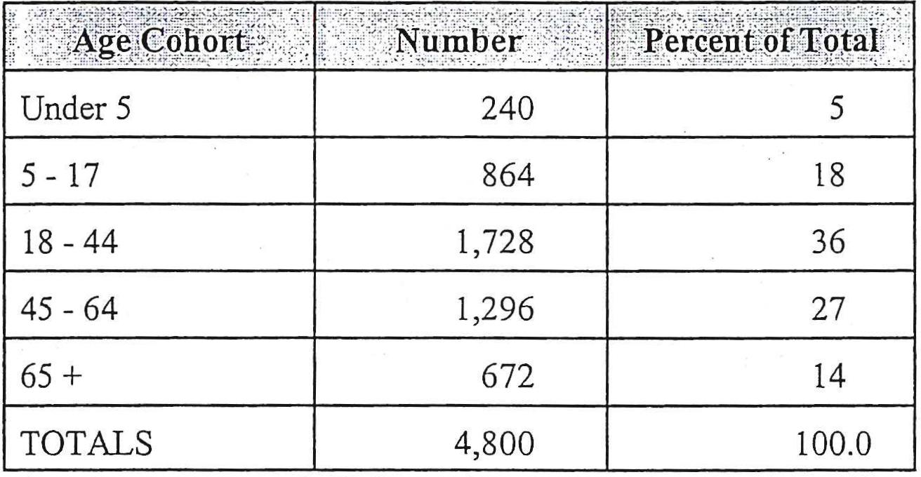
Source: Androscoggin Valley Council of Governments

14

ECONOMY
Findings
Greene's labor force increased by 12% between 1993 and 1997.

Consumer retail sales increased by $4A million or 92% between 1991 and 1997.
- :* Sixty percent: of Greene's labor force works in Lewiston or Auburn.
Over the next ten years, there will be a demand for expansion to existing and new service-related businesses.
Economic History
Greene, like many New England towns, witnessed its economy flourish during the mid to late 1800s. Before Greene prospered as a small industrial center, it was primarily an agricultural community. During the mid 1800s, Greene had four saw mills, three grist mills, a shingle mill, and four stores.
Around the year 1849, the Androscoggin and Kennebec Railroad was completed bringing outside trade to the area. As a result, the station at Greene Center became one of the busiest rural stations on the line with shipments of lumber, boxes, barrels, apples, milk, eggs, and other produce.
At the turn of the century, Greene experienced a decline in population and small industries as people moved to the cities in search for other jobs. With a population decline, Greene also experienced a loss in commercial businesses. As a result, Greene became a community of general farming once again.
Over the last 20 years, the Town has experienced growth of service businesses responding to Greene's growing population. However, because Greene is close to the urban center of Lewiston/Auburn, residents shop and buy many of their goods there.
Regional Economic Perspective
The Town of Greene is located in the Lewiston-Auburn Metropolitan Statistical Area (MSA). A Metropolitan Statistical Area, together with adjacent communities, has a high degree of economic and social integration with a large population nucleus. The Lewiston-Auburn MSA includes Greene, Auburn, Lewiston, Lisbon, Mechanic Falls, Poland, Sabattus, and Turner.
15

Table 1-13 lists non-farm wage and salary employment in the Lewiston-Auburn MSA for the years 1993 to 1996. The largest employment increase between these years was in the nonmanufacturing industries, 7%, whereas employment in the manufacturing industry decreased by 5%.
The nonmanufacturing industries include employment in construction, retail trade, eating and drinking places, finance and insurance, and other service type industries. Within these categories, the Lewiston-Auburn MSA's largest increase occurred in wholesale trade (15%) and services (15%).
Although the manufacturing industries experienced an overall loss in employment between 1993 and 1996, there were several industries that experienced growth. These included lumber and wood products (32%) and printing (6%). Areas which experienced the largest losses were in the non-durable goods industries (10%).
By 1996, there were a total of 41,400 people employed in the Lewiston-Auburn MSA. Total employment in the MSA grew by 4.6% between 1993 and 1996. Highlights on employment characteristics within the MSA are:
- From 1993 to 1994, total non-farm wage and salary employment increased roughly 3.2%
- From 1995 to 1996, employment increased by less than 1.2%
- Non-manufacturing consisted of 79% and 81% of the total employment in 1995 and 1996 respectively.
- Employment in six sectors decreased from 1993-1996. The greatest decrease was in leather and leather products - a 33% decline. Total manufacturing employment decrease 5%, non-durable decreased 10%, retail decreased less than 1%, health services decreased 5%, and government decreased 1%.
- Majority of employment in 1996 was in services (32%), retail trade (20%) and manufacturing (19%).

16

Table 1-13
Lewiston-Auburn Metropolitan Statistical Area
Non-Farm Wage and Salary Employment
1993-1996
 | - 1993 | ⁻1994 | 1 1995 | 1996 | ¹⁾/0 Change  1993-1996
Total | 39,580 | 40,880 | 40,920 | 41,410 | 4.62
Total Manufacturing | 8,350 | 8,810 | 8,680 | 7,910 | -5.27
Durable | 2,210 | 2,200 | 2,250 | 2,380 | 7.69
Lumber & Wood | 310 | 350 | 380 | 410 | 32.26
Logging | 10 | 10 | 10 | 10 | 0.00
Non-Durable | 6,140 | 6,610 | 6,430 | 5,520 | -10.10
Printing/Publishing | 680 | 710 | 730- | 720 | 5.88
Leather, Leather Prod. | 1,830 | 2,190 | 1,900 | 1,230 | -32.79
Total Non-Manufacturing | 31,230 | 32,070 | 32,240 | 33,500 | 7.27
Construction | 1,550 | 1,550 | 1,570 | 1,700 | 9.68
Trans/Utilities | 1,520 | 1,680 | 1,720 | 1,690 | 11.18
Wholesale Trade | 1,900 | 2,020 | 2,150 | 2,190 | 15.26
Durable Goods | 990 | 1,050 | 1,140 | 1,130 | 14.14
Retail Trade | 8,280 | 8,270 | 8,200 | 8,240 | -0.48
Finance, Insurance |  |  |  | 1,960
Services & Mining | 11,590 | 12,170 | 12,330 | 13,290 | 14.67
Health Services | 4,800 | 4,890 | 4,660 | 4,560 | -5.00
Government | 4,490 | 4,540 | 4,450 | 4,430 | -1.34

Source: Maine Department of Labor Employment and Earnings Statistical Handbook, 1993, 1994, 1995, 1996.
Location of Employment
An indication of the strength and importance of the local economy can be derived from information regarding where people live and work. Although the 1990 Census is dated information, it can provide insight to the distribution of employment of Greene's labor force.

17

Table 1-14 presents the 1990 distribution of Greene's labor force by place of employment. Not surprisingly, the majority of Greene's residents (60%) worked in Lewiston or Auburn. Of Greene's total work force, 10% lived and worked in Greene. This percentage remained unchanged between 1980 and 1990.
Table 1-14
Distribution of Greene's Labor Force
by Place of Employment
1990

Nee of Erriploymen
Greene
Auburn
Augusta
Bath
Leeds
Lewiston
Turner
Winthrop
Other & Not Reported
Total
..Number of⁻Persons |  | Tercent,. ofTotal:.
1980 | 1990 | - 1980 | 1990
208 | 316 | 15 | 16
184 | 264 | 13 | 14
77 | 33 | 6 | 2
27 | 86 | 2 | 4
12 | N/A | 1
651 | 900 | 47 | 46
11 | 50 | 1 | 3
58 | 26 | 4 | 1
164 | 264 | 1? | 14
1,392 | 1,939

Source: 1980/1990 U.S. Census
Greene's Economy
Greene's primary role within the region is that of a bedroom community. For the most part, the local economy is based on small retail sales and service business. The primary general consumer type businesses are automobile sales/service, food and general merchandise.
The Maine State Planning Office tracks data on taxable retail sales derived from sales tax collections. The table below details consumer retail sales in Greene for the years 1991 - 1997. Consumer retail sales do not include business operating purchases such as utility sales and heating oil and, therefore, provides a more accurate picture of what is commonly thought of as retail store sales.
Between 1991 and 1997, consumer retail sales increased by 92% or approximately $4,376,000 not considering the rate of inflation. This rate of increase was above that of other suburban communities around Lewiston and Auburn which increased by 61% over the same time period.
18

Table 1-15
Greene
Taxable Consumer Retail Sales
1991-1997
(In 000s of Dollars
 | - Consumer Sales | Percent Change
1991 | 4,770
1992 | 5,550 | 16.4
1993 | 5,780 | 4.1
1994 | 6,590 | 14.0
1995 | 7,540 | 14.4
1996 | 8,484 | 12.5
1997 | 9,146 | 7.8

Source: Maine State Planning Office
Labor Force
Since 1993, Greene's labor force has increased by approximately 267 or 12% based on information collected by the Maine Department of Labor. The growth in the town's labor force is an indication of the improving local and regional economy after the recession of the early 1900s and population growth in Greene. This rate of labor force growth was substantially above that of Androscoggin County which grew by 3% over the same period. Another indication of improving economic conditions is the decline in the unemployment rates since 1993 which peaked at 7.6%. By the end of 1997, the rate had fallen to 5.5% of the labor force.
Table 1-16
Average Annual Labor Force
1993-1997
19

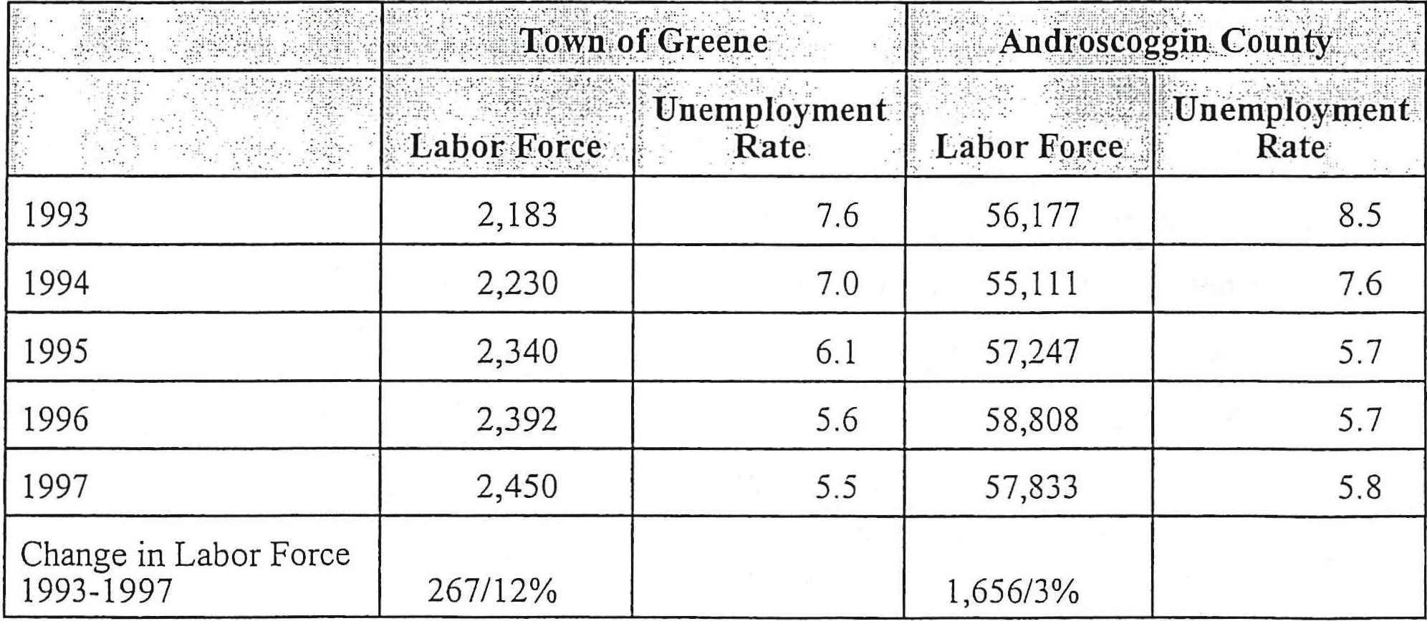
AndroScoggin. County. '
own of Greene
2,183
7.6
Unemployment
Labor Force Rate
1997 2,450 5.5
Change in Labor Force
1993-1997 267/12%
r. Labor Force | Unemployment-Rate
56,177 | 8.5
55,111 | 7.6
57,247 | 5.7
58,808 | 5.7
57,833 | 5.8
1,656/3%

6.1
5.6
7.0
1993
1994
1995
1996
2,230
2,340
2,392

Greene's 1990 employment patterns show a dependence on manufacturing and services. Between 1980 and 1990, the greatest gains in employment were in services, retail trade, and manufacturing. It is interesting to note that employment in the manufacturing of durable goods increased by 204. Employment patterns reflect the importance of the retail and service center of Lewiston and Auburn.
Table 1-17
Distribution of Labor Force by Industry
1980/1990
Industry | Greene |  |  |  | Androscoggin County
 | # of Workers |  | % of Total  Employed Labor  Force |  | # of Workers | % of Total  Employed.  Labor Force
 | 1980 | 1990 | 1980 | 1990
Agriculture, Forestry | 28 | 32 | 2 | 2 | 878 | 3
Construction | 103 | 152 | 8 | 8 | 3,501 | 7
Manufacturing | 386 | 514 | 28 | 27 | 12,826 | 25
Durable Goods | 91 | 253 | 7 | 13 | 5,956 | 10
Nondurable Goods | 295 | 261 | 22 | 14 | 6,870 | 10
Transportation | 25 | 53 | 2 | 3 | 1,421 | 3
Public Utilities | 77 | 52 | 6 | 3 | 1,054 | 2
Wholesale Trade | 73 | 26 | 5 | 1 | 1,941 | 4
Retail Trade | 184 | 347 | 13 | 18 | 9,418 | 19
Finance Inc. Real Estate | 45 | 141 | 3 | 7 | 3,185 | 6
Services | 395 | 624 | 29 | 32 | 13,646 | 27
Business & Repair | 58 | 67 | 4 | 4 | 1,680 | 3
Health | 153 | 212 | 11 | 11 | 4,905 | 10
Educational | 99 | 91 | 7 | 5 | 3,914 | 8
Entertainment | 56 | 61 | 4 | 3 | 314 | 1
Other Professional | 29 | 127 | 2 | 7 | 2,833 | 6
Public Administration | 54 | 66 | 4 | 3 | 1,552 | 3
Total | 1,370 | 1,939 |  |  | 50,588

Source: 1980/1990 U.S. Census
20

Major Employers
The largest employer in Greene is Maine Poly, Inc. located on Route 202. The producers of polyethylene sheeting printing, tubing and anti-static and conductive films reported a total employment of 180 individuals in 1990. This compares with 45 employees in 1984. Other major employers are Glen Rock Springs and Design Fab.
Other local employment opportunities are centered around retail and service industries responding to a growing local population.
Economic Expectations
Residents will remain dependent on employment opportunities outside of Greene. The retail and service center of Lewiston and Auburn will continue to provide significant employment opportunities for Greene residents. Population growth through the year 2009 will demand new and expanded service related business in Greene.

21

22

HOUSING CHARACTERISTICS

Findings
- The number of year-round homes increased by 282 between 1980 and 1990.
- From 1990.to 1998, 235 building permits were issued for new residential homes.
- Over the last five years, the average sale pride of a home was $81,500.
- The demand for new homes will remain high over the next ten years.
Introduction
Local housing characteristics are an essential part of a comprehensive plan. An understanding of housing trends, availability, conditions, and affordability is important in the overall planning process. Analyzing housing conditions and trends will provide information to decision makers concerning additional provisions for affordable housing and the need for a mixture of housing types.
Housing/Growth Trends - 1980-1990
The 1990 Census reported 1,277 year-round housing units and 169 seasonal units in Greene. Information collected from the Greene town records indicate that Greene's year-round housing stock grew by 235 units or approximately 18 percent between 1990 and June 1998.

23

Table 1-18
Regional Year-Round Housing Growth
1980 - 1990
Source: U.S. Census

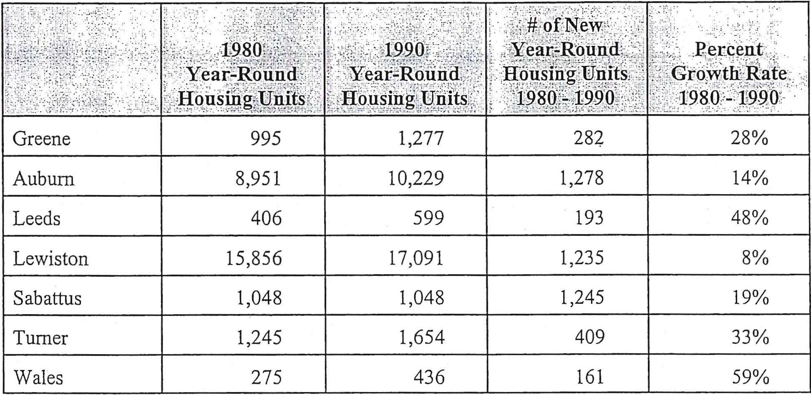
1,278
14%
10,229
Auburn
8,951
48%
193
Leeds
406
599
8%
1,235
Lewiston
15,856
17,091
1,245
19%
Sabattus
1,048
1,048
₃₃%
409
1,654
1,245
Turner
₅₉%
161
Wales
436
275
Greene
995
1,277
282
28%
Year-Ron nd IIou sing Units
of New
Year-Round Housing Units
1980.- 1990
.Percent
Growth Rate.
„
1980-, 1.-990
Type of Dwelling Unit
Greene's 1990 year-round housing stock was comprised primarily of the traditional single-family home. Mobile homes comprised approximately 25 percent of year-round housing stock in 1990. Multi-family dwellings accounted for the fewest dwelling units in 1990 with a reported 87 or 6.6% of the total housing stock. A total of 169 seasonal dwelling units was reported by the 1990 Census. This number represented an increase of 85 above the 1980 count. Local information does not reflect such an increase and, in fact, points to a decrease as the result of conversion to year-round.

24

Table 1-19
Housing Units, Change by Type
1980 - 1990
Source: 1980 & 1990 Census

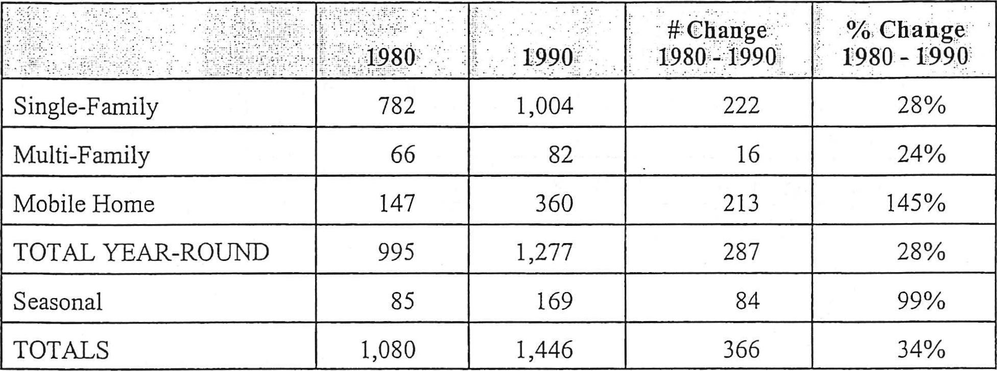
28%
222
1,004
360
145%
213
28%
287
1,277
169
99%
84
366
1,446
34%
782
Single-Family
82
Multi-Family 66
Mobile Home
147
TOTAL YEAR-ROUND
995
Seasonal
85
TOTALS
1,080
# Change
1980 - 1990
% Change
1980 - 1990.
1.990
16
24%
Since 1980, the mobile home has gained a greater percentage of the housing stock in Greene. In 1980, the mobile homes accounted for 15% of the total year-round housing stock; whereas in 1990, it had risen to 25% of the total housing stock. Although numerous factors have contributed to this increase, two that appear relevant are their affordability and land costs in Greene.
Table 1-20
Distribution of Housing Unit by Type
1990
Owner/Renter Patterns

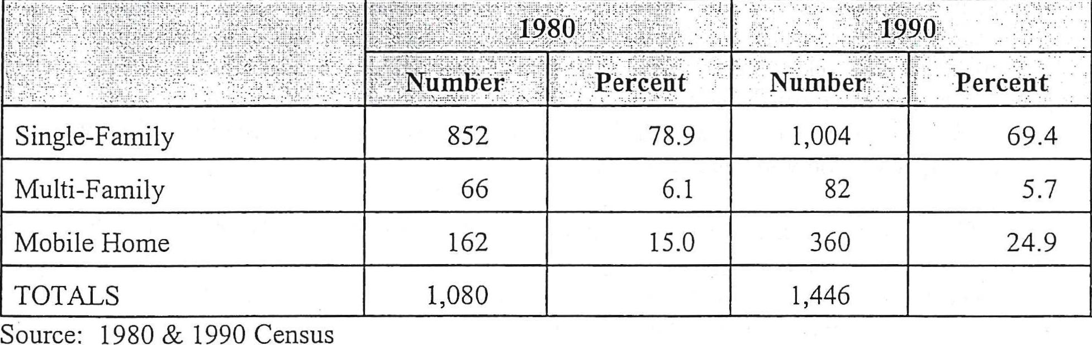
Numii.er
5.7
6.1 82
15.0 360 24.9
66
Multi-Family
162
Mobile Home
1,446
1,080
TOTALS
Source: 1980 & 1990 Census
Single-Family
1,004
852
Percent
69.4
Rural communities typically have a much larger percentage of owner occupied dwelling units than renter occupied dwelling units. This is due to the large percentage of the overall housing stock comprised of the single-family home. In 1990, 90% of all housing units were owner occupied and 10% renter occupied. This distribution was consistent with other rural communities in Androscoggin County. Since the time of the 1990 Census, it has been assumed that the distribution of owner vs. renter occupied housing units has remained similar to that of 1990.

25

Table 1-21
Distribution of Occupied Year-Round Housing Units by Tenure
1990

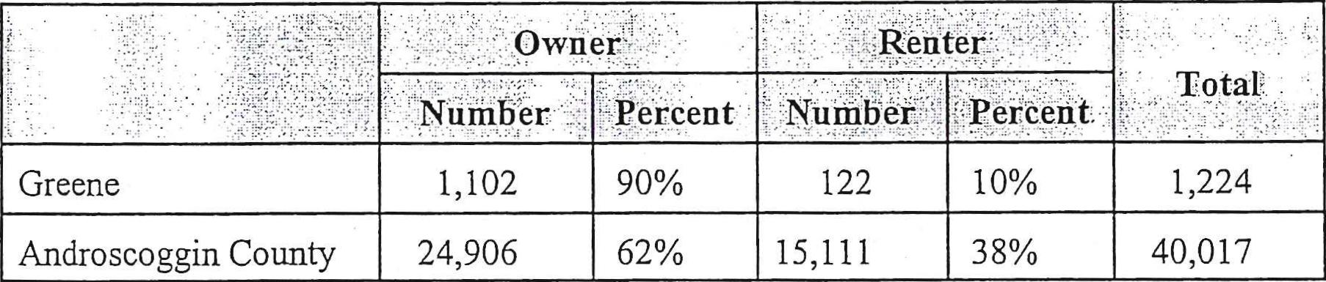
Greene
Androscoggin County
Owner |  | Renter
Number. | Percent | 1•Itirqb61⁻_ ' | Percent
1,102 | 90% | 122 | 10%
24,906 | 62% | 15,111 | 38%

1,224
40,017

Source: 1990 Census
Vacancy Rates
Although no vacancy rate survey was conducted as an element of the comprehensive plan based upon local knowledge, the following has been assumed. Because multi-family units are limited in Greene, the vacancy rate is expected to be less than one percent. It is also expected that the vacancy rate for year-round dwelling units is less than one percent as well.
Housing Conditions
The condition of a community's housing stock is an indicator of the community's well being and the need for housing rehabilitation programs. Several methods are available to assess housing conditions including analysis of Census information, questionnaires and physical inspection of individual dwelling units. Each method has its advantages and disadvantages with the best being the physical inspection of each dwelling unit. The analysis of the condition of Greene's current housing stock does not rely upon physical survey of the town's dwelling units but rather the age of the housing stock. General assumptions can be made that the older the structure, the more likely it is to have structural, electrical or insulation deficiencies. Caution must be used, however, when age alone is considered as an indication of physical condition. Many older homes are commonly in excellent condition.
In 1990, 63% of Greene's year-round housing stock was constructed after 1970. This compares to 34% of all of Androscoggin County. If it is assumed that age of a community's housing stock reflects the physical condition, then Greene's housing stock should be in better condition than that of overall Androscoggin County because of its younger age.

26

Table 1-22
Age of Housing Stock
Year Structure Built
1990
Source: 1990 U.S. Census

1989-March 1990
1985-1988
1980-1984
1970-1979
1960-1969
1950-1959
1940-1949
1939 or earlier
TOTAL
Greene- |  | Androscoggin County
:Number | . Percent | Number | Percent
48 | 3.3 | 1,074 | 2.5
212 | 14.2 | 3,879 | 8.9
144 | 10 | 2,430 | 5.6
512 | 35.4 | 7,427 | 17
259 | 17.9 | 4,838 | 11.0
75 | 5.2 | 4,043 | 9.2
25 | 1.7 | 3,044 | 7.0
171 | 11.8 | 17,080 | 39.0
1,446 |  | 43,815

Overall, the indicators point towards the Town's housing stock being in general good condition. Although structurally substandard dwelling units are found in Greene, there is not a significant community problem with substandard housing.
Housing Trends - 1990-1998
Greene's year-round housing stock grew by some 18% between 1990 and 1998. Building permits for a total of 235 dwelling units were issued over the period. These were comprised of 161 single family dwelling, 70 mobile homes, and 4 multi-family dwellings.

27

Table 1-23
Housing Trends
1990- 1998
Year | Single-Family . | Mobile Home. | ...Mul4Tanilly | TOTAL
1990 | 15 | 10 | -- | 25
1991 | 17 | 4 | 1 (2 units) | 23
1992 | 26 | 9 | -- | 35
1993 | 19 | 8 | 1(2 units) | 29
1994 | 11 | 10 | -- | 21
1995 | 22 | 8 | -- | 30
1996 | 23 | 8 | -- | 31
1997 | 17 | 11 | -- | 28
1998* | 11 | 2 | -- | 13
TOTALS | 161 | 70 | 2 (4 units) | 235

Source: Town of Greene
Affordability of Housing
Essential to community growth and development is the availability of affordable housing either renter or owner-occupied. The lack of safe affordable housing may force young individuals or families to leave Greene and hinder economic growth and development.
The 1990 Census reported that 80% of the renters in Greene paid less than $500 per month for rent, it is believed that rates have risen some since then.

28

Table 1-24
Gross Rent
Specified Renter Occupied Housing Units
1990
Source: 1990 Census

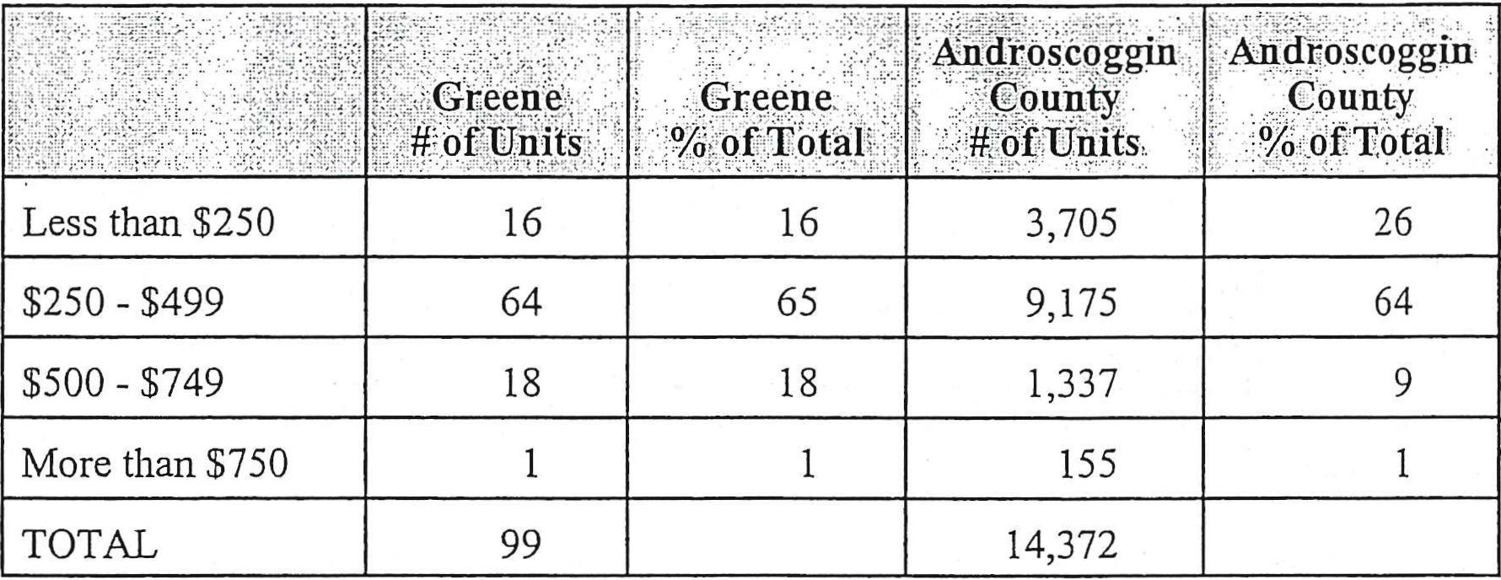
16
16
Less than $250
65
64
$250 - $499
18
18
$500 - $749
1
1
More than $750
99
TOTAL
- Androscoggin  County  it of Units | . Androscoggin Count);  -% of Total
3,705 | 26
9,175 | 64
1,337 | 9
155 | 1
14,372

reene
of Units
Greene
%. of Total'
The real estate transfer tax declaration forms provide sales prices of all homes sold including mobile homes. As the table below shows, Greene's average sale price of residential housing increased from $66,500 in 1992 to $90,500 in 1996.
Table 1-25
Sales Price Residential Homes
1992-1996
Source: Maine State Housing Authority

1992
1993
1994
1995
1996
Greene
Number of,Sales - | Mean Sale Price
13 | $66,500
18 | $83,750
33 | $84,000
24 | $82,900
28 | $90,500

The United States Department of Housing and Urban Development (HUD) has established guidelines for computing general income guidelines for determining housing affordability. The income levels that are a primary concern with respect to affordability are moderate, low, and very low. These are 120%, 80%, and 50% of median income respectively. In 1989, the median household income in Greene was $32,900. It is estimated that in 1998, the median family income had increased to $42,000. As shown in the following table, a household that earned no more than $21,000 would be considered as a very low income household.

29

Table 1-26
Moderate, Low-Income, and Very Low Income Households
As a Proportion of Total Households
Greene, 1989
n_come Aniount

APPF⁰x¹Plae'Pe.rcent4ge of,Totat'IIpuseholds

20%
Moderate $39,500

Low
Very Low
$26,300
$16,500
20%

Source: U.S. Depai talent of Housing and Urban Development, Androscoggin Valley Council of
Governments
Income figures for the years since the 1990 Census are not available for Greene. However, the table below lists 1998 figures which have been generated for Androscoggin County by the Department of Housing and Urban Development (HUD). Also shown are the low-income (80% of median) and very low-income (50% of median) threshold figures for Androscoggin County and amounts that constitute "affordability" for home purchase for each of the three income categories.
Table 1-27
Affordable Housing Rents and Sale Prices
Androscoggin County

Median Annual Family Income
Household Income Group
- Affordable Selling Price

16%
$37,100 | Very Low Income | Up to $18,500 | Up to $ 35,600
 | Low Income | $18,500 - $29,700 | Up to $ 64,000
 | Moderate Income | $29,700 - $44,500 | Up to $126,800
Source: U.S. Department of Housing and Urban Development
Based upon income information and generally accepted affordable housing sale prices,
affordable housing opportunities in Greene are an issue for very low income households that may wish to purchase a home in Greene. Given the low rental vacancy rate for rental units and rental costs, limited options are available for those individuals and families with incomes of less than $18,500.
Future Housing Demand
Future population and the characteristics of the existing housing stock are major factors in identifying future housing demands. Adequate housing is important in supporting economic growth. This element of the comprehensive plan identifies the need for additional housing over the ten-year planning period. As with any forecast, unforeseen influences can greatly influence its validity.
30

Greene's year-round population is expected to reach approximately 4,800 by the year 2009. Based upon an average household size of 2.75 persons in the year 2009, a demand for some 250 new year-round dwelling units will exist over the ten-year period.
Besides the number of units, an examination of the type of units (single-family or multi-family) is necessary. Key factors in making this determination are income levels, household size and age of the population. Average household size has been projected to decrease to 2.85 persons. Based upon available information and recent trends, the demand for housing will be primarily in the middle and lower income brackets.

31

32

PUBLIC FACILITIES AND SERVICES

Findings
- :* Over the ten-year planning period, improvements and expansions to municipal buildings will be necessary.

Overall enrollment in SAD #52 remained stable between 1995 and 1998.
Introduction
An examination of Greene's public facilities and their current day capacities is an important element of the comprehensive plan. In addition, the future demands upon the Town's public services and facilities must be assessed and their adequacy to meet such demands determined. Greene's increase in population has created a demand for expanded services and facilities and will create demands for new service.
Fire Department
Fire protection is provided to the residents of Greene by the Greene Fire Department. The volunteer department has nine vehicles and is funded by Town appropriations and donations.
There are 25 volunteer firefighters and a fire chief who is elected by the firemen. The fire station is located on the corner of Patten and Sedgly Road. Currently, the fire department has the capability to fight only wood burning fires. They have no equipment to handle chemical and hazardous fires. As Greene continues to grow, added equipment to fight such fires will be needed.

33

Table 1-28
Fire Protection/Rescue Equipment
1998
Engme U | Year | Make | Model
6 | 1956 | 10-Wheel Drive Army Truck | 500 gal/min -- 1600 gal. tank
2 | 1985 | Chevy Pumper | 1000 gaUmin -- 1000 gal. tank
4 | 1956 | 10-Wheel Drive Tractor Trailer Unit | Tanker -- 5000 gal. tank
5 | 1971 | International Wheeler | 1000 gaUmin -- 2000 gal. tank
5 | 1972 | Ward Lafrance
7 | 1977 | International Wheeler | 1000 gaUmin -- 2000 gal. tank
8 | 1956 | Four-Wheel Drive Pickup | Brush Truck
 | 1972 | Ward Lafrance | Snorkel
 | 1992 | GMC | Rescue Vehicle

There are several issues the department will have to face in the future. Increased growth and development will create the need for increased fire protection as well as the possibility of an incident involving hazardous materials. Another potential problem relates to maintaining an adequate number of volunteers to respond to day time fires. Most of the resident population travels to Lewiston and Augusta for work. This situation could create a lack of volunteers to fight fires that occur during the day.
The department continues to attempt to upgrade its equipment. A ten-year replacement cycle for trucks appears appropriate. Because the current fire station is constructed of combustible material, the fire department will be seeking funds for a new noncombustible building. The fire station over the 10-year planning period will likely need replacement to house equipment and be office fireproof construction.
Emergency Rescue
Residents in the Town of Greene are provided emergency medical services through the Greene Rescue Squad. The rescue squad is comprised of volunteers with equipment in the same building as the Fire Department.
Funding for the rescue unit is provided through town appropriations and through private donations.
Police Protection
The Town of Greene does not provide municipal law enforcement services but rather relies on the Androscoggin County Sheriffs Department and Maine State Police. Greene is one of seven communities in Androscoggin County which does not provide some type of municipal law enforcement.
34

Public Works Department
The Town maintains a public works department that is managed by the Road Commissioner who also serves as the Town Manager. The Town owns all of its own trucks with the exception of one backhoe which is leased on a yearly basis. It is the department's responsibility to maintain roads during the winter and summer months.
Table 1-29
Public Works Buildings and Equipment
1990
. Building/Equipment | Location | Age  , , | Condition  . •
Salt/Sand Shed | Main Street | New | Excellent
Garage | Main Street |  | Fair
Grader |  | 1975
Backhoe |  | 1997
GMC Truck |  | 1979 | Good
International |  | 1994 | Excellent
International |  | 1988 | Good
International |  | 1985 | Good
Street Sweeper |  | 1994
Loader |  | 1982 | Good

Solid Waste
The Town operates a transfer station located on the Quaker Ridge Road for residential wastes. Commercially generated wastes are not accepted at the station, and its disposal is the responsibility of the generator. A recycling program is in place. Most household wastes is currently disposed of at Mid Maine Waste Action Corp. in Auburn. Other wastes such as bulky, wood, white goods and tires are hauled to other commercial disposal sites. Some 1,500 tons of residentially generated wastes are disposed of annually.
The existing facility will be adequate to serve the town over the ten-year planning period. Town Government
The Town of Greene is managed by a Town Manager and five selectmen. The selectmen are elected to three-year terms. The town meeting is held the first Friday and Saturday in March. Elections are on Friday at the town office and the open meeting is on Saturday at the Greene Elementary School. Elections by ballot are on Friday and action on the warrant are on the floor of town meeting on Saturday.

35

Municipally Owned Buildings
The Town of Greene owns nine buildings used for municipal purposes. These include the Town Office which was constructed in 1982. While the office is considered in excellent condition, space has become inadequate to carry out municipal functions. The primary purpose of the building is for the town manager to conduct town business and for a meeting place for the boards and committees.
The Public Works Depaitilient is housed at the town garage on Main Street. The building is 20 years old and is of concrete block construction. Space in the garage for equipment storage is not sufficient. The site itself is small limiting the potential for expansion. Associated with the town garage is the new salt/sand shed.
The fire station is located on Sedgely and Patten Roads. The building is discussed in the fire protection chapter of this plan. The fire depaitinent wishes to construct a new building made of non-combustible material.
The town is investigating an addition to the library. Land has been purchased for an addition. Educational Facilities
Greene is a member of Maine School Administrative District #52 (SAD 52), also known as the River Valley School District. The District also includes the Towns of Turner and Leeds. All district high school and junior high school students attend facilities in Turner. Greene and Leeds have their own elementary schools, Greene Central School and Leeds Central School, and Turner has both a primary and elementary school.
Total enrollment in the District increased by 1.5% between 1995 and 1998. The most significant gain within the District was in grades 9 through 12 with an 11% increase or 72 students.
Table 1-30
SAD #52
Total School Enrollment
1994 - 1998
Year | K-6.. | 7-8- | 9-12 | TOTAL
1995-1996 | 1,267 | 358 | 663 | 2,293
1996-1997 | 1,263 | 357 | 693 | 2,313
1997-1998 | 1,215 | 378 | 735 | 2,328
Source: SAD #52
Greene's overall school enrollment decreased by 2% between 1995-1998. However, as shown in Table 1-31, there was an 11.5% increase in enrollment in grades 7 and 8 and a 9.1% increase in grades 9-12.

36

Table 1-31
Town of Greene School Enrollment
1994 - 1998
Year |  |  | 9-12 | TOTAL
1995-1996 | 438 | 115 | 242 | 795
1996-1997 | 419 | 130 | 236 | 785
1997-1998 | 401 | 143 | 243 | 787
1998-1999 | 386 | 130 | 264 | 780
% Change  1995-1998 | -11.9 | 11.5 | 9.1 | -1.9
Source: MSAD #52
With increased school enrollments throughout the District, school facilities have had to be expanded in the past several years. Turner Elementary School was expanded in 1988, and the new Tripp Middle School expansion opened in 1988 as well. In addition, the Leeds Central School's enlargement was completed in 1989. A new primary school opened in 1991 in Turner, and a $17 million expansion is under construction at Leavitt Area High School. Recent facilities expansions have not kept pace with new enrollments, and several portable classrooms have had to be leased by the District. Two are found at the Greene Central School.
Health Care Facilities
Greene residents rely on two major hospitals in Lewiston, Central Maine Medical Center and St. Mary's Hospital, and upon the local health use facilities afforded by the D.F.D. Russell Medical Center in Leeds.
Utilities/Communications
Greene is provided electrical service by Central Maine Power Company and telephone service by CommTell Telephone Service.
Cable TV service is provided by FrontierVision to portions of Greene. The local access channel WGLT TV 4 provides a wide range of local programming of local events.

37

38

TRANSPORTATION
Findings
Route 202 is the major highway through Greene carrying approximately 11,000. vehicles daily:

Since 1991 local road conditions have been significantly improved.
+ The development of anew exit on the turnpike in Sabattus is likely to increase traffic volumes on Sawyer Road.
Introduction
Greene's transportation system is comprised of its roadway system and the Guilford Industries (Central Maine) Railroad which runs for approximately six miles through Greene.
A community's roadway system is extremely important to future development. Traditionally, the roadway system has been second only to education in the amount of tax dollars expended annually. Greene contains approximately 70 miles of public roads. The Maine Department of Transportation has placed the roads in Greene into one of three functional classifications. They are defined as follows:
Arterial Highways: The most important travel routes in the state. They carry high speed long distance traffic and attract a significant amount of federal funding. They usually carry interstate or U.S. Route number designations. Route 202 is considered an arterial.
Collector Highways: These routes collect and distribute traffic from and to the Arterial Routes serving places of lower population densities and somewhat removed from the main travel routes. The Allen Pond and Sawyer Roads are collectors.
Local Highways: All highways not in the Arterial or Collector classification. They serve primarily for service to adjacent land areas and usually carry low volumes. The majority, 51 miles, of Greene's roads are classified as local highways.
39

Table 1-32
Greene's Road Mileage by Classification

Type | Miles
Arterial | 6.26
Collector | 11.64
Local | 51.61
TOTAL | 69.51
Source: Maine Department of Transportation, Town of Greene
Route 202 is the only arterial classified road in Greene. The highway is a major connector between Lewiston, Auburn, and Augusta. Collector roads include the Allen Pond Road, Sawyer Road and a small segment (.17 mile) of the Merrill Hill Road.
The Maine Department of Transportation has maintenance, snow removal responsibilities for Route 202 and summer maintenance on the Allen Pond and Sawyer Roads.
Table 1-33
Road Mileage
Town of Greene
State/State Aid | 17.90
Local | 51.61
TOTAL | 69.51
Source: Road Commissioner, Town of Greene
Roadway Conditions
Physical conditions of all town maintained roads were rated by the Greene's Road Commissioner. The rating was based upon a good, fair or poor classification with consideration given to surface conditions, ditching width, and traffic volumes. Based upon the Road Commissioner's analysis, approximately 25 miles are considered in good condition, 28 miles in fair condition, and 10 miles in poor condition. Since 1991, local road conditions have been greatly improved.

40

Table 1-34
Road Condition
1998
Condition of Road Mileage ercent of Total
Good 25.49 40
Fair 27.68 44
Poor 10.08 16
Source: Greene Road Commissioner
Map I-1 indicates the condition of roads. It is now widely accepted that it is most cost effective to undertake maintenance of paved roads at a point before deterioration of the surface becomes too severe. The Town has developed a multi-year road improvement/paving program.
Roadway Capacity
Roadway capacity is the function of a particular road or highway to allow traffic to move freely without hazard. Nationally accepted measurement of capacity is Level of Service (LOS) which employs a scale of A to F with A the best and F the worst. LOS analysis has not been conducted for the roadways in Greene, however, annual average daily traffic information and pavement conditions for State 202 was reviewed. Based upon the Annual Average Daily Traffic figures and pavement conditions of Route 202 it has adequate capacity. This is also true for local roads. A new turnpike exit in Sabattus may increase through traffic on Sawyer Road which is in poor to fair condition.
Motor Vehicle Accident Data
The Maine Department of Transportation (MDOT) maintains accident reports of all reportable accidents (those involving $500 damage or personal injury). A report entitled "Maine Accident Report Summary" provides information relating to the location and nature of accidents. One element of the summary report is the identification of a "Critical Rate Factor" (a statistical comparison to similar locations in the State). Locations with a "critical rate factor" of greater than 1.0 with more than eight accidents should be of concern because they can be potential high-accident locations. Based upon the information provided by MDOT, there are four areas with a critical rate factor greater than 1.00 and eight or more accidents in Greene. These areas are at the intersection of Route 202 and the Allen Pond Road and Route 202 from Allen Pond Road to Patten Road, Daggett Hill Road and Route 202 and College Road from North Hatch Hill Road to Sullivan Road. College Road is becoming an alternate route to avoid Route 202.
Railroads
The Guilford Industries Railroad line traverses Greene in a northeast/southwest direction. The line connects to Lewiston-Auburn south areas south and north to Livermore Falls and Jay and to northern Maine. The rail line through Greene carries primarily raw materials for the paper mills in Jay and finished products. The line also serves Maine Poly, Inc. in Greene.

41

42

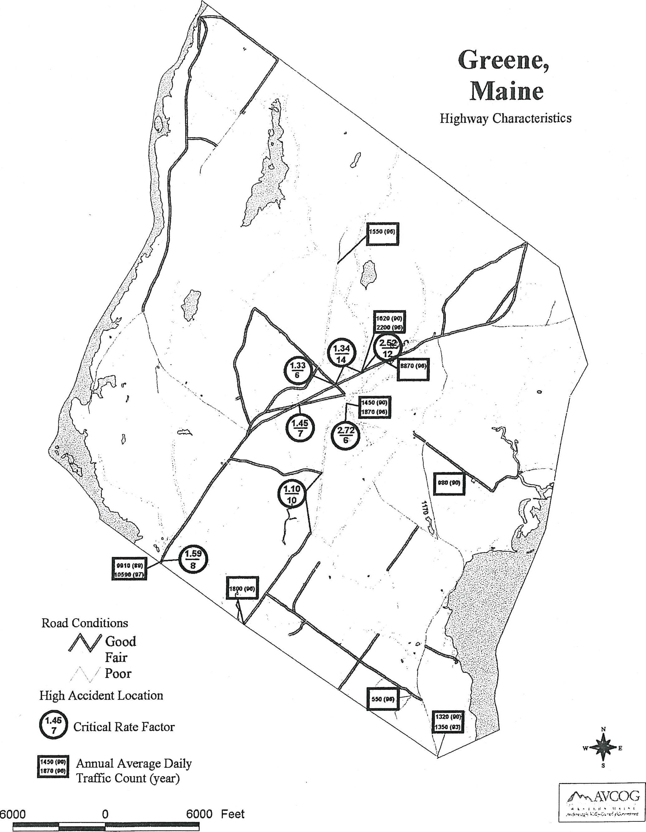
Greene,
Maine
Highway Characteristics
Road Conditions
Al Good
Fair
/ Poor
High Accident Location
Critical Rate Factor
E
1430 (00)
1970 (00)
Annual Average Daily Traffic Count (year)
6000 0
6000 Feet
AVCOG

OUTDOOR RECREATION RESOURCES
Findings
.*:* Greene's natural resources have traditionally provided for many outdoor recreation opportunities.

+ There is a need for additional outdoor recreation facilities based on acceptable standards.
+ Some traditional outdoor recreation activities may be reduced as the result of development and land posting.
Introduction
Recreation opportunities both organized and unstructured are important elements of Greene's quality of life. Municipal organized recreational activities are directed by the Greene Athletic Association and Conservation Commission. The Athletic Association is overseen by a board of directors and offers organized sports activities in baseball, basketball, cheering, soccer, softball, and t-ball. The Conservation Commission maintains, improves and developments the town's outdoor recreation areas.
Public Recreation Areas and Facilities
The town owns several recreation areas. These include the Greene Recreation Park, the Hooper Pond Recreation Site, the Allen Pond Access Site and Murch Field. The Recreation Park some 100 acres in size is found next to the Greene Central School. Ball fields, multi purpose/soccer field and horse shoe pits are located here. Future plans call for an additional ball field, picnic area and nature area. Murch Field located off the Patten Road has been developed as a Little League baseball type field. The Hooper Pond Recreation Site developed within the past several years provides small boat access to Hooper Pond, picnic tables and parking. In addition skating is available in the winter. The Allen Pond Access Site provides carry in boat access to Allen Pond.
Residents of the town enjoy the use of the recreation facilities at the Greene Central School that include a playground, outdoor basketball court, tennis court, multi-purpose field and the gymnasium.
Baseball and soccer are also played at the Missionary Field that is privately owned. Long tam use on this field is not assured.
45

Private Recreation Facilities
There are two privately owned recreation areas in Greene. They are the Allen Pond Camp Ground and the Bull Run Motocross Track.
Snowmobile Trail System
The Greene Dragons Snowmobile Club maintains the local snowmobile trail system. Not only are these trails used by snowmobilers but cross country skiers and snowshoers as well. The system of local trails is made possible by the willingness of private land owners to allow the club to develop and maintain trails over their land.
Important Hunting and Fishing Areas
Greene has traditionally been a favorite hunting area for both town residents and nonresidents. Farmland, abandoned farmland and woodlands provide excellent wildlife habitats for both game and non game species. The Androscoggin River and Sabattus Pond have traditionally been favorite waterfowl hunting areas. Some of traditional hunting area has been lost due to development and posting.
The ponds, brooks and rivers provide many fishing opportunities. Sabattus Pond and the Androscoggin River are popular bass waters. Sabattus Pond has a developing pike fishery although illegally introduced.
Recreation Facility Needs Analysis
Current outdoor recreation facilities have been assessed based on recognized facility standards. These standards should be used as a guide to currently needed facilities and anticipated facility needs based upon the forecasted year 2009 year round population. This analysis is based on facilities owned by the town of Greene and areas the public has been granted use currently.

46

Table 1-35
Outdoor Recreation Facilities and Needs
Type of Facility , | Recommended  Stds. per 1000  pop. | Existing  Facilities | 1998^{A}  Surplus/  (Deficiency) | 2009^{B}Surp1us/ (Deficiency)
Neighborhood Playground | C | 1 | 0 | 0
Community Recreation Area (12-25 acres) | C | 1 | 0 | 0
Community Park (100+ acres) | C | 1 | 0 | 0
Baseball Diamond (90 ft. basepaths) | .16 | 0 | (¹) | (1)
Softball/Little League  Diamond* | .75 | 3 | 0 | (¹)
Basketball Court* | .5 | 1 | (1) | (¹)
Tennis Court* | .67 | 1 | (1) | (2)
Multi purpose Field (Football, Soccer, Field Hockey)* | .5 | 2 | 0 | 0
Swimming Area (square feet) | 750 | 0 | (3,000) | (3,600)
Ice Skating Area* (square feet) | 5000 | 0 | 0 | 0
Picnic Table | 2 | 2 | (6) | (8)
Nature Study Area | C | 1 | 0 | 0

^{A} Based on a population of: 4,000
^{B} Based on a 2009 population of: 4,800
^{C} Standards are as follows:
Neighborhood playgrounds, for towns with a population greater than 1,000, should be
located within ^{1/2} mile of housing concentrations of 50 or more homes and include
playgrounds, basketball courts, play fields, etc.;
One community recreation area, 12-25 acres, for towns with a population greater than
5,000, developed with ballfields, tennis courts, swimming facilities, ice skating, etc.;
0.ne community park, 100+ acres, for towns with a population greater than 5,000, largely
undeveloped for walking, cross country skiing, nature study, etc.;
minimum one nature study area for towns with population greater than 1,500.
* Minimum one per Town.
Based on this analysis there is currently a need for a 90-foot basepath baseball field, outdoor basketball court, tennis court and swimming area.
47

I
48

NATURAL RESOURCES
Findings
- Greene's natural resources are important to its character.
- Approximately 15 percent of the land area in Greene is classified as having prime farmland soils.
- A major threat to surface water quality is phosphorus.
+ The Androscoggin River has significant recreation potential.

The natural resources base of a community plays an important role in overall community development. Natural resources can enhance or limit the growth potential and are significant factors in the planning of a community's future.
Topography
Topography relates to the general land from an area. Often, a locale may be referred to as mountainous, hilly or flat. Knowledge of the topographic characteristics of a community are important because of its influence on development, views and aesthetics.
There are two factors that are important when topography is considered: relief and slope. Relief reflects the height of land above sea level and surrounding areas. It identifies significant or dominant physical features that form natural barriers that hinder development or valley corridors that permit easy access. Slope, on the other hand, measures the amount of rise or fall in feet for a given horizontal distance. It is a significant aspect of landform which presents various limitations to development and other land use activities. As slopes become steeper, construction is more expensive, roads and services are more difficult and expensive to construct and maintain, and the potential for environmental degradation increases.
Generally speaking, Greene can be separated into two sections. The first is the northwest side of Route 202 where the topography can be considered hilly, and the second is the southeast of 202 where more flat, rolling areas are found.
Local relief ranges from over 740 feet above sea level atop Clark Mountain to about 240 feet above sea level where the Maine Central Railroad crosses Greene's southern border into Lewiston.
49

Slopes of greater than 15% are scattered throughout the community with major concentrations in the vicinity of Clark Mountain and Hill Ridge. Approximately 10 percent of Greene's total land area has slopes of greater than 15%.
Soils
Soils are extremely important to community development. They are the underlying material upon which roads, buildings, sewage and waste disposal occur. Development upon or in soils that are unsuitable for proposed uses will likely increase development and construction costs, annual maintenance costs, and cause environmental degradation.
Soil mapping undertaken by the United State Department of Agriculture, Soil Conservation Service, indicates three main soil associations in Greene. They include: Charlton-Sutton Paxton; Hollis-Sutton-Buxton, and Scantic Leicester-Scarboro. These associations are generally evenly distributed through the town.
A soils association is a landscape that has a distinctive, proportional pattern of soils. It normally consists of one major soil and it is named for the major soil. The general description of the major soil associations found in Greene are as follows:
Charlton-Sutton-Paxton Association: Deep, medium textured and moderately coarse textured, well drained and moderately well drained, nearly level to moderately steep slopes, on hills and ridges.
Scantic-Leicester-Scarboro Association: Deep, medium-textured and moderately coarse textured, poorly drained and very poorly drained, level to gently sloping soils.
Hollis-Sutton-Buxton Association: Shallow to deep, medium-textured and moderately coarse textured, well drained and moderately well drained, nearly level to steep soils, generally on the tops of low hills and ridges.
A practical approach to categorizing soils for planning purposes is to use soil potential ratings. Soils potentials for low density residential development is a system to rate the potential of the soil to be used for low density development. Soils potentials for low density development have been developed by the Soil Conservation Service for Androscoggin County. The potentials are based on the cost of building houses, roads and septic systems on the particular soil. The rating system places soils into a three-category classification system: very high to high potential, medium potential, and low to very low potential.
Approximately 50 percent of the land area in Greene has a soils potential rating of medium. The areas with medium soils potentials are generally suitable for low density residential development even though some costs for overcoming soil limitations are significant. Some 20% of the land area has soils rated as high to very high for low density residential development with the remaining 30% having low potential. Concentrations of the medium and high density soils can be found throughout the town but specifically near Route 202, and the northwest and southeast corners of town.
Although this soils potential rating system should not be used for locating specific development areas, it does provide insight into areas which are more suitable than others for low density residential development and should be considered along with other factors in determining potential growth areas.

50

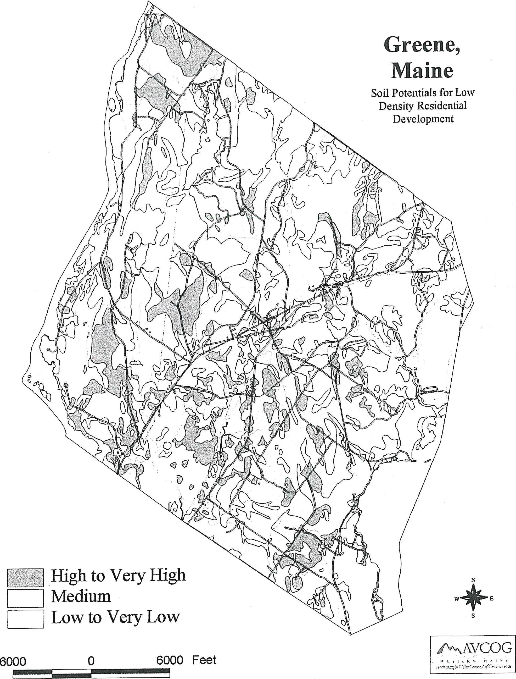
Greene,
Maine
Soil Potentials for Low
Density Residential
Development
High to Very High
Medium
Low to Very Low
6000
6000 Feet
0
PA,\AVCOG

Prime Farmland Soils
As defined by the United States Department of Agriculture, Soil Conservation Service (Natural Resource Conservation Service), prime farmland soils are those which, nationwide, have physical characteristics which make them the best agricultural lands. Except for urban land, the designation of "prime farmland" is tied directly to soil properties and not to current or past land use; it can be land in cultivation, forest, pasture, or idle, and it can be remote or inaccessible. If, however, the land is urban, or built-up, it is not designated as prime farmland.
Approximately 15 percent of Greene's land can be classified as prime farmland. Significant areas of prime farmland soils are located near the Androscoggin River, specifically the northern section of town, and along the edges of Coburn, Longley, and Bull Run Roads.
Wetlands
Wetlands perfolin a variety of functions. They serve as "natural sponges" that control water runoff by providing a buffer for excess water while allowing a steady, even, release of that excess to both the surface and ground water. Some wetlands serve as recharge areas for aquifers. Wetlands also perform a cleansing function by absorbing some physical and chemical pollutants from the runoff Wetlands are also important wildlife habitats. The pattern of water cover and vegetation accounts for the differing types of wetlands and the differing types of wildlife use.
The United States Department of Interior has published a series of National Freshwater Wetlands Maps that identify both forested and non-forested wetlands as small as two acres. In Greene, the primary wetland types are plustrine scrub-shrub and seasonally flooded/saturated forested wetlands. Major wetland areas in Greene are located around Daggett Bog, along Stetson Brook between Route 202 and College Road, south of the Sullivan Road between the railroad and College Road, along Hooper Brook south of Little Sabattus Pond, at the north end of Sabattus Pond and in the northeastern portion of Greene.
The Mandatory Shoreland Zoning Law requires municipalities to regulate land use activities adjacent to non-forested wetlands of 10 or more acres in size.
Surface Waters
Greene's major surface waters include the Androscoggin and Dead Rivers, Sabattus Pond shared with the towns of Sabattus and Wales, Allen Pond and Little Sabattus Pond and a number of brooks and streams.
Androscoggin River
The Androscoggin River forms the western border of Greene. The Gulf Island Dam in Auburn, constructed in 1925-27, creates the largest impoundment, the Gulf Island Pond, along the river.
The Androscoggin River has a highly regulated flow management system. A number of headwater lakes are manipulated to store water during periods of high runoff and to release water to the river system during periods of low =off. This flow management system was established to enhance the river's suitability for power production and manufacturing processes. Through flow regulation, spring flows are reduced and summer flows are increased significantly above what would naturally occur.

53

54

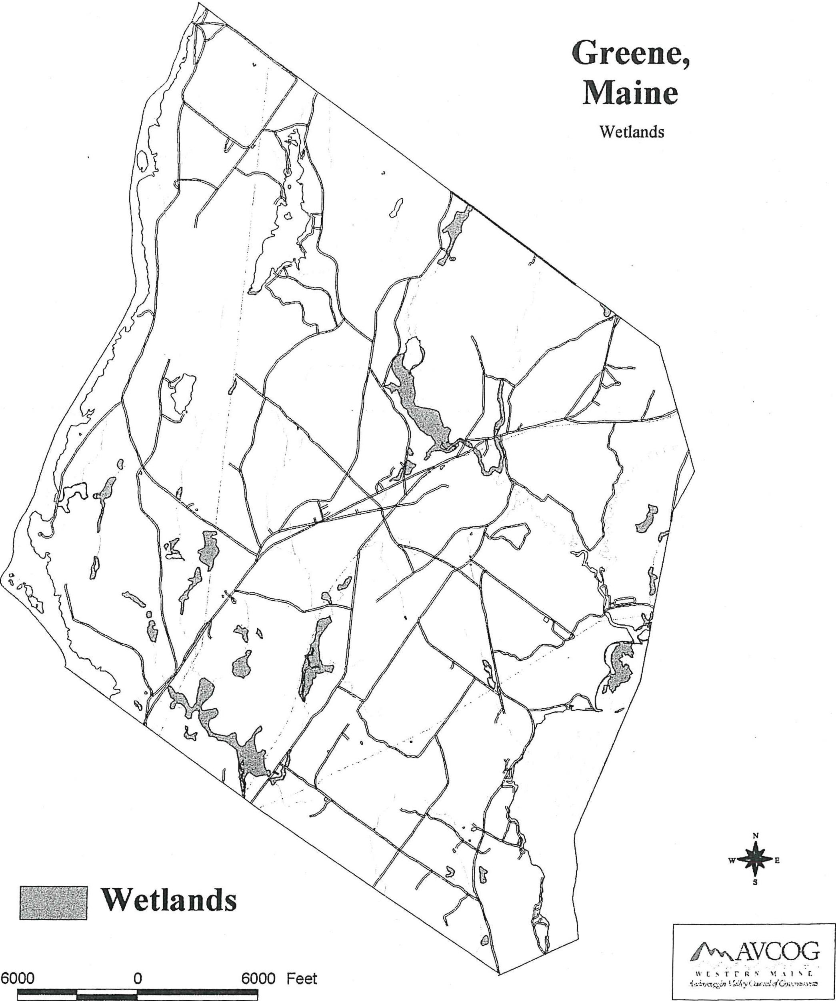
Greene,
Maine
Wetlands
Wetlands
6000
6000 Feet
41AVCOG
IVESTCR, %I *1,1: y

The pulp and paper industry anchored along the Androscoggin River during the mid 1980s. The continued expansion of this industry had long-term impacts upon the economy of the river basin and the quality of its waters. Mills were constructed at Berlin, New Hampshire, Livermore Falls and Rumford; they discharged raw liquors from the sulfite pulping process to the river. As the pulp and paper industry and the economy grew, increased demands were placed upon the river to assimilate industrial and domestic wastes.
In the early 1940s, the public would not tolerate the condition of the river which gave off hydrogen sulfide gases and discolored exposed metal and paint. In a report presented to the Maine Sanitary Water Board in February, 1942, it was stated that, "the pollution responsible for the objectionable conditions of the river is derived from industrial wastes and municipal sewage discharges without treatment." It was further noted that "few streams in the United States of comparable size showed evidence of such extreme pollution." It was estimated that the industrial discharge to the river was equivalent to that from a population of 2,411,500 people.
Since the 1940s, both industries and municipalities have constructed treatment plants which treat waste before they are discharged to the river. The river is classified as "C" as it flows past Greene.
The Androscoggin River is one of Maine's major industrial rivers. However, the river, in Greene, has been found to have a significant recreational potential and, as water quality improves, an even greater potential. The Lower Androscoggin River Recreation Study and Management Plan found that the ten-mile section of the overall study corridor which begins at Gulf Island Dam and proceeds upstream to approximately two miles above the Greene-Turner Bridge, exhibits the greatest overall recreational potential within the study corridor. The large impoundment of water, some 2,000 surface acres, created by Gulf Island Dam, has a positive impact upon several recreational activities. Shoreline characteristics within this ten-mile segment are conducive as well to a number of recreational activities evaluated. Physical characteristics which create a high potential for the majority of the activities evaluated within the ten-mile section are many. The large impoundment of water is conducive to canoeing, power boating and boat fishing. The large islands enhance the potential for canoe camping and provide for wildlife habitat.
Numerous large coves or bays are also positive influences upon canoeing, fishing, hunting and nature study due to their biological factors which can attract fish and wildlife. Shorelines within this section are primarily undeveloped which is also a positive factor to the potential of many activities evaluated.
The Dead River
The Dead River is the major tributary of Sabattus Pond. It originates in Leeds and flows southerly for approximately 8 miles to its confluence with Sabattus Pond. The drainage area for this river is 20.3 square miles.
The Dead River is currently a Class B river under the State classification of fresh surface waters system. Class B waters shall be such quality that they are suitable for the designated uses of drinking water supply after treatment, fishing, recreation in and on the water, industrial process and cooling water supply, hydroelectric power generation, and as habitat for fish and other aquatic life.

57

Streams and Brooks
There are a number of streams and brooks that drain portions of Greene. They include the following:
Allen Stream
Hooper Brook and its tributaries
Stetson Brook
East Branch of Stetson Brook
and many unnamed streams
All these streams and brooks are designated as Class B under the State Fresh Surface Waters classification system.
Drainage Areas
There are four major drainage systems in Greene. The entire eastern portion, or approximately 50 percent of Greene's area, drains to Sabattus Pond. This occurs either directly or through the Dead River which flows south from Leeds. Drainage from north-central Greene also enters the Dead River from its major tributary, Hooper Brook, which flows from the west.
The second major drainage system is located in south-central Greene. Here surface water leaves Greene through Stetson Brook, and the stream to the east that flows into No Name Pond, located in Lewiston.
The third major drainage system is in the northern part of town. Water drains directly into Allen Pond, then flows north into Leeds through the ponds outlet, Allen Stream.
The final major drainage system in Greene is the entire western edge of town which drains into the Androscoggin River. Eventually all water from Greene finds its way to the Androscoggin.
Greene's Lakes
Greene has a combination of eight lakes and ponds which include the following:
Allen Pond
Allen Pond is located in the upper northwest portion of Greene and has experienced increased development in recent years. This 183-acre pond has a mean depth is 16 feet and is 46 feet deep
at its deepest point. Water quality is considered good by the Maine Depai tiiient of Environmental Protection. Because of an oxygen deficiency below 20 feet as well as competition from warm water fish limit, the cold water fishery of the pond is limited.

58

Berry Pond
Berry Pond is located in west central Greene near the Androscoggin River. The pond is relatively small (32 acres) with a maximum depth of 16 feet. The pond shallowness results in high water temperatures at all depths during the summer months.
Daggett Bog
Daggett Bog is a relatively small bog with a large drainage area. Daggett Bog is primarily an 89-acre wetland area that has approximately four acres that is considered surface water. It is located near Meadow Hill Road and Route 202 in the southern section of town.
Deane Pond
Deane Pond is a small pond (10 acres) located just east of Allen Pond. Deane Pond is relatively inaccessible because of the topography surrounding the pond. There are no roads which lead into the pond and steep slopes on both sides. Currently, there is no development on or near the pond.
Little Sabattus
Little Sabattus Pond is isolated within 2 large wetlands that Hooper Brook flows through. The Pond has a surface area of 25 acres and a maximum depth of 14 feet. Warm surface temperatures exist throughout the summer.
Sabattus Pond
Sabattus Pond has a total surface of 1966 acres with a mean depth of 12 feet and 16 feet at its deepest point.
Sabattus Pond, which is shallow and eutrophic, has shown the effects of extensive cultural impact since the 1930s. Excessive aquatic vegetation and algae growth were noted by Maine Department of Inland Fish and Game in 1941. Since that time, the Pond has received much attention by the local and state authorities with, unfortunately, minimal upgrading of the water quality.
Sampling of the water quality in the pond undertaken in 1969 concluded that the pond contained abnormally high concentrations of bacteria and nutrients. It was further concluded that these concentrations were the result of (1) improper manure disposal practices being undertaken in the watershed of the pond; and (2) improperly constructed, malfunctioning cesspools and septic sewage systems serving many of the camps and cottages along the shore of the pond. A further analysis by the Depaituient of Environmental Protection in 1973 affirmed the conclusions and recommended the extension of sanitary sewers around the pond and better manure storage and utilization practices be undertaken in the drainage basin.

59

60

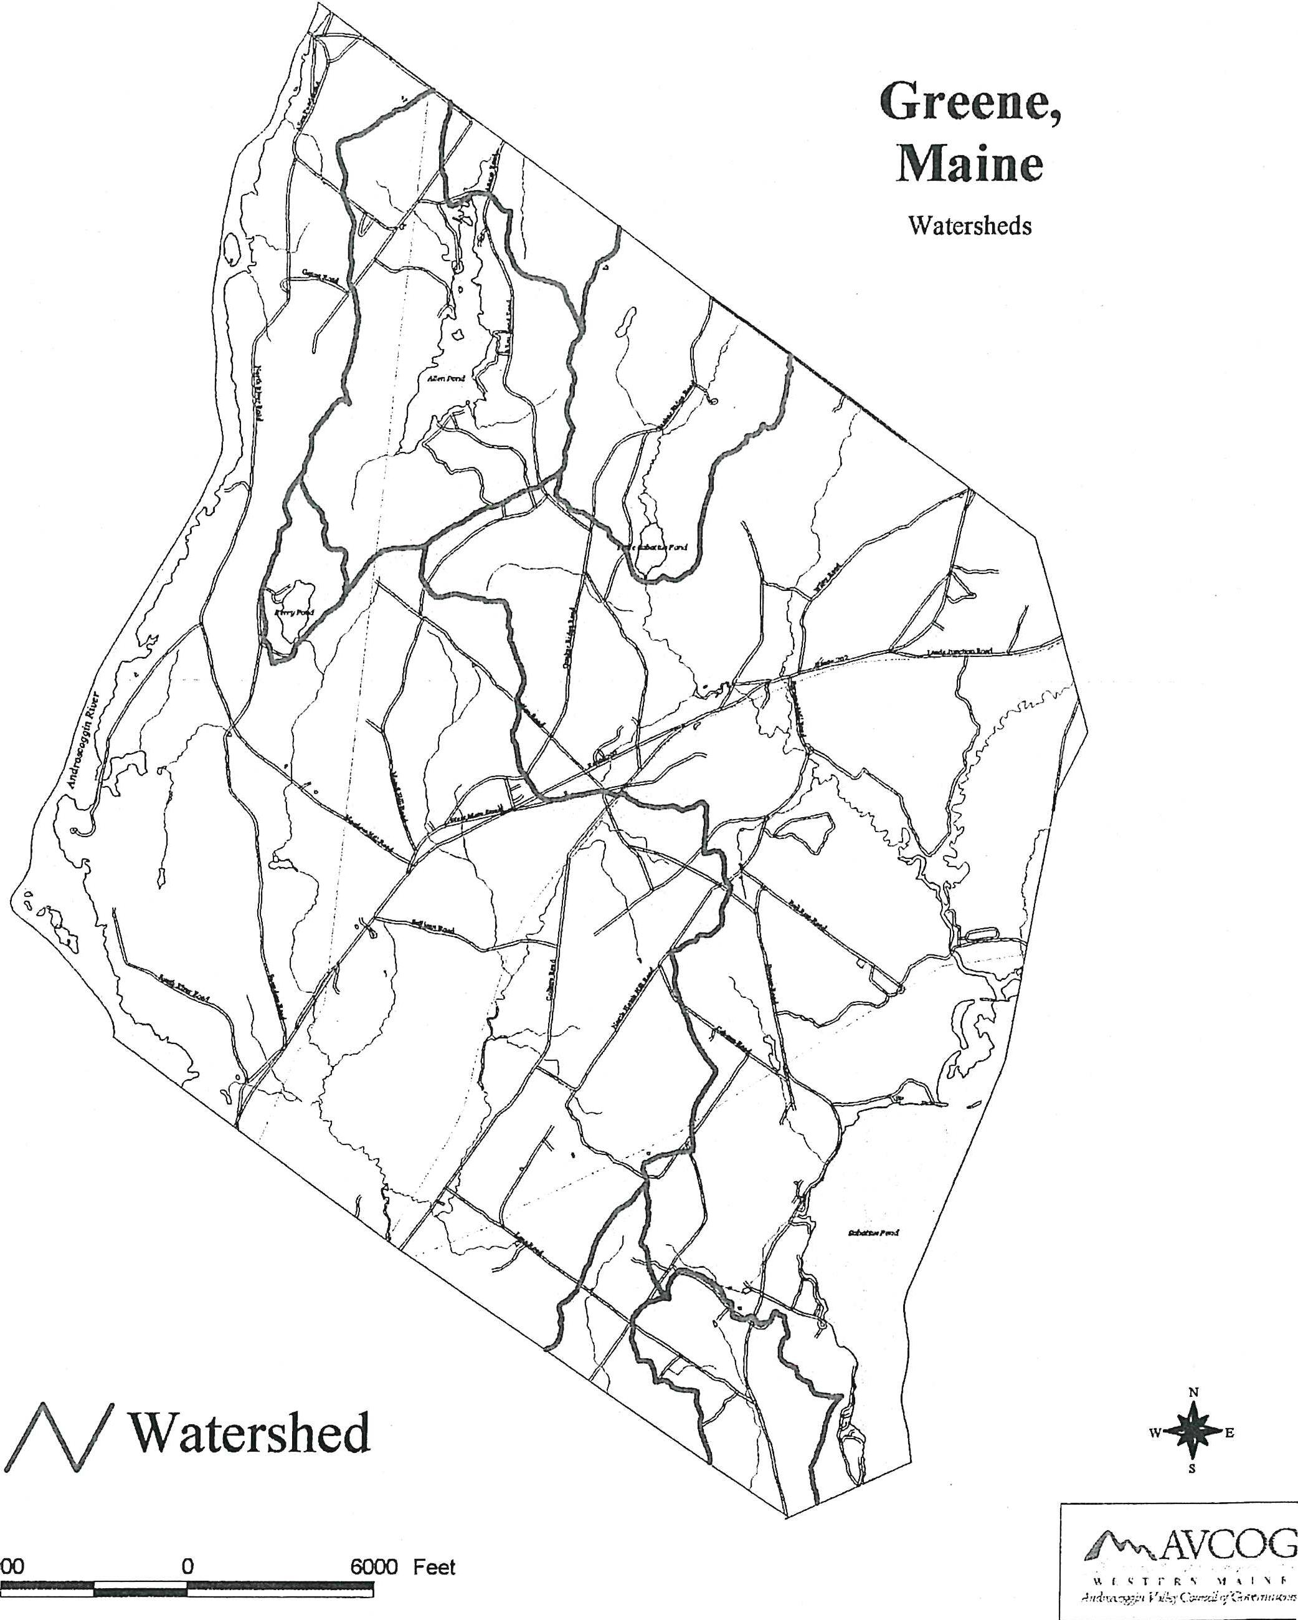
Greene,
Maine
Watersheds
NWatershed
W+E
6000 Feet
Pf\r\AVCOG
v.I,TrRN If‘INF
•

Lake Watersheds and Water Quality
Studies over the past decade indicate phosphorus, which acts as a fertilizer to algae and other plant life in the lake, is a major threat to lake water quality. While shoreland zoning has provided some protection, the studies indicate phosphorus can be contributed in significant quantities from the entire watershed.
The quality of water in a lake depends on the condition of the land in its watershed. Phosphorus is abundant in nature, but in an undisturbed environment, it is tightly bound by soil and organic matter for eventual use by plants. Natural systems conserve and recycle nutrients and water. Runoff from the forest is relatively low in quantity and high in quality. Water is stored in depressions and evaporates or seeps into the ground to become ground water, thereby preventing it from running over the land surface and exporting nutrients (i.e., phosphorus) from the system. Land development changes the natural landscape in ways that alter the nolinal cycling of phosphorus. The removal of vegetation, smoothing of the land surface, compaction of soils and creation of impervious surfaces combine to reduce the amount of precipitation stored and retained dramatically increasing the amount of water running off the land as surface runoff. The increased runoff from disturbed land generally carries higher concentrations of phosphorus and may also exacerbate erosion and sedimentation problems.
Greene has all or a portion of eight lakes and lake watersheds within its boundaries. Five of these including Berry, Daggett, Deane, Little Sabattus and an unnamed pond are considered small ponds and support some housing development within their watersheds. Berry Pond has also experienced some residential development along its shorelines. The watersheds of Berry, Deanne and Daggett Ponds are all contained entirely within Greene. Allen Pond and No Name Pond are considered medium size ponds and both support considerable year-round and seasonal residential development. Allen Pond's watershed is contained almost entirely within Greene. No Name Pond is located in Lewiston and about one-third of its watershed located in Greene. Sabattus Pond is considered a relatively large pond whose watershed is only partially located in Greene. Sabattus Pond supports heavy year-round and seasonal residential development both within the watershed as well as immediately along its shoreline.
The following table lists the lakes whose watersheds are either partially or entirely within Greene. The list includes the name of the lake or pond, its surface area, the direct drainage area in Greene and the percentage of the watershed in Greene. It also lists the allowable phosphorous load to produce an increase of phosphorous concentration of 1.0 part per billion (that is considered the increase in phosphorous concentration which will cause a noticeable change in water quality) and the phosphorous load that can be generated within Greene. In general, vulnerability is proportional to the phosphorous load that will cause a one part per billion change in phosphorous lake concentration.

63

Table 1-36
Vulnerability Listing
Greene, Maine
Ground Water

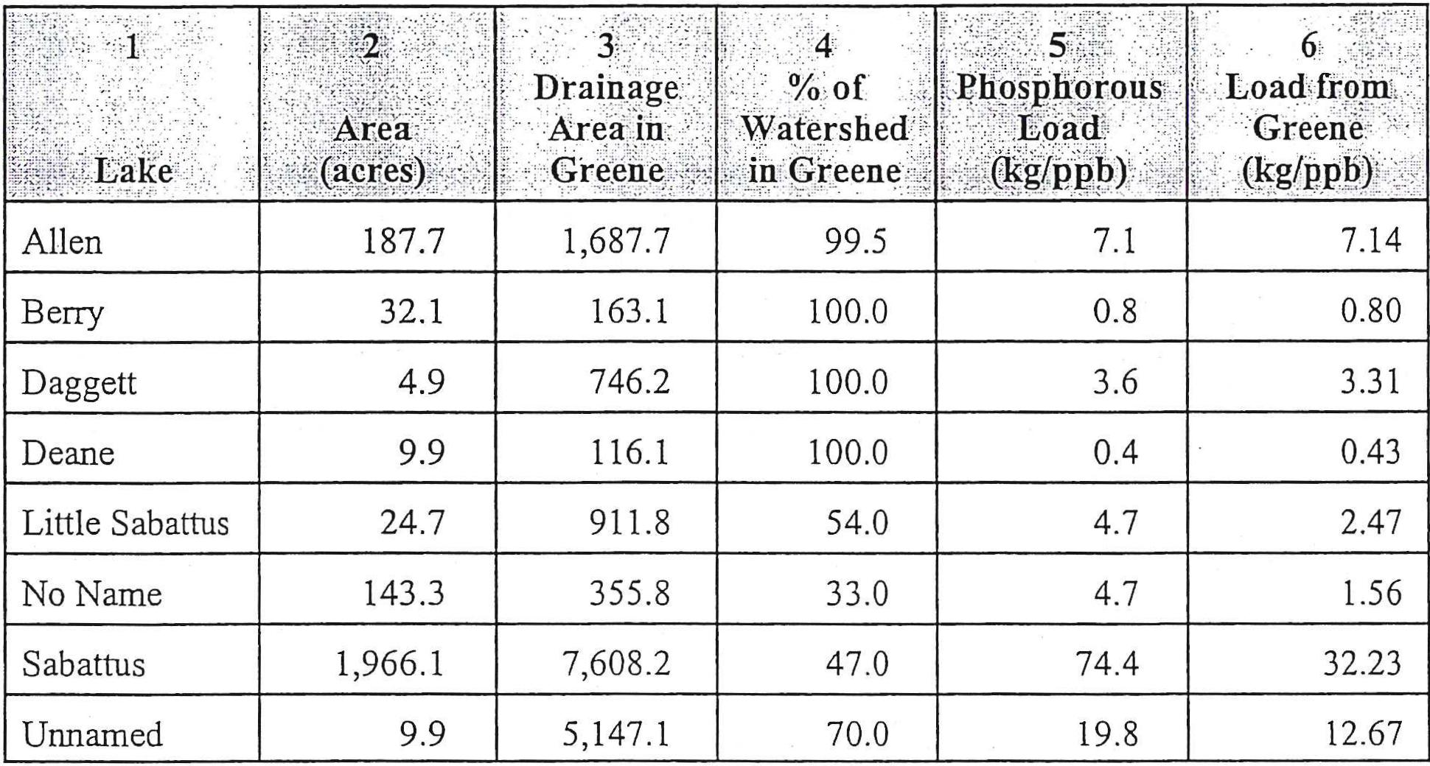
hosphorous
Load
.g/PP!⁾)
187.7
7.1
Allen
Berry
0.8
32.1
Daggett
3.6
4.9
9.9
0.4
Deane
Little Sabattus
4.7
24.7
143.3
4.7
No Name
Sabattus
74.4
1,966.1
9.9
19.8
Unnamed
3  Drainage  Area in  Greene | 4  °A of  Watershed  in Greene.
1,687.7 | 99.5
163.1 | 100.0
746.2 | 100.0
116.1 | 100.0
911.8 | 54.0
355.8 | 33.0
7,608.2 | 47.0
5,147.1 | 70.0

6
Load from
Greene
(1.cg/ppb)'
7.14
0.80
3.31
0.43
2.47
1.56
32.23
12.67
Ground water is water that is derived from precipitation that infiltrates the soil, percolates downward, and fills the tiny, numerous spaces in the soil and rock below the water table. In Maine, only 10 to 20% of an average of 42 inches of precipitation each year stays in the ground as ground water; the remainder runs off into streams or is returned to the atmosphere by evaporation. Wells draw water from permeable layers or zones in the saturated soil and rock that are called aquifers. Two major types of aquifers occur in Maine: sand and gravel aquifers and bedrock aquifers. Wells in sand and gravel aquifers can yield up to 2,000 gallons per minute (gpm) while wells in fractured bedrock generally yield much less; often only enough for single family residential use.
Sand and Gravel Aquifers
A sand and gravel aquifer is a water-bearing geologic formation consisting of ice contact, outwash, and alluvial sediments left by the melting glaciers and subsequent melt-water rivers and streams that were once part of this area in Maine (roughly 12,000 years ago). The sand and gravel deposits range from ten feet to more than one hundred feet thick.
Sand and gravel aquifers are generally large, continuous, sand and gravel deposits that extend along a river valley. The sand and gravel deposits fill the valley between the hills on either side to create a fairly flat valley floor. In most cases, the flow path of ground water through the aquifer is from the valley walls towards a stream or river flowing across the valley floor. The stream, then, acts as a drain where ground water enters the surface water drainage system, and flows downstream.

64

The Maine Geological Survey has mapped the location of significant sand and gravel aquifers in Greene. A large sand and gravel aquifer is located in the northeast corner of town and includes much of the flat region surrounding the Dead River. It is mapped as being capable of producing 10 to 15 gallons per minute. However, several shallow gravel packed wells are reported to produce up to 60 gallons per minute.
These quantities are suitable for commercial and industrial uses as well as clustered residential uses. Any future municipal supply would need to develop a well field covering a significant area or using more than one area.
Sand and gravel aquifers can be contaminated from any substances that seep into the ground directly or are carried into the ground after dissolving in water. As water infiltrates from the ground surface and goes down through the unsaturated zone above the water table, the soil, sands and gravel act as a filter and remove some of the contaminants. The degree of filtration depends on the thickness of the unsaturated zone above the water table, and the kind of contaminants. Once contaminants enter the water table, they may travel thousands of feet over time. In most Maine aquifers, the water table is generally closing to the surface (within 20 feet) so that natural removal of contaminants by the soil is not nearly complete before the contamination reaches the ground water. Once contaminants enter the ground water, they do not flush out of the system readily. Residual contaminants are often left on the particles of sand or gravel to leach slowly into the surrounding ground water. Often hundreds of years are necessary for an aquifer to clean itself through natural means.
Bedrock Aquifers
Most of the private individual wells in Maine are drilled into bedrock. The wells penetrate through water-bearing cracks, or fractures, in the bedrock. These water-bearing fractures are bedrock aquifers. Most domestic wells penetrate relatively small fractures and, therefore, produce only small amounts of water. However, there are some areas where the volumes of water are adequate to provide for municipal water supplies.
Over the past several years, it has been found that bedrock aquifers are highly susceptible to contamination. The fracture system in the rock is often generally extensive and interconnected over large distances. Since the water is confined to the narrow fractures, it may move very quickly over the large distances especially when the supply is being pumped out. The type and depth of soil above the bedrock, as well as the extent of area recharging the bedrock aquifer, determine the degree of contamination. The greatest potential for bedrock aquifer contamination comes from underground storage of petroleum and other chemical products. Underground storage tanks are that much closer to the water table, and, in some cases, may even have been placed in the water table. Most of these tanks do not have a monitoring system to warn of leakage.
Unlike sand and gravel aquifers, bedrock aquifers have not been mapped. Data collected from local well drillers provide information on the availability of water from the bedrock. However, all uses which store or handle petroleum products and hazardous materials as well as uses which handle such leachable materials as road salt are potential threats to the ground water in the bedrock.

65

Floodplains
A floodplain is the flat expanse of land along a river or shoreline that is covered by water during a flood. Under the Federal Flood Insurance Program, the 100-year floodplain is called the flood hazard area or special flood hazard area. During a flood, water depths in the flood plain may range from less than a foot in some areas to over ten feet in others. However, regardless of the depth of flooding, all areas of the floodplain are subject to the requirements of the Flood Insurance Program. Floodplains along rivers usually consist of a floodway where water flows, and a flood fringe where stationary water backs up. The floodway will usually include the channel of a river or stream, as well as some of the land area adjacent to its banks.
Flooding problems in Greene occur at scattered locations along the Androscoggin River, Hooper Brook, and Stetson Brook, and along the shores of Allen Pond and Sabattus Pond. Flooding generally occurs in the winter or early spring as a result of heavy rainfall or snow-covered or frozen ground. Ice jams on the Androscoggin River occasionally compound flooding problems. The major flood damage in Greene is suffered by single-family and seasonal dwellings, farmland, utilities, railroads, roads, and bridges. A number of the houses along the shores of Allen and Sabattus Ponds are subject to damage from high water.
Forest Resources
As with the majority of communities in Maine, Greene is primarily forested. Soils are important to wood production. In soils rated "good" for forest uses, growth rates are high and produce good yield of forest products. In soils rated "poor," growth rates are so slow and intensive management may not be justified as an economic practice.
Recent work on forest quality site identification has found that rooting depth, water availability, and nutrients all contribute to how well trees grow and what species do better. The most important of these is rooting depth. The same slopes which diminish site quality for housing development make excellent sites for growing trees. Those more limited sites with restricted routing zones created either by higher seasonal water tables or shallow ledge are normally characterized by softwood forest of spruce, fir, and cedar. The mixed hardwoocUsoftwood species forests normally occur on intermediate sites.
Much of Greene's forest land is former agricultural land. Pioneer species such as poplar, birch, and white pine were the first to occupy abandoned sites. In some instances, these trees have been succeeded by hemlock, spruce, maple, beech, oak, and other more shade tolerant species. Other areas have retained their original post-agricultural timber types because of natural influences (disease and fire) from harvesting practices.
Much of the present forest, on all but the steepest slopes, is grown up agricultural land. Forests are generally characterized by a mixture of hardwood species on the better drained sites and softwood more poorly drained sites. The forests of Greene are mostly hardwood types with the softwood areas restricted to dry ridge tops and wet seeps and low lands with high water tables. The normal harvesting method used is partial removal of the volume in the stand. This may range from 25 to 75 percent of the stand. This method allows forests to regrow and be harvested again on intervals 10 to 40 years.
In 1994, there were 10 parcels totaling 789 acres classified under the tree growth tax law. Of the total 789 acres, 311 acres were hardwood, 276 acres mixed-wood, and 211 softwood.

66

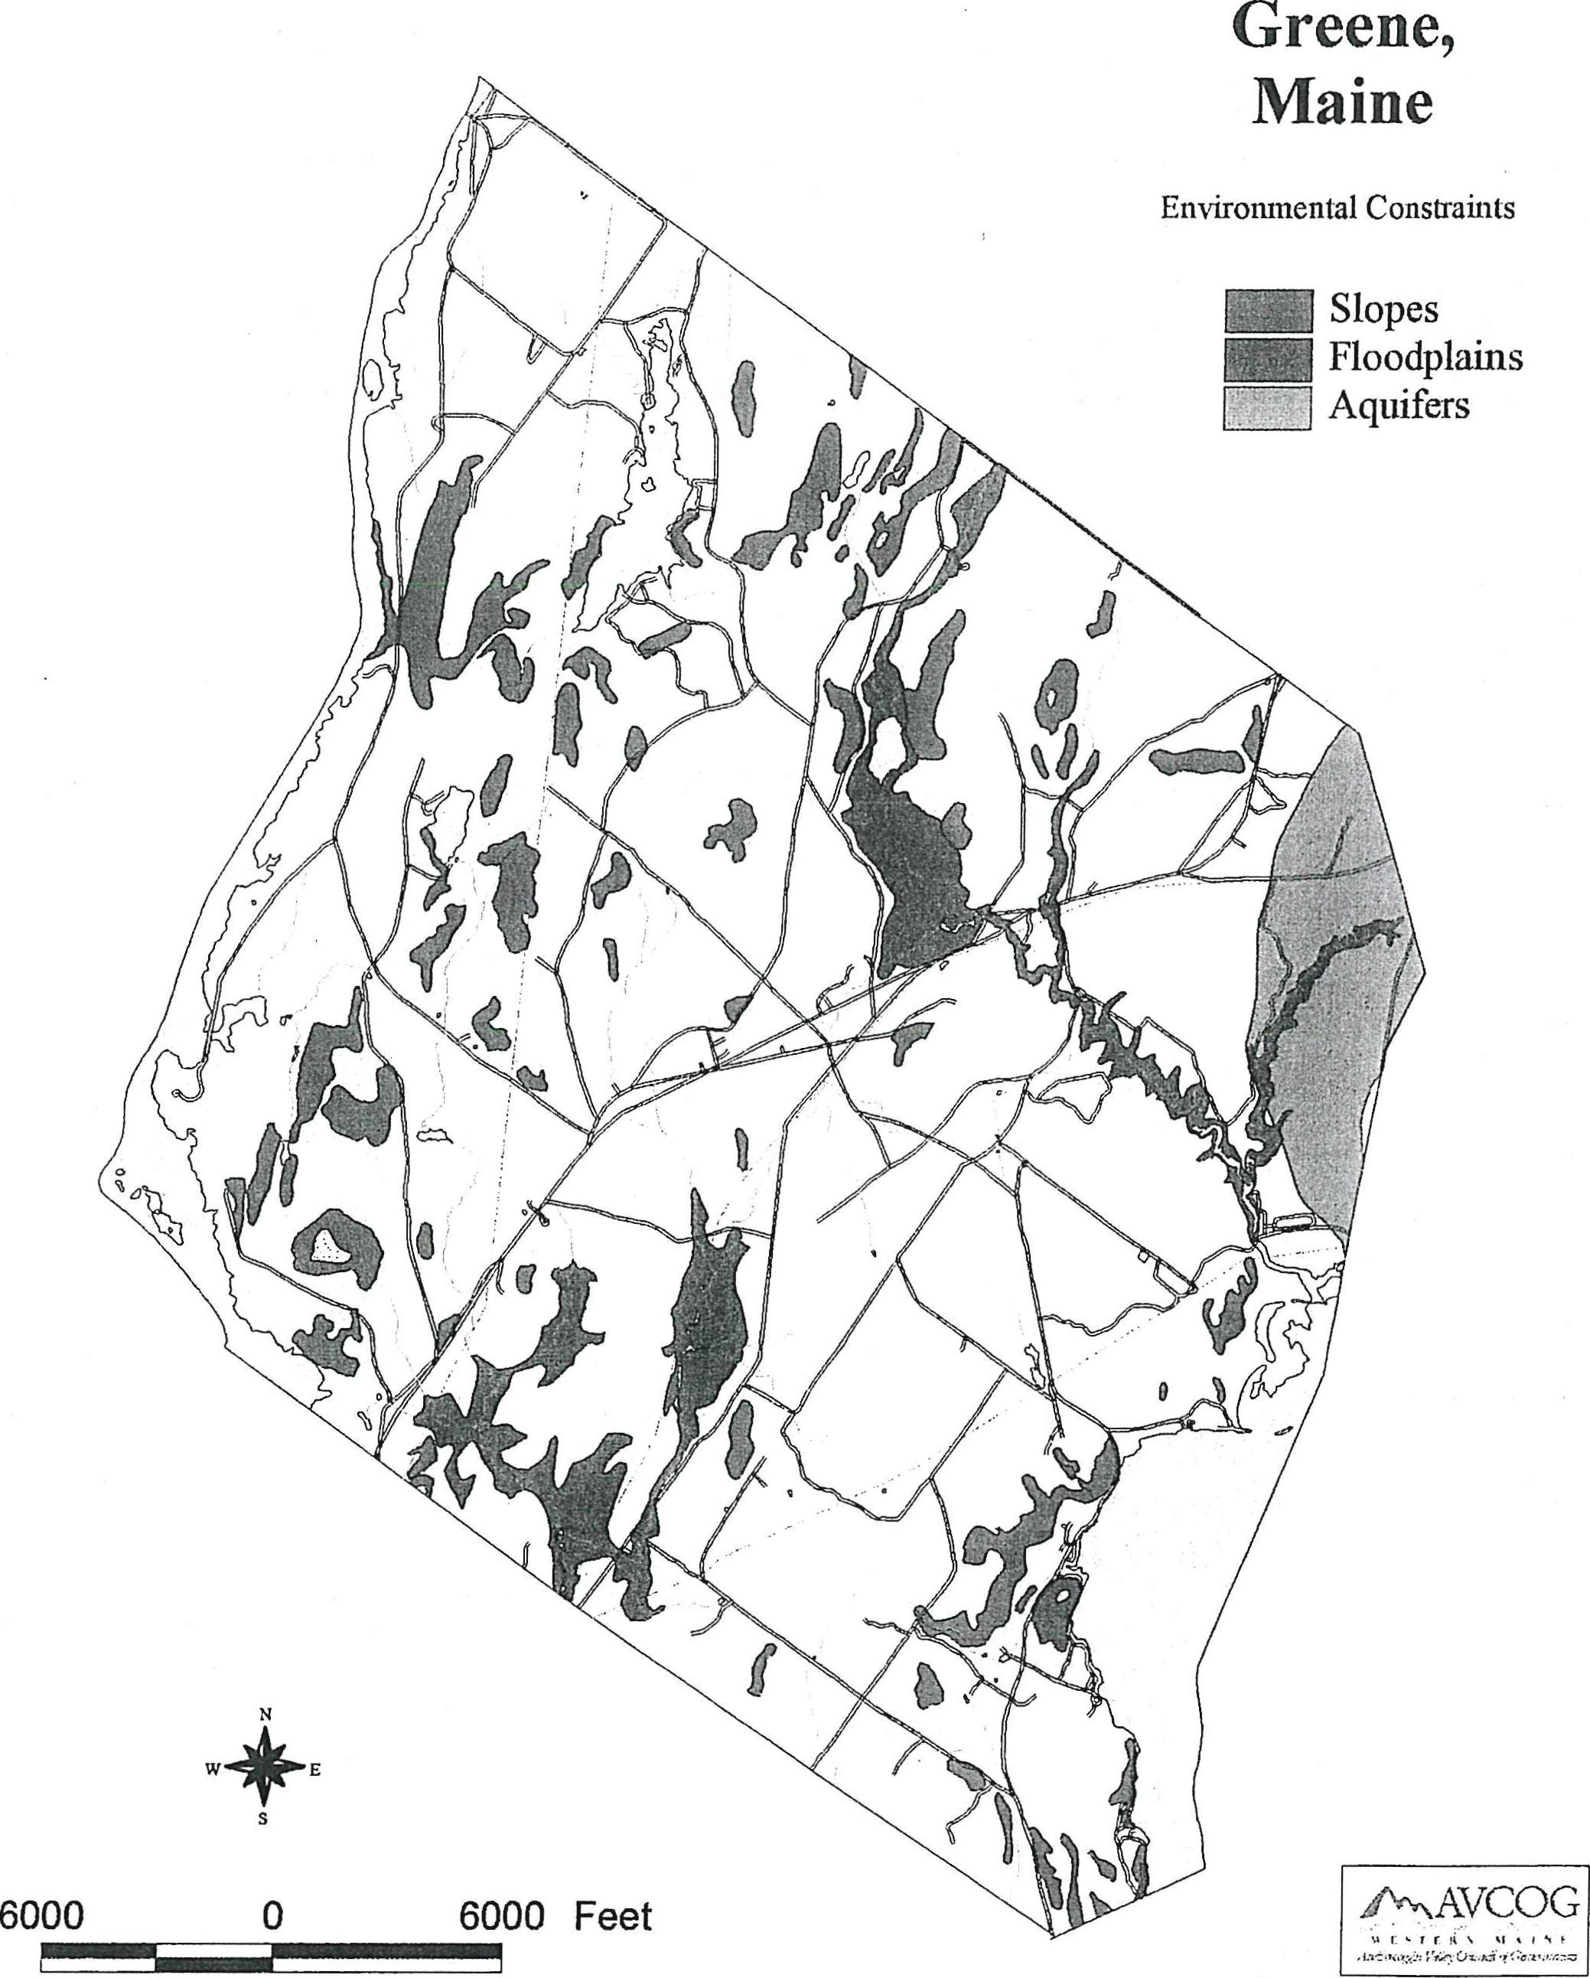
Greene,
Maine
Environmental Constraints
Slopes Floodplains Aquifers
W E
0
6000
6000 Feet
iiNNNAVCOG
vr%tr,is %/hi

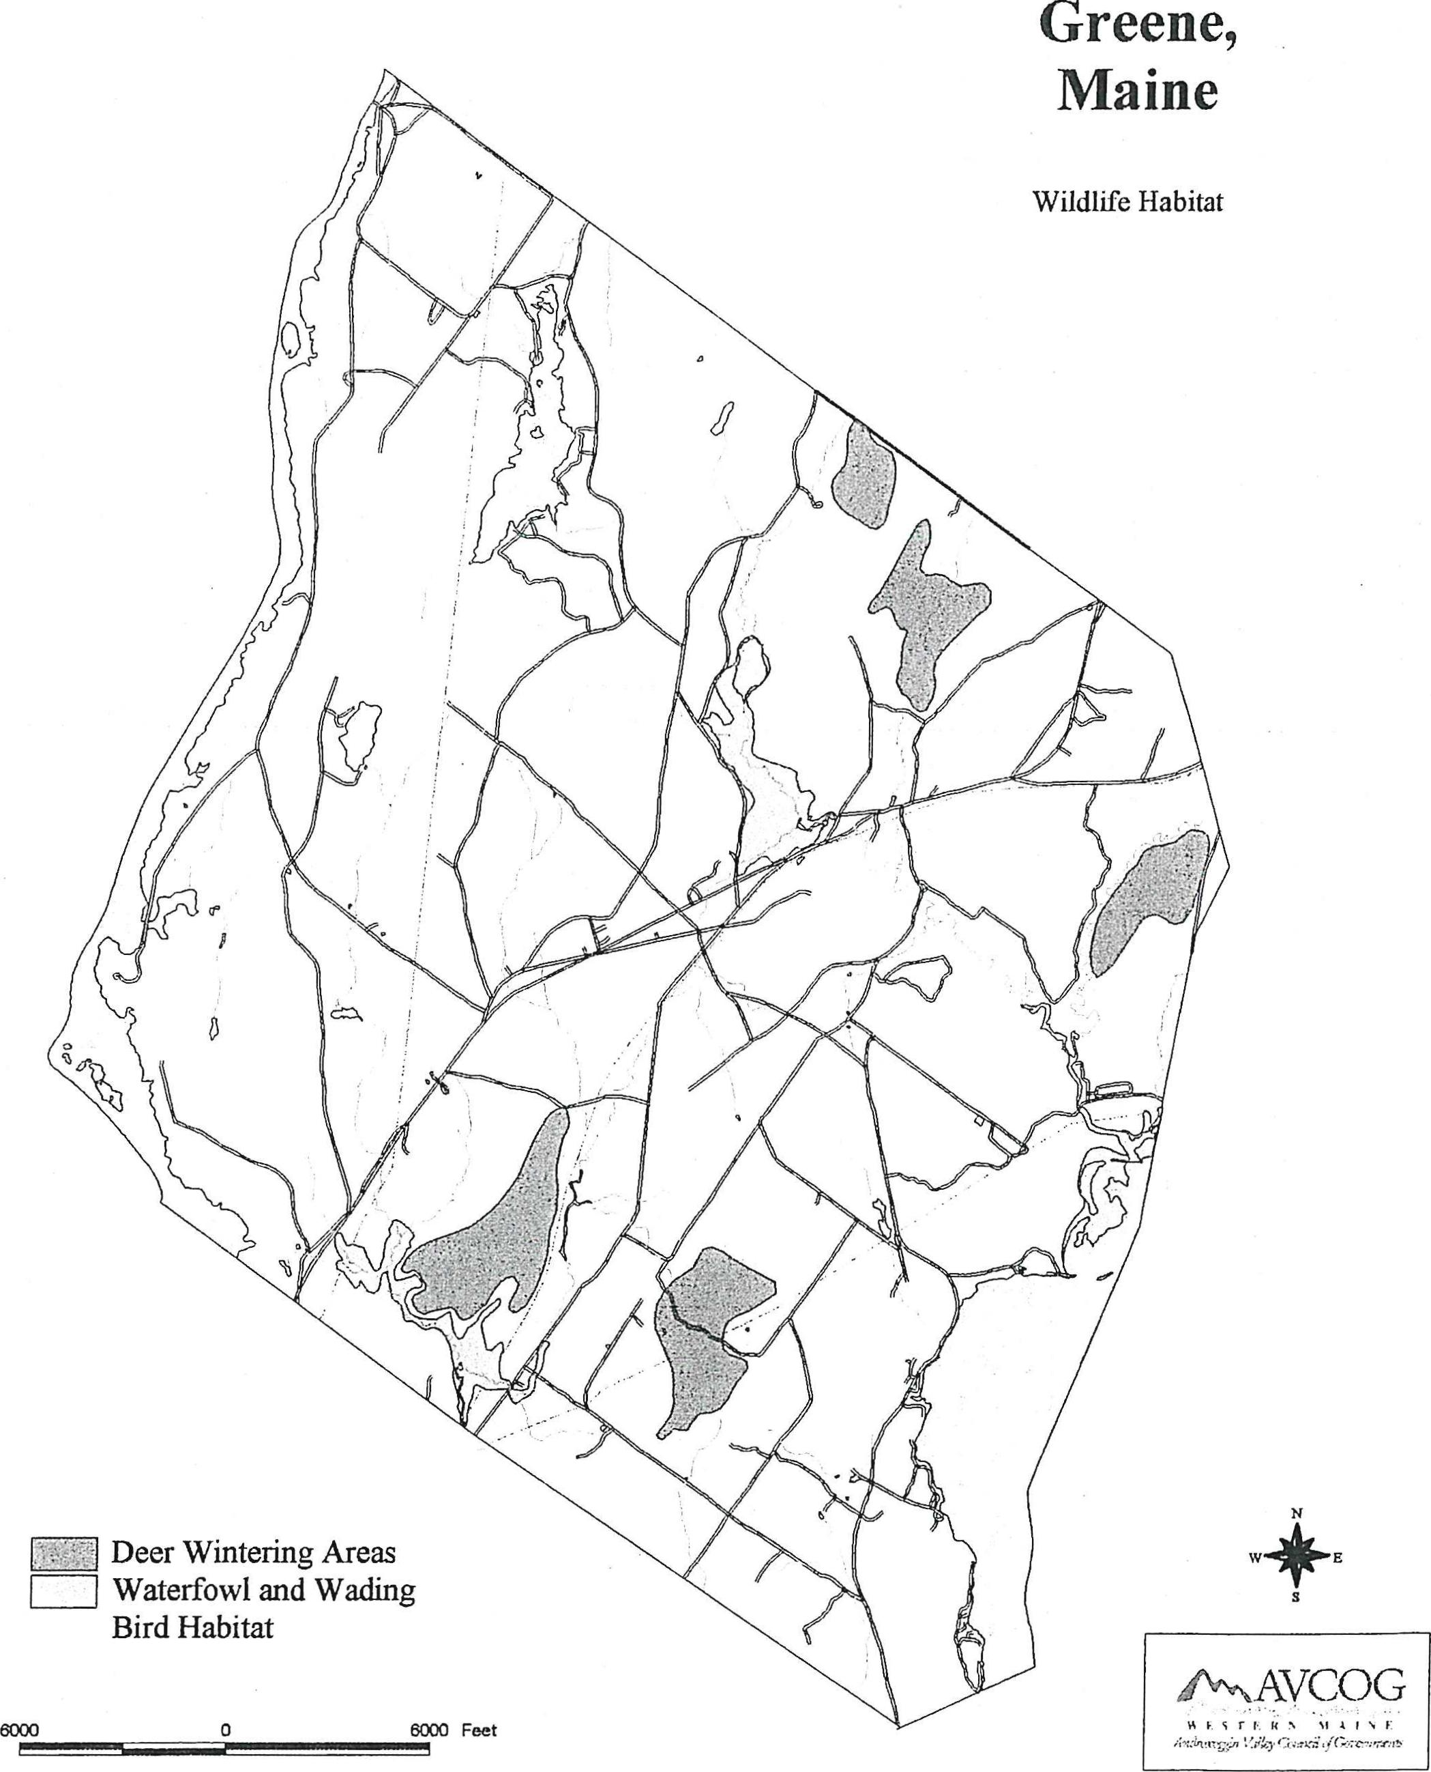
Greene,
Maine
Wildlife Habitat
W E
Deer Wintering Areas Waterfowl and Watling Bird Habitat
8000 0 6000 Feet
41""NAVCOG
14F.srvuN NIAINE

Wildlife Habitat
Wildlife should be considered as much a natural resource of the Town as are surface waters or forest land. Wildlife species are a product of the land and, thus, are directly dependent on the land base for habitat. Wildlife habitat is constantly changing through natural succession, and in today's world, wildlife habitat is increasingly being affected by humans. As local and regional conditions and land use practices change, the wildlife of an area can also be expected to change for all wildlife requires adequate habitat to sustain their populations. If a habitat does not exist, or an existing habitat is lost, various types of species will not occur. Through thoughtful land use planning, adequate habitat and, in particular, areas of critical concern can be managed to maintain wildlife as a viable resource.
Although there are many types of habitat important to our numerous species, there are four which are considered critical. They are:
- wetlands
- riparian areas (shorelands of lands, ponds, rivers and streams) and major watercourses
- deer wintering areas
- other unique and/or critical habitats (including special conditions needed for certain species)
The Department of Inland Fisheries and Wildlife (LF&W) has an ongoing program to map the locations of potential and known essential and significant wildlife habitats including deer wintering areas and waterfowl and wading bird habitat. In addition, they may identify other locations of special concern for wildlife. The IF&W has mapped five deer wintering areas. These deer wintering areas have been assigned an indeterminate habitat value meaning that the necessary field investigation has yet to be completed to establish a habitat value of high, medium or low. Waterfowl and wading bird habitat including nesting and feeding areas have also been mapped. Three areas have been determined to be of significance. A number of other surface waters and wetlands offer value to waterfowl but are not considered as significant.
Unique Natural Areas
Exemplary Botanical Features: The Natural Areas Division of the Maine Department of Conservation has compiled data on Maine's rare, exemplary botanical features. While this information is available for comprehensive planning, it is not a substitute for on-site surveys. The quantity and quality of data provided is dependent on the research and observations of many individuals and organizations.
Rare plants and natural communities located in Greene, according to the Maine Department of Conservation, include the following:

71

Scientific Name Common Name
Cypridium arietinum Ram's Head Lady's Slipper
Castanea dentata American Chestnut
Carey stricta Sedge Meadow
Scenic Resources
Greene is endowed with a number of scenic areas and views. The Town's topography with several high ridges and hills provide for several panoramic views. The Comprehensive Planning Committee identified the following scenic areas views during the inventory phase of the plan development.
Table 1-37
Scenic Resource Assessment
* The village area has always been a place for picture taking and many of those shots have appeared in numerous postcards of the town.
* The top of Longley Road has a panoramic view of the distant mountains.
* Hills Ridge has another panoramic view of the distant mountains.
* The Sawyer Mansion and memorial building is a very scenic area of Sawyer Road as well as historical to the town.
* The overlook of Sabattus Lake also on Sawyer Road at the top of Saunders Hill.
* Others can be found at the top of Merrill Hill Road, the top of Addition Hill at the Leeds/Greene town line, Deer Run off So. Hatch Hill Road, Berry Pond area and on Sullivan Road.
72

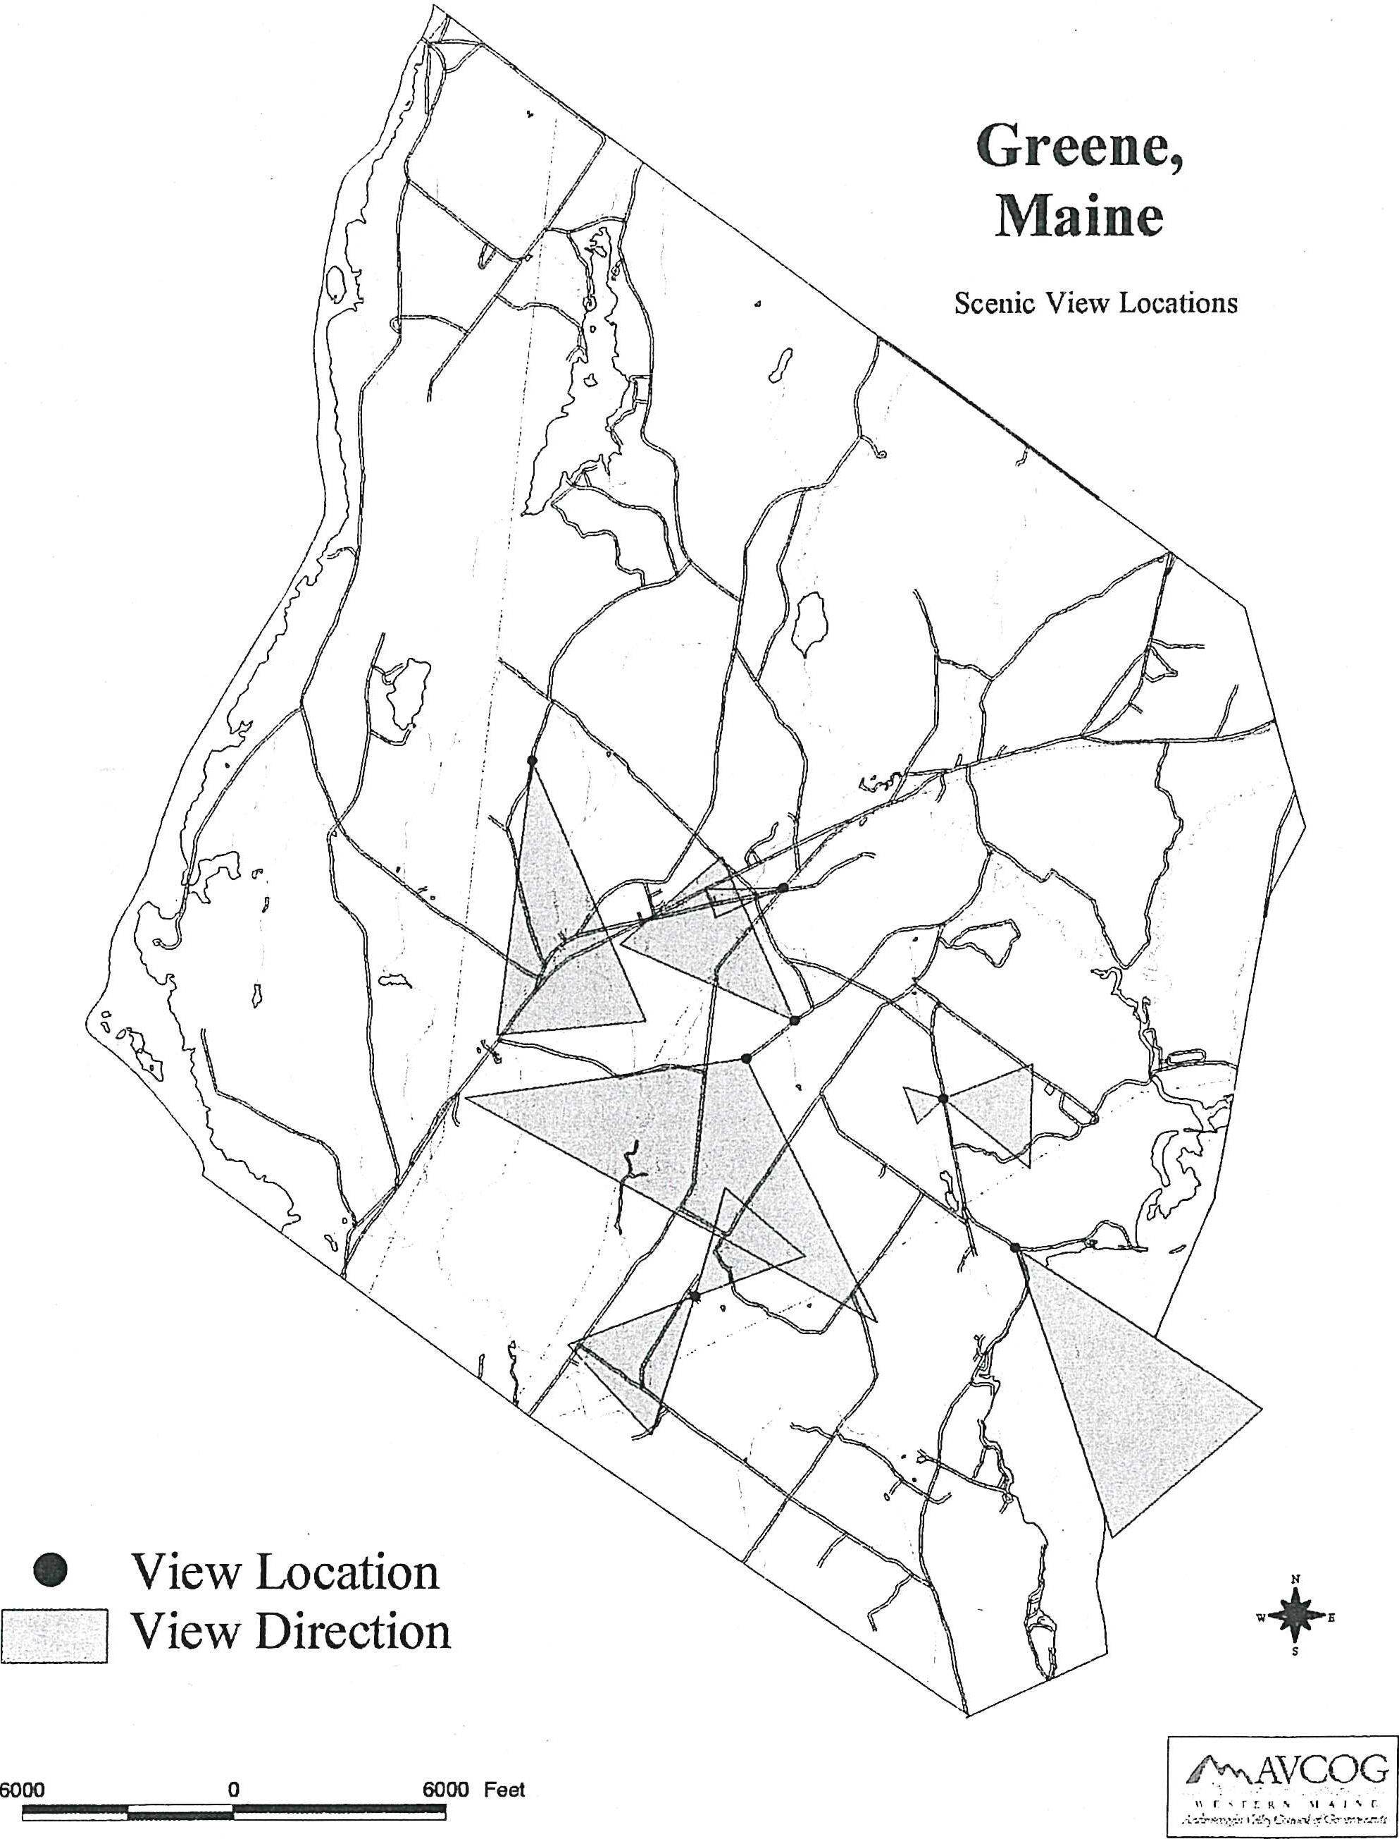
Greene,
Maine
Scenic View Locations
- View Location View Direction
CY*
6000
0
6000 Feet
P.'\•\AVCOG

LAND USE/UTILIZATION
Findings
+ Over the past 20 years, there has been a significant decrease in the amount of land use for active agriculture.
+ Since 1970, there have been 1,000 new residential dwellings.
+ The most prevalent residential development pattern is that of scattered residential along most public roads.

Introduction
A major element of the comprehensive plan is the analysis of the use of land and existing development patterns. Through such an analysis, insights into community functions, spatial relationships, past and current priorities and future directions are possible. Current land use patterns and expected future development trends are cornerstones in the development of policies and strategies which will shape Greene's future land utilization characteristics.
Greene has a total land area of approximately 36 square miles and ranks eighth in land area of the 14 communities in Androscoggin County. The Town developed as an agricultural community and prospered as an industrial center through the early to mid 1800s. At the turn of the 20th Century, Greene's population and industry declined, drawn by cities. Agriculture was the mainstay of Greene's economy through the mid 1900s. Greene's proximity to the employment centers of Lewiston/Auburn, Augusta, and Bath/Brunswick has made the Town an attractive bedroom community evident by the increase in year-round housing units from 327 in 1960 to an estimated 1,600 in 1998.
Forest Land
Forest or wood lands cover the majority of land area in Greene. In an Androscoggin County Land Use Assessment published by the Androscoggin Valley Council of Governments in 1981, some 19,500 acres of woodland at various stages of maturity existed in 1977. Since 1977, there has been a decrease in the total number of woodland acres primarily due to residential development. While some land is reverting from open fields to woodland, it has not been at a rate of residential development in wooded locations.
Owners of woodland in Greene are unlikely to participate in the State Tree Growth Tax Law of which its purpose is to encourage forest landowners to retain and improve their forest lands by assessing their value at current use. In 1997, 956 acres in 13 parcels were registered under the program. This represented 2.7% of the total acres registered in Androscoggin County. Only the
75

communities of Lewiston (228 acres) and Wales (163 acres) had fewer acres registered under the program. Although woodlands are harvested for commercial purposes from time to time, active commercial forestry appears limited in Greene.
Agricultural Land Use
Agriculture was a mainstay of Greene's early economy and an important component to the town's character. Today, a single dairy farm remains in operation. In addition, a deer farm, horse farm, and several small farms exist. Once open fields have been converted to residential use, some are hayed, others are bush hogged to be kept open, and others are returning to woodland. The agricultural land use classification includes those lands currently utilized to produce agricultural commodities such as croplands, hayland, pasture lands, orchards, and farmsteads.
In 1977, it was estimated that there were 1,500 acres of land in some type of agricultural use, the largest being pasture (800 acres) followed by hay land (402 acres). The amount of land used for active commercial agriculture use has decreased significantly over the past 20 years. Many of the fields once used for hay and pasture are now only mowed to be kept open, others are reverting to woods and still, others have been converted to residential uses. It can be expected that other open fields and orchards will be lost as indicated by for sale signs. Fourteen fauns were reported with almost 2,000 acres of land in 1990 by the Department of Agriculture.
Based on a visual survey of open fields and agricultural activity, it is estimated that since 1977, some 700 acres of land once in agricultural use is no longer in such use. Factors that have contributed to this decline include agricultural economics and Greene's desirability as a bedroom community.
Concentrations of active agricultural land use are found in the northwestern corner of Greene along Line Road, Sawyer Road, Longley Road and River Road; the Patterns and Quaker Ridge Roads; Sprague Mill, Gray Road and the northeasterly end of Sabattus Pond.
Village Land Use
Greene Village is defined as the area adjacent to Main Street between Route 202 and the Maine Central Railroad tracks. This area consists of a mixture of public uses including the Greene Elementary School, town office, public library, church, grange, and residential. Many of the residential structures are larger older homes likely constructed before 1900. Lot sizes range from less than 10,000 square feet up to more than 2 acres. Street frontages are as small as 70 feet and as large as more than 300 feet.
Enlargement of this village area is restricted by the Maine Central Railroad tracks to the east and Route 202 to the west. Little vacant land is available for development.
Residential Land Use
It is estimated that Greene contained some 1,500 year-round housing units as of the end of 1997. This represents some 1,000 new year-round residential dwellings since 1970. Residential development has had the greatest impact on overall community land use patterns over the past 30 years. Greene's residential land use and development can be separated into several categories. These include the more compact village area, subdivision residential, scattered residential development and seasonal residential.

76

Village Residential
Village residential land use is characterized by older residential neighborhoods. Two areas of this residential development pattern are found in Greene. They include Greene Village or the area east of Route 202 and west of the railroad tracks and the West Main Street area. These are characterized by lots ranging from less than 20,000 square feet to as much as 80,000 square feet. These areas are the most densely developed areas in Greene.
Subdivision Residential
Subdivision residential includes those areas which have been approved for development whether or not lots have been built on. Over the past 20 years, this residential development type located on land subdivided into lots of one to several acres has accounted for approximately one third of the new residential development. Subdivision residential development includes both areas served by new street constructed as an element of the subdivision and subdivision lots served by existing public roads. This residential development type may be found adjacent to the Allen Pond Road, River Road, Sedgely Road and Quaker Ridge Road among others.
From January 1, 1988 to June 1, 1998, the Greene Planning Board approved 17 additional subdivisions containing a total of 115 lots. They were as follows:
Table 1-38
Subdivision Development
1988-1998
1988
Bass Points Estates 3 Lots
Meadowview Estates 18 Lots
Mountain View Estates Phase III 2 Lots
RacIdey Estates 18 Lots
Riverview Estates 8 Lots
1989
L'Herreux Subdivision 3 Lots
Oullette Properties 2 Lots
J&S Parshall Subdivision 4 Lots
Quaker Hill Estates 2 Lots
1990
Dear Run Subdivision 33 Lots
McCarron Subdivision 4 Lots

77

1992
Sylvia Roberts Acre 1 Lot
1993
Allen Pond Estates 3 Lots
Clark Mt. Estates 5 Lots
Sunset Hills Estates 3 Lots
1997
Allen Pond Settlement 3 Lots
Hidden Acres 3 Lots
Source: Town of Greene Records/Prepared by AVCOG/July 1998
Scattered Residential
The most prevalent residential development land use pattern in Greene is that of scattered residential adjacent to most public roads. The majority of the new residential land use has been in this form. While this type of land use can be found adjacent to most public roads, it is primarily located adjacent to College Road, River Road, Allen Pond Road, and Lane Road. This type of residential development pattern has changed past land use patterns from rural undeveloped or sparsely developed roadsides to residential land use strung out along many miles of roadside.
Seasonal Residential
Seasonal residential land use is centered around the town's two major ponds, Allen and Sabattus. The shores of Sabattus Pond contain the majority of the seasonal dwellings. At both,Allen and Sabattus Ponds, there has been a trend of converting once seasonal dwellings to year round use. Much of this development took place prior to the enactment of the mandatory Shoreland Zoning Law in the early 1970s. Therefore, much of the development is on small lots with small shore frontages when compared to current day standards.
Commercial Land Use
The land adjacent to Route 202 has become the commercial area of Greene. This is in vast contrast when Greene Village was the commercial center and railroad station located there was one of the busiest rural stations on the Androscoggin and Kennebec Railroad. Today, some 30 commercial and service related businesses are located adjacent to the approximately six miles on Route 202 in Greene. Businesses range from grocery to used motor vehicle sales. Commercial nodes or areas of concentrated commercial land uses are located southeast of West Main Street and between the Sawyer Road and Allen Pond Road.
Smaller commercial and service businesses including home occupation are found throughout the town.

78

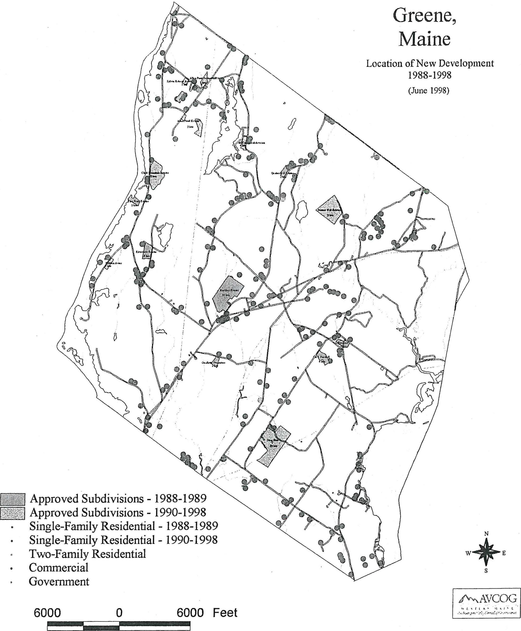
Greene,
Maine
Location of New Development
1988-1998
(June 1998)
Approved Subdivisions - 1988-1989 Approved Subdivisions - 1990-1998 Single-Family Residential - 1988-1989 Single-Family Residential - 1990-1998 Two-Family Residential
Commercial
Government
N
W+ E
S
6000
6000 Feet
0
1\⁻\,.. AVCOG

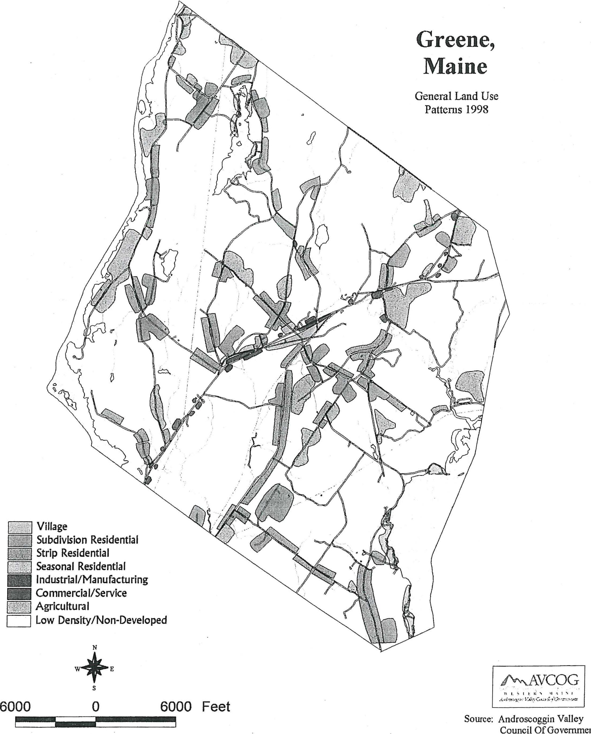
Greene,
Maine
General Land Use Patterns 1998
Village
Subdivision Residential Strip Residential Seasonal Residential
IIII Industrial/Manufacturing ME Commercial/Service
Agricultural
Low Density/Non-Developed
W4¹¹.' E
P"NAVCOG
6000
0
6000 Feet
Source Androscoggin Valley Council Of Govemmei

IndustriaUManufacturing Land Use
Manufacturing and industrial type land uses occupy a small amount of land in Greene. In this category is Maine Poly, the largest, and TNE Inc. and Bubier Packing. These are located adjacent or in close proximity to Route 202.
Development/Land Use Trends
Over the past 20 years, Greene has experienced considerable land use change. Residential development has accounted for the most significant shift in Greene's land use characteristics over the period. This shift has primarily been at the expense of woodland adjacent to existing town roads. Over the past ten years, open fields have been converted to residential uses as well. Year-round residential growth patterns are best expressed as being that of scattered with no particular area of the community experiencing significantly greater growth than another.
Over the ten-year planning period, the demand for residential growth will continue to be high. Although this growth will be tempered by regional, state and national economic trends, Greene's proximity to several major employment centers makes Greene attractive for future residential growth. Based upon population and household size projections, some 300 new residential dwelling units are expected over the next ten years.
Commercial/business growth has occurred over the past ten years in Greene. This growth has been driven by the Town's increased population and attractive commercial development locations along Route 202. Additional growth and development in the retail trade and service sectors is expected. Locational demand will continue along the Route 202 corridor.
Industrial/manufacturing land use is limited presently. Major increases in this land use classification are not expected over the period. Several factors contribute to this and include general lack of infrastructure (water and sewer) and competition for attracting such uses including Auburn and Lewiston.
Commercial agriculture, important to Greene's development and community characteristics has declined greatly over the last 20 years. It is expected that agriculture will not play an important role in the economy over the ten-year planning period. In addition, the role agriculture has played in the Town's character in the past will diminish as open fields revert to woodland or are developed for residential uses.
Comprehensive Plan and Land Use Ordinances
Comprehensive Plan
Greene's current Comprehensive Plan was adopted in 1977. That Plan's overall goal was to maintain the rural nature of Greene. Several problems and areas of concern were identified in the 1977 plan. These included town wide zoning to aid in regulating growth and maintaining the rural character, enactment of a subdivision ordinance, more enforcement of existing codes and ordinances, maintain or upgrade ponds and streams, improved recreation opportunities, public beach, solid waste disposal, school system watched for overcrowding, inadequate police protection, clean industry and commercial establishments for local shopping. While some of these areas of concern have been addressed including solid waste disposal, improved recreational opportunities and local shopping, others have not.
In 1991, a new comprehensive plan was presented to the voters for adoption but was rejected.

83

The Town of Greene has adopted the following land use related ordinances. Town of Greene Land Use Ordinance. This Ordinance places all land area not regulated under the Mandatory Shoreland Zoning Law in a Rural District. It requires a minimum lot size of 80,000 square feet and road frontage of 250 feet. It also includes site plan review standards which are used by the planning board to review commercial type development and land subdivisions. Building Code for the Town of Greene. This code establishes a requirement for a building permit and basic construction standards. Flood Plain Management Ordinance. The Flood Plain Management Ordinance has been adopted to comply with the Flood Insurance Program.
The town has an elected planning board, appointed board of appeals and put-time certified code enforcement officer.
Ordinance Effectiveness
The Town of Greene Land Use Ordinance is used by the planning board to review both land subdivisions and commercial type development proposals. While the current ordinance provides the town through its planning board review development proposals, it lacks many development standards commonly in use in Maine communities. With the level of development activity in Greene, the current Land Use Ordinance should be considered as containing minimum standards to serve the community.

84

FISCAL CAPACITY

Findings
- Property taxes, are- the largest source of town revenues.
+ The town's mu rate remained the same between 1995 and 1997
- In terms of adjusted dollars for inflation total: municipal expenditures increased by 25%.lietWeen.1.993⁻-and⁻⁻1997.
- The rate of growth in property valuation between 1993 and 1997 has been approximately the rate of inflation.

Introduction
A community's fiscal capacity refers to its ability to meet current and future financial needs through public expenditures. As Greene develops over the next ten years, demands to maintain and/or improve various municipal services, facilities and equipment will be placed upon its fiscal capacity. Demands may include improved roads, public facilities, and equipment. The comprehensive plan will make various recommendations requiring public investment. These recommendations must be considered in light of Greene's fiscal capacity or its ability to finance such improvements.
Revenue
The largest source of revenue for the town is from property taxes. Table 1-39 lists the local valuation, state valuation, property tax revenue and the town's mil rate for fiscal years 1993 to 1997.

85

Table 1-39
Valuation and Mil Rate
Greene
Fiscal Years 1993 - 1997

-
Property
Taxes
1993 | 154,933,000 |  | 141,750,000 |  | 0.01075 | 1,622,570
1994 | 158,157,000 | 2.1 | 144,800,000 | 2.1 | 0.01180 | 1,866,260
1995 | 159,386,000 | 1.0 | 142,450,000 | (1.6) | 0.01380 | 2,199,520
1996 | 165,793,000 | 4.0 | 141,500,000 | (0.6) | 0.01380 | 2,287,940
1997 | 168,157,900 | 1.5 | 150,300,000 | 6.2 | 0.01380 | 2,281,000

Source: Town of Greene Reports
Between fiscal years 1993 and 1997, the local assessed valuation increased by approximately $8.5 million or 3%. The largest increase in valuation occurred between 1996 and 1997 with approximately $9 million. The increase in valuation can be attributed to residential and personal property. The six percent increase in valuation over the six-year period approximated the decrease in the value of the dollar based on the consumer price index (CPI). This allowed the mil rate to remain steady between 1995 and 1997. In 1997 the total assessed value of Greene consisted of 97% land and buildings and 3% personal property. There is approximately $4.2 million real property exempt from taxation. The state valuation of Greene increased from $142 million in 1993 to $150 million in 1997 representing a 6% increase.
The mil rate remained unchanged between the years 1995 and 1997. The amount of property taxes assessed from 1993 to 1997 increased by approximately $658,000. This represents an increase of approximately 40 percent over the six-year period. Considering the consumer price index, the amount of property taxes assessed in adjusted dollars increased by approximately 30 percent between 1993 and 1997.
Other major consistent sources of revenues are excise and intergovernmental revenues. Excise taxes collected increased from $291,000 in 1993 to $397,000 in 1997. Excise tax collection increased each year between 1993 and 1995 while a general municipal trend was a decline in excise tax collections due to a weak economy. Intergovernmental revenues that include state revenue sharing, local road assistance and other state and federal grants represent approximately 10 percent of total revenue annually.

86

Table 1-40
Municipal Revenue
Greene
..  Fiscal Year⁻⁻  - • | 1993 | •  1994• | '1995 | 1996 ' | 1997
Property Taxes | 1,681,112 | 1,820,804 | 2,149,776 | 2,292,001 | 2,342,002
Excise Taxes | 291,174 | 331,165 | 333,550 | 360,223 | 396,904
Intergovernmental Revenues | 226,469 | 231,373 | 231,023 | 276,171 | 310,625
Interest Income | 21,795 | 20,262 | 28,213 | 41,556 | 39,529
Other | 234,128 | 268,474 | 127,958 | 157,025 | 114,714
TOTAL | 2,454,678 | 2,672,079 | 2,870,520 | 3,118,267 | 3,176,774

SOURCE: Town of Greene Annual Reports
Expenditures
Total municipal expenditures increased by approximately $775,000 or 35 percent in the five-year period between 1993 and 1997. Considering the CPI for adjusting dollars for inflation, municipal expenditures increased by approximately 25 percent over the period. The largest expenditure item was for education that in 1997 accounted for 62%of the town's total expenditures. Between 1993 and 1997 this budget item increased by some $641,000 or 53%. Other major expenditure items are for general government, public works and health and sanitation.

87

Table 1-41
Expenditures
Greene
Fiscal Years 1993 - 1997
aieqrSr. ' | 1 | 19 | 1995, | ,  99 , 6 : . • | - .  1997-
General Government | 317,778 | 350,774 | 367,455 | 373,355 | 377,348
Public Safety | 20,934 | 22,769 | 19,723 | 24,445 | 23,934
Health & Sanitation | 126,353 | 302,440 | 113,001 | 108,188 | 113,275
Public Works | 329,378 | 424,146 | 355,801 | 333,955 | 389,393
Recreation | 21,977 | 13,474 | 18,865 | 16,372 | 19,236
Education | 1,203,148 | 1,450,197 | 1,645,742 | 1,736,641 | 1,844,117
County Tax | 149,393 | 122,435 | 165,919 | 174,229 | 178,503
Overlay | 0 | 0 | 0 | 0 | 0
Debt Service | 0 | 0 | 0 | 0 | 0
Unclassified | 23,072 | 89,735 | 35,372 | 49,260 | 213,661
TOTAL | 2,192,003 | 2,775,970 | 2,721,868 | 2,816,445 | 2,967,262

Source: Town of Greene Annual Reports
Capital Projects Fund
The town maintains part of the general fund equity for capital projects. In 1998 there was approximately $100,000 in the capital project fund. While this fund is not designated for specific projects, road improvements are a priority.
Municipal Debt
As of the end of fiscal year 1997 the town of Greene had no outstanding long-term debt. The amount of debt allowed a municipality is governed by state law; the law limits a town's outstanding debt to 15% of the town's last full state valuation. This limit is reduced to 7.5% if the debt for schools, sewer, water and special-district purposes are excluded. Based upon Greene's state valuation, the maximum debt under state law, including debt associated with specials districts, Greene could carry would be approximately $22 million. However, such a debt would likely increase the tax rate significantly. Nevertheless, should the town need to borrow for public improvements, Greene has significant borrowing power.

88

Fiscal Capacity
A community's fiscal capacity is based upon the ability to pay normal municipal operating costs, including education, public works, public safety and finance major capital expenditures compared with the ability of the tax base and other revenue sources to support such expenditures. In considering Greene's capacity to fund normal municipal services and capital projects two areas are important. First, in recent years annual increases in valuation have been approximately at the rate of inflation. A rate of the increase in valuation greater than the rate of inflation would allow new expenditures to be implemented without a mil rate increase. Greene does however have significant borrowing power based on the maximums established in state law. Future borrowing for capital expenditures should be based upon projected valuation increases and their impacts upon individual taxpayers.

89

0
0
•

.
0
•
•

GREENE

COMPREHENSIVE PLAN
Section II
Planning Issues
Goals, Policies, Strategies
Future Land Use Plan
Capital Investment Plan
Regional Coordination Program
Prepared by
The Greene Comprehensive Plan Committee
with assistance from
Androscoggin Valley Council of Governments

November 1999

The Comprehensive Plan, presented in two sections--the Inventory & Analysis and Goals, Policies, & strategies--should serve as a guide for the community and town officials as they make decisions about the future of Greene. The Plan suggests general directions, recognizing the specific details will require further efforts. The Plan should be considered a living document meaning that it will require review and revisions as Greene changes over time.
The Plan is not a zoning ordinance and the future land use map is not a zoning map. The Plan is, however, intended to guide future changes in the Town's land use regulations so that they will reflect the goals and polices of this Plan. Similarly, the discussions of capital needs and spending priorities are intended as general guides, not specific proposals.
This Plan is the result of the efforts of the Comprehensive Plan Committee and the citizens of Greene that provided .ideas during the planning process.

TABLE OF CONTENTS
Greene Comprehensive Planning Program
Community Vision/Planning Topics
Goals/Policies/Strategies 1
PLANNING TOPIC: Historic and Archaeological Resources 2
PLANNING TOPIC: Economic Development 4
PLANNING TOPIC: Housing 6
PLANNING TOPIC: Public Facilities and Services 8
PLANNING TOPIC: Transportation 10
PLANNING TOPIC: Outdoor Recreation 13
PLANNING TOPIC: Natural Resources 15
_ PLANNING TOPIC: Land Use and Development Patterns 19
FUTURE LAND USE PLAN 23
GREENE COMPREHENSIVE PLANNING PROGRAM
CAPITAL INVESTMENT PLAN 29
REGIONAL COORDINATION PROGRAM 34

-

Greene Comprehensive Planning Program
Community Vision/Planning Topics
Goals/Policies/Strategies
Rural character/setting/atmosphere consisting of tranquility, open space, people that know one another, diversified population, privacy, low crime rate and the traditional village center.
Sense of community including comfortable intimate feeling, small town government, youth sports and outdoor recreation opportunities.
The natural resource base including rivers, ponds, forest and agriculture.
Today, Greene is seen by its citizens as many different things. The Greene of tomorrow will be the result of many factors. It is the intent of the Comprehensive Plan to establish a vision of Greene taking into consideration many divergent views.
In the broadest sense, the Comprehensive Plan envisions a Greene that:
- Is a quiet, peaceful, rural community that is affordable, safe for children and senior citizens alike with an involved citizenry.
- Is a community that has strived to maintain those characteristics that make it rural including a land base suitable for agriculture while providing for compatible economic growth and development.
-* Is a community that has quality education and schools, recreation facilities and
municipal facilities and services that have not overburdened tax payers.
- Is a community that recognizes the value of historic buildings and sites, the historic village and open space.
The Comprehensive Plan attempts to present recommendations for how the town can work toward these visions as the town continues to change.
The Comprehensive Plan includes an inventory and analysis presented in Section I which considers past, current and future community characteristics.
In developing the goals, policies and strategies for the Greene Comprehensive Plan, the Comprehensive Planning Committee began by developing a number of planning issues. Those planning issues are identified in this section of the plan. Based on the planning issues, the Comprehensive Plan Committee developed recommendations which are also presented in this section of the plan.
The goals, policies and strategies of the Comprehensive Plan are presented in a series of planning topics. These planning topics relate to the long term goals of Greene. In addition, the planning topics have been discussed by the Comprehensive Plan Committee at their numerous meetings.
1

PLANNING TOPIC: Historic and Archaeological Resources
Greene's Goal
- To conserve the values of important historic, cultural and archaeological resources. Overview
Greene's history is strongly tied to an agricultural-based economy. Greene is rich in old buildings which contribute to its historic value. Areas with a concentration of historic buildings include the Village and Fogg's Corner. The original roads and many stone walls, built as the land was cleared for farms, are important historic features as well.
Archaeological resources are physical remains of the past, most commonly buried in the ground or very difficult to see on the surface. Although no prehistoric sites have been documented within Greene, they are likely to exist along the banks of the Androscoggin River.
Planning Considerations
- Significant historic buildings, sites and features are not now protected from changes that could alter or destroy their historic significance.
- The Town currently has no safeguards to assure that significant archaeological resources are not lost.
Historic and Archaeological Policy
Pursuant to these goals, the historic and archaeological policies of the comprehensive plan are:
- To maintain the historic values of documented historic features, sites and structures.
- To assess the impact of development on known archaeological sites. Implementation Strategies
A. Short-Term Activities-To accomplish these goals and policies, the Greene community should undertake the following within one to two years of plan adoption.
1. The town should apply to the Maine Historic Preservation Commission and/or other sources for a grant to assist in a professional survey of historic features, sites and structures and to document them as either of local significance or as eligible for the National Register of Historic Places.
Responsibility: Board of Selectmen/Historical Society

2

- The Land Use Ordinance should be amended to include standards to assess impact upon historic structures, sites and locations, by allowing the Planning Board to require either a survey of the site or the consultation with a qualified professional, and to require measures to be implemented to minimize negative impact caused by development or redevelopment of the site or adjacent to the site.
Responsibility: Planning Board/Ordinance Committee
- The Land Use Ordinance should be amended to require the assessment of impact upon archaeological sites listed or eligible to be listed on the National Register of Historic Places.
Responsibility: Planning Board/Ordinance Committee
B. Mid-Term Activities-To Accomplish these goals and policies, the Greene Community should undertake the following within three to five years of adoption of the plan.
- Develop an education program for owners of structures of historic significance in voluntary techniques to maintain historic values.
Responsibility: Historical Society
- Conduct an inventory of stone walls.
Responsibility: Historical Society
- Develop a Restoration Plan for stone walls of local significance. Responsibility: Historical Society
- Seek designation for listing on the National Register of Historic Places of qualifying structures and the Village.
Responsibility: Historical Society/Individual property owners
C. Long-Term Activities-To accomplish these goals and policies, the Greene Community should undertake the following within six to ten years of adoption of the plan.
1. Seek a home in the Village that can serve as a museum for the town's history. Responsibility: Historical Society

3

PLANNING TOPIC: Economic Development
Local Goal
- Promote an economic climate that encourages environmentally sound business opportunities in appropriate and suitable areas in town.
Overview
Greene, like many New England towns, witnessed its economy flourish during the mid to late 1800s. Before Greene prospered as a small industrial center, it was primarily an agricultural community. During the mid 1800s, Greene had four saw mills, three grist mills, a shingle mill, and four stores. More recently, the Town has experienced growth of service-related businesses located primarily along Route 202 responding to Greene's growing population.
Greene's labor force has increased significantly since 1993 (12%), reflective of the Town's growing population. Total consumer sales increased by 92% between 1991 and 1997, which was greater than all surrounding communities. The Town's workers are dependent upon employment outside Greene with 75% leaving the Town for their place of employment. Lewiston/Aubum serves as the primary employment center for the Town's labor force.
It is expected that the dependence upon Lewiston/Auburn as an employment center for Greene's residents will continue. It is also expected that a demand for additional service-related businesses will occur due to the Town's increasing population.
Planning Considerations
- Future demands for local services will provide for a small increase in local employment opportunities.
- Efforts need to be directed toward increased local employment opportunities.
- The dependence upon Greene's labor force for employment outside of Greene will continue.
Economic Development Policy
Pursuant to these goals, the economic development policies of the comprehensive plan are:
- To allow in-home business throughout the town while maintaining the values of adjacent residential properties and neighborhoods.
- To be an active partner in promoting economic development that is suited to the town.
- To assure that local development standards do not impede economic and business growth while maintaining valued community character.

4

4. To encourage agriculture and forestry activities as components of the local and regional
economies.
Implementation Strategy
A. Short-Term Activities- To accomplish these goals and policies, the Greene community should undertake the following within one to two years of plan adoption.
- Appoint an Economic Development Committee whose responsibility would be to develop an economic development strategy and marketing plan for Greene and assist businesses that want to locate or expand in Greene.
Responsibility: Selectmen
- The home occupation standards contained in the Land Use Ordinance should be reviewed to ensure they provide for home occupation development while assuring compatibility with adjacent properties and residential areas.
Responsibility: Planning Board/Ordinance Committee
- The town should support initiatives directed toward current use taxation of agricultural land and forest land.
Responsibility: Selectmen
B. Mid-Term Activities- To accomplish these goals and policies, the Greene community should undertake the following within three to five years of plan adoption.
1. The Land Use Ordinance should be amended to provide for staff( such as code
enforcement officer, fire chief, road commissioner, planner) review and approval of minor or small commercial projects that currently require full Planning Board review and approval.
Responsibility: Planning Board
C. Long-Term Activities- To accomplish these goals and policies, the Greene community should undertake the following within six to ten years of plan adoption.
1. Through a public/private partnership a business park should be developed.
Responsibility: Economic Development Committee/Selectmen

5

PLANNING TOPIC: Housing
Greene's Goal:
- Manage housing opportunities that meet the needs of various households and income levels that are consistent with the residential and rural character of Greene.
Overview
Greene had a large increase in new housing units between 1990 and 1998; some 235 new units were added. Based upon expected population growth and maintaining a vacancy rate that allows flexibility in housing choices, some 250 new dwellings will be needed to house Greene's population in 2009.
The traditional stick built home comprises the greatest share (72%) of the total year-round housing stock. However, between 1980 and 1990, the mobile or manufactured home acquired a greater share. The number of mobile homes increased by 145% in the period. Multi-family housing is limited in Greene.
Greene's housing costs have increased steadily since 1992. The average sale price of a home in Greene increased from $66,500 in 1992 to $90,500 in 1996.
Planning Considerations
- Greene will continue to experience a greater pressure to increase in housing development than surrounding communities.
- Some 250 new housing units are expected over the next ten years.
- Rental housing is limited in Greene.
Pursuant to these goals, the housing policies of the comprehensive plan are:
- To encourage alternatives, including cluster development, to conventional grid-type subdivisions, and strip residential development along existing roadways.
- To encourage the development of affordable housing opportunities which maintain quality construction, durability, safety and compatibility with the character of Greene
- To guide new housing development to appropriate areas in order to achieve balanced growth, preserve rural residential character, natural resources and historic identity of the community.
- To assure the new residential structures and major renovations to existing residential structures comply with minimum construction and safety standards.

6

Implementation Strategies
A. Short-Term Activities-To accomplish these goals and policies, the Greene community should undertake the following within one to two years of plan adoption.
- The Land Use Ordinance should be amended to allow the creation of apartments in single family dwellings only if sufficient off-street parking, adequate sewage disposal, maintenance of external structural characteristics and a minimum square footage of living area standard are met.
Responsibility: Planning Board/Ordinance Committee
- The Land Use Ordinance should be amended to allow the reduction in the required road frontage and lot area for multi family type housing development to serve the elderly in designated areas.
Responsibility: Planning Board/Ordinance Committee
- The Land Use Ordinance should be amended to provide for innovative open space type subdivision development.
Responsibility: Planning Board/Ordinance Committee
- The Land Use Ordinance should be amended to encourage residential development in designated areas near existing services and areas of residential development by allowing smaller lot sizes.
Responsibility: Planning Board/Ordinance Committee
- The Land Use Ordinance should be amended to included provisions that allow the temporary habitation of a dwelling unit, on lots where single family dwellings exists so that adult children can care for aging parents or related persons with a disability.
Responsibility: Planning Board/Ordinance Committee
B. Mid-Term Activities-To accomplish these goals and policies, the Greene community
should undertake the following within three to five years of plan adoption.
1. The Building Code for the Town of Greene should be reviewed and amended as necessary to assure it remains current with changing construction techniques and that new construction and renovations provide for structural integrity and safety of occupants.
Responsibility: Code Enforcement Officer/Fire Chief
7

PLANNING TOPIC: Public Facilities and Services
Greene's Goals
- To provide and maintain efficient and high quality municipal services and facilities to meet the needs of Greene.
- To meet fiscal needs while maintaining a tax rate that is within the means of its citizens.
Planning Considerations
- Population growth will demand new or expanded public safety services including fire, police and emergency medical services.
- An improved fire station is needed.
- Increased population and service demands have created a need for more municipal office space.
- Additional inhabitants and their philosophy of public services will create new demands to deliver municipal services.
- Greater public involvement is needed in the governmental affairs of Greene.
- A demand for municipal recreation facilities exists and will increase. Public Facilities and Services Policy
Pursuant to these goals, the public facilities and services policies of the comprehensive plan are:
- To ensure that future development and redevelopment do not overburden the town in the provision of high quality municipal services
- To encourage current and future residents to be involved in local decision making.
- To anticipate major capital investment through capital improvement programming.
- To ensure that future development is sited where municipal services can be economically provided.
Implementation Strategies
Short-Term Activities- To accomplish these goals and policies, the Greene community should undertake the following within one to two years of plan adoption.

8

- The town should develop a formal Capital Improvement Program as outlined in the Capital Investment Plan portion of the comprehensive plan
Responsibility: Town Manager/Selectmen/Budget Committee
- The Land Use Ordinance should be amended to include provisions that require an applicant to provide the Planning Board with a financial analysis of the proposed developments impact on municipal services.
Responsibility: Planning Board/Ordinance Committee
- On an annual basis the impact of new development and redevelopment on the cost of providing municipal services should be analyzed. Should the analysis show that development is requiring additional expenditures beyond that which it supports, an impact fee ordinance should be developed.
Responsibility: Planning Board/Selectmen/Budget Committee/Depai ment Heads
- A public facility and building needs analysis should be developed which identifies deficiencies and contains priorities for improvements.
Responsibility: Selectmen/Department Heads
- The town should continue to support WGLT efforts to broadcast public meetings and events.
Responsibility: Selectmen
- A "catchy" brochure to be given to all residents, and TV spots to be aired on WGLT, should be developed to increase interest in local government affairs.
Responsibility: Selectmen/WGLT

9

PLANNING TOPIC: Transportation
Local Goal
- To maintain a transportation system to ensure that all citizens have a safe means of travel and to promote access to a system that provides adequate transportation to all citizens.
Overview
Greene has approximately 52 miles of totally town-maintained roads. Road conditions including State aid roads as rated by the Road Commissioner, revealed that 25 miles are considered good, 27 miles in fair condition, and 10 miles in poor condition.
Route 202 is the major travel route through Greene. It averages approximately 11,000 vehicles per day.
Planning Considerations
- Expanded new growth will create a demand for additional public roads.
- A significant portion (58%) of the total town road mileage in Greene has been rated in fair or poor condition.
- Increased traffic may degrade roads already in poor condition. In particular, Sawyer Road will be at risk should a new turnpike exit be constructed in Sabattus.
- Route 202 is a major travel corridor. New and expanded commercial development accessed by Route 202 will create traffic conflicts.
- New development along or served by substandard roads will create a more immediate demand for upgrading.
Transportation Policy
Pursuant to these goals, the transportation policies of the comprehensive plan are:
- To encourage improvements to the transportation system that are beneficial to economic growth and the safe movement of the traveling public.
- To maintain and improve where necessary the local road system.
- To ensure that new public and privately owned roads conform to construction standards that will assure durability, safe access and movement of motor vehicles.

10

- To ensure that new development or redevelopment accessed by Route 202 and collector roads maintain the traffic carrying functions of these roads and minimize congestion and accident potential.
- To require developers of new or redeveloped projects that would exceed exiting town road capacity to make roadway improvements necessary for planned traffic volumes.
- To minimize impacts associated with increased commuter traffic on town maintained roads.
- To maintain a Capital Improvement Program that includes funds to repair and rebuild those roads requiring extensivezepaiLiand improvement.
- To provide for pedestrian and bicycle transportation systems in densely developed areas of the community.
Implementation Strategies
A. Short-Term Activities-To accomplish these goals and policies, the Greene community should undertake the following within one to two years of plan adoption.
- The Land Use Ordinance should be amended to contain standards to manage access to highways for development and redevelopment. Such standards should include a minimum level of service be maintained at intersections that minimizes turning delays, and maintains a stable flow of traffic, sight distances, minimum distances between driveways, widths of driveways and limits on the number of driveways based on traffic volume and road frontage.
Responsibility: Planning Board/Ordinance Committee
- The Road Specifications contained in the Land Use Ordinance should be amended to upgrade design and construction specifications, require that new roads providing access to three or more dwellings whether to be publicly or privately-owned, be constructed to the specifications and provide that privately owned roads not be required to be paved but meet all other specifications for a public road.
Responsibility: Planning Board/Ordinance Committee
- The Land Use Ordinance should be amended to allow the Planning Board to request the applicant to conduct a traffic impact analysis to determine the suitability of public roads serving the proposed development. Should the Planning Board find that insufficient capacity or unsafe conditions would exist then the applicant would be required to undertake off site improvements or make a financial contribution toward improvements.
Responsibility: Planning Board/Ordinance Committee

11

- The town should continue to participate with regional groups such as the Regional Transportation Advisory Committee, neighboring communities and the Maine Department of Transportation to encourage the improvements of Route 202 and collector roads (Allen Pond and Sawyer Roads) necessitated by increased commuter traffic.
Responsibility: Selectmen/Town Manager
- The town should continue to plan and dedicate funds for roadway improvements in areas where residential and commercial growth is desired through its Road Improvement Program.
Responsibility: Road Commissioner
B. Long-Term Activities-To accomplish these goals and policies, the Greene community should undertake the following within six to ten years of plan adoption.
1. Grants should be sought and/or local funds dedicated for the construction of sidewalks in Greene Village.
Responsibility: Selectmen/Town Manager/Town Meeting

12

PLANNING TOPIC: Outdoor Recreation
Greene's Goal
- To provide outdoor recreational opportunities for all town residents. Overview
Recreation opportunities both organized and unstructured are important elements of Greene's quality of life. Municipal organized recreational activities are directed by the Greene Athletic Association and Conservation Commission. The Athletic Association is overseen by a board of directors and offers organized sports activities in baseball, basketball, cheering, soccer, softball, and t-ball. The Conservation Commission maintains, improves and develops the town's outdoor recreation areas.
Planning Considerations
- Expanded and/or new recreation programs are needed for Greene's residents. This demand will increase as the population increases.
- Changing land use and land ownership patterns may reduce opportunities for some traditional outdoor recreation activities such as hunting and hiking.
Outdoor Recreation Policy
Pursuant to these goals, the outdoor recreation policies of the comprehensive plan are:
- To plan for the upgrading and development of outdoor recreation facilities and programs to serve the needs of all ages.
- To support the programs of the snowmobile club.
- To recognize traditional outdoor recreation activities such as fishing, hunting, and hiking and encourage education, safety and respect for private property.
Implementation Strategies
A. Short-Term Activities-To accomplish these goals and policies, the Greene community should undertake the following within one to two years of plan adoption.
1. The town should support programs such as Project Land Share and land owner programs that support and encourage continued public access to private property for outdoor recreation activities.
Responsibility: Selectmen/Snowmobile Club/Conservation Commission

13

- An outdoor recreation plan should be maintained that sets short and long term priorities for facility maintenance, facility improvement and land acquisition for fields and access to surface water.
Responsibility: Conservation Commission/Athletic Association
- The town should upport statewide initiatives directed toward current use taxation of agricultural, forest and other non developed land to retain openspace and land bordering surface water.
Responsibility: Selectmen
- Inform land owners of the Farm and Openspace and Tree Growth Programs. Responsibility: Selectmen/Conservation Commission

14

PLANNING TOPIC: Natural Resources
Greene's Goals
To conserve and protect the quality and quantity and productivity of all water resources within and adjacent to the community.
* To conserve and protect significant natural resources to ensure the rural character
of the community.
Overview
The natural resource base of a community plays an important role in overall community development. Natural resources can enhance or limit growth potential of a community and are significant factors in the planning of a community's future. Various natural resources also enhance the quality of life within the community.
Greene's natural resources played a major role in the Town's historic development. While natural resources have declined in the importance to the local economy, they are significant components in Greene's character.
Because Greene relies upon subsurface systems for all sewage disposal, soils are important to current and future environmentally safe development. Based upon soil potential ratings for low density residential development, some 20% of the town's land area has a high development potential. Thirty percent has a low rating and 50% has a rating of medium.
Greene's surface waters include the Androscoggin and Dead Rivers, six great ponds totally or partially located in Greene, and a number of streams and brooks. These surface waters are used primarily for recreation, with the Androscoggin River an important power generating and recreation river.
The mixture of woodlands, fields, and wetlands provide significant habitat for wildlife. A number of deer wintering areas and high value waterfowl breeding and nesting areas are found throughout the community.
Planning Considerations
- All sewage disposal in Greene is currently by subsurface sewage disposal systems and will remain the same in the future. Use of unsuitable soils or excessive densities may cause contamination and health problems.
- Wetland areas are multi-functional natural resources. The degradation of their values will have lasting impacts.
- The Androscoggin River, ponds and their shorelands in Greene are significant natural areas. Development values and natural resource values may conflict in the future.

15

- Wildlife is an important resource in Greene. Habitat loss could greatly reduce wildlife presence.
- All drinking water in Greene is obtained from ground water. Contamination of this resource will require costly solutions.
- The greatest threats to surface water quality is from erosion and sedimentation.
- Various types of land use activities and development within the watersheds of ponds can greatly impact water quality.
Natural Resource Policy
Pursuant to these goals, the natural resource policies of the comprehensive plan are:
- To assure that development and subsurface sewage disposal takes place on or in soils suited for the proposed use.
- To assure that new development, redevelopment and other land use activities do not degrade surface or ground water resources.
- To maintain the resource values of wetlands.
- To conserve wildlife habitat including deer wintering areas and travel corridors adjacent to rivers, streams and wetlands.
- To recognize the natural resource values of ponds and the Androscoggin River and their shorelines.
- To encourage the owners of land best suited for agriculture to maintain such land for current and/or future agricultural use.
- To encourage management that will maintain multiple use forests.
- To conserve state or federal documented unique natural sites and areas.
- To maintain the scenic qualities of Greene.
Implementation Strategies
A. Short-Term Activities-To accomplish these goals and policies, the Greene Community should undertake the following within one to two years of the adoption of the plan.

16

- The Land Use Ordinance should be amended to require lots to contain a reserved area for a replacement subsurface wastewater disposal system for lots which have a limiting factor of 15 inches and less.
Responsibility: Planning Board/Ordinance Committee
- The Land Use Ordinance should be amended to require that in development reviews potential soil contaminants are identified and best management practices are implemented to minimize the potential for soil contamination.
Responsibility: Planning Board/Ordinance Committee
- The Land Use Ordinance should be amended to include performance standards to assure that those commercial and industrial uses that carry a potential threat to the quality of ground water are designed to protect ground water.
Responsibility: Planning Board/Ordinance Committee
- The Land Use Ordinance should be amended to include performance standards for erosion and sediment control and storm water management that maintains the quality of the town's surface waters.
Responsibility: Planning Board/Ordinance Committee
- The Land Use Ordinance should be amended to include performance standards for phosphorus export for subdivision and commercial developments that are to be located in the direct watershed of a great pond.
Responsibility: Planning Board/Ordinance Committee
- The Code Enforcement Officer should continue to strictly enforce the standards in the Shoreland Zoning Ordinance including those standards to protect wetlands and their resource values.
Responsibility: Code Enforcement Officer
- The Land Use Ordinance should be amended to include provisions to require an applicant for subdivision or site plan review to request information available from the Maine Department of Inland Fisheries and Wildlife on the location of significant wildlife habitats including fisheries and measures to conserve such habitats.
Responsibility: Planning Board/Ordinance Committee
- The Land Use Ordinance should be amended to allow the Planning Board, in their review of subdivisions and commercial projects, to require natural buffers adjacent to ponds, wetlands, rivers, streams and brooks that maintain suitable habitats.
Responsibility: Planning Board/Ordinance Committee

17

- The town should support statewide initiatives directed toward current use taxation of agricultural, forest and other non developed land.
Responsibility: Selectmen
- The Land Use Ordinance should be amended to include provisions for a density bonus(the increase in the number of lots)for those developers of land suited to agriculture and commercial forestry who design their development to conserve agricultural or forest land values for current or future use.
Responsibility: Planning Board/Ordinance Committee
- The Land Use Ordinance should be amended to allow the Planning Board to consider the long term effects of development on adjacent commercial forest and agricultural land.
Responsibility: Planning Board/Ordinance Committee
- The Land Use Ordinance should be amended to allow the Planning Board to require information concerning the impact of proposed development on identified and documented rare and endangered species and the measures to conserve them.
Responsibility: Planning Board/Ordinance Committee
- The Land Use Ordinance should be amended to require an assessment of the impact on identified scenic sites and views by proposed subdivision and commercial development, and to grant the authority to the Planning Board to require development that is found to impact such sites to minimize negative impacts caused by such development.
Responsibility: Planning Board/Ordinance Committee
B. Mid-Term Activities-To accomplish these goals and policies, the Greene Community should undertake the following within three to five years of the adoption of the plan.
- In conjunction with other communities that share common watersheds of lakes and ponds develop regional phosphorus export allocations.
Responsibility: Planning Board
- Discuss with owners of agricultural and forest lands the options and benefits of conservation easements.
Responsibility: Androscoggin Land Trust

18

PLANNING TOPIC: Land Use and Development Patterns
Greene's Goal
- To manage land use and development so that valued characteristics are conserved, opportunities are provided for economic growth, demands on municipal services are minimized and rights of property owners are respected.
Overview
Greene has a land area of approximately 36 square miles--the majority of which is forested. It is estimated that some 19,000 acres are covered by trees of various species and stages of maturity. Over the past 20 years, agricultural land in Greene has decreased significantly due to abandonment or development. It is estimated that some 700 acres are used for agricultural purposes today.
Residential development patterns in Greene have been the major factor in the change of Town's character of the past ten years. The majority of the Town's new residential units have been scattered along existing town roads. Between 1988 and 1998, there have been 17 subdivisions approved with a total of 115 lots. Commercial land use is scattered throughout the community; however, the majority is located along Route 202.
Since 1970, the most significant trend in development patterns in Greene has been scattered residential development adjacent to existing public roads. Numerous factors can contribute to this development trend. However, the result has been the stringing of residential development along many of the town roads.
Planning Considerations
- Large lot residential development throughout the town will consume significant land areas, reduce open space and create residential strip development.
The majority of roads in Greene are in fair to poor condition. Residential development on or served by these roads will create demands for their upgrading.
- Current land use regulations aid in perpetuating strip residential development.
- A shift from agricultural to residential land use will greatly impact the character of Greene.
- The intermixing of potentially conflicting land uses is possible in Greene.
- Continued traditional commercial development along Route 202 may lead to a commercial strip.
- Future land use activities and development may reduce scenic views.
- The conversion of seasonal dwellings to year round may lead to changed land use patterns.

19

Pursuant to the goals, the land use and development patterns policies of the comprehensive plan are:
- To provide for areas for manufacturing and commercial land use which will not conflict with less intensive land use, where transportation systems are suitable and where environmental degradation will not result.
- To ensure that the architectural design of new commercial and redeveloped commercial development and the characteristics of advertizing features including signs are compatible with the community and surrounding areas.
- To ensure that new development is served by roads that have the capacity and are in such condition to serve the development safely.
- That new development or redevelopment accessed by Route 202 and collector roads maintain the traffic carrying functions of these roads and minimize congestion and accident potential.
- To manage growth in accordance with the ability of the Town to meet public service costs.
- To provide for innovative development techniques, including cluster type development, that conserve land and significant natural areas and minimize the effects of strip type development.
- To manage residential development to maintain the traditional rural qualities of Greene.
- To assure that development, redevelopment, and other land use activities minimize degradation to surface and ground water.
- To maintain the social and economic values of residential areas and neighborhoods.
- To maintain Main Street as the village core and expand village type development to other suitable locations.
- To assure that subsurface sewage disposal systems are adequate and road access is suited to year round use prior to the conversion of a seasonal home to year round.
- To allow development of mobile home parks in suitable locations.
- To encourage the conservation of the resource values of forest and agricultural land.
- To assure that forest and agricultural land developments consider resource values in development design.
- Ensure that shoreland development maintains the quality of wildlife habitats, wetlands, scenic vistas and water.

20

Implementation Strategies
A. Short-Term Activities-To accomplish these goals and policies, the Greene community should undertake the following within one to two years of plan adoption.
- The Land Use Ordinance should be amended to contain access management standards to highways for commercial development and redevelopment. Such standards should include a minimum level of service be maintained at intersections that minimizes turning delays and maintains a stable flow of traffic, sight distances, minimum distances between driveways, widths of driveways and limits on the number of driveways based on traffic volume and road frontage.
Responsibility: Planning Board/Ordinance Committee
- The Land Use Ordinance should be amended to allow the Planning Board to request the applicant to conduct a traffic impact analysis to determine the suitability of public roads serving the proposed development. Should the analysis find that insufficient capacity or unsafe conditions would exist then the applicant would be required to undertake off site improvements or make a financial contribution toward improvements necessitated by the development.
Responsibility: Planning Board/Ordinance Committee
- The Land Use Ordinance should be amended to require subdivisions that propose lot access from off-site roads to minimize driveways or access points and/or use shared driveways.
Responsibility: Planning Board/Ordinance Committee
- The Land Use Ordinance should be amended to require the applicant to submit sketch plans of both a traditional and open space/cluster subdivision along with a discussion of the advantages and disadvantage of each design when a subdivision of more than 10 acres or 5 lots is proposed in rural locations Based on site characteristics and the policies of the comprehensive plan the planning board should recommend the subdivision type most appropriate for the site.
Responsibility: Planning Board/Ordinance Committee
- The Land Use Ordinance should be amended to require that subdivision plans proposed for open fields include provisions to preserve the top of ridge lines, to locate buildings on the edges of fields or in wooded areas and to maintain the character of the town.
Responsibility: Planning Board/Ordinance Committee
21

- The Land Use Ordinance should be amended to include provisions for a density bonus(the increase in the number of lots)for those developers of land suited to agriculture and commercial forestry who design their development to conserve agricultural or forest values are for current or future use.
Responsibility: Planning Board/Ordinance Committee
- The Land Use Ordinance should be amended to include provisions relating to noise, odor, electronic interference and light glare that protects residential areas from impacts of development that requires review and approval by the Planning Board.
Responsibility: Planning Board/Ordinance Committee
- The Land Use Ordinance should be amended to contain standards for the conversion of a seasonal dwelling to a year round dwelling in a shoreland area to include a Seasonal Conversion Permit issued by the Local Plumbing Inspector, a minimum of two off street parking spaces and a plan to maintain and plow any private road leading to the dwelling if it should provide access to more than one dwelling.
Responsibility: Planning Board/Ordinance Committee
- The Land Use Ordinance should be amended to include performance standards to assure that those commercial and industrial uses, that carry a potential threat to the quality of ground water, are designed to protect ground water.
Responsibility: Planning Board/Ordinance Committee
- The Land Use Ordinance should be amended to include performance standards for erosion and sediment control and storm water management that maintains the quality of the town's surface waters.
Responsibility: Planning Board/Ordinance Committee
- The town should support statewide initiatives directed toward current use taxation of agricultural, forest and other non developed land.
Responsibility: Selectmen
- The Land Use Ordinance should be amended to include provisions to allow the Planning Board to consider the long term effects of development on adjacent commercial forest and agricultural land.
Responsibility: Planning Board/Ordinance Committee

22

FUTURE LAND USE PLAN
Introduction
One of the most important purposes of the comprehensive plan is to establish a guide for future growth and development. The plan establishes the foundation for land use decisions, defines various development areas within the community, and identifies future capital improvement needs. It is important, therefore, that the comprehensive plan set forth a realistic development guide so that the community can prosper and maintain valued characteristics.
The Future Land Use Plan identifies desired future development patterns and characteristics. The Future Land Use Map synthesizes the statement of policies presented in the comprehensive plan. It must be realized that, as demands dictate, the Future Land Use Plan and Map will require revisions. Principles that guided the development of Greene's Future Land Use Plan and Map includes the following:
- To manage development so that Greene's valued rural characteristics including forests, farmland, open spaces, ponds, scenic views, and other natural resources are maintained.
- To provide suitable locations for new and expanded service/commercial/industrial development.
- To manage commercial development along the Route 202 corridor to minimize traffic congestion and accidents, to maintain its traffic carrying function and to present attractive gateways to Greene.
- To maintain the social and economic values of residential areas.
- To manage development to be compatible with the availability of municipal services.
- To maintain and expand village areas.
Conservation Areas
The purpose of Conservation Areas is to manage development and use activities to conserve important natural resources.
Certain areas within Greene warrant special consideration due to their natural values and the potential for degradation as the result of various land use activities. Some land use activities and construction within these areas require stricter regulation or, in some circumstances, perhaps prohibition. These areas include:
a. Floodplains: The major floodplains in Greene are found along Hooper and Stetson Brooks. The land area within the 100-year floodp lain that is not developed or suitable for development should be placed in a protection district that prohibits new structural
23

development. In areas that are within the 100-year fioodplains that are developed, new construction and redevelopment should comply with the standards of Greene's Floodplain Management Ordinance.
- Wetlands: Non forested freshwater wetlands of ten acres or more in size and that have been rated as having moderate or high wildlife values regulated under the Mandatory Shoreland Zoning Act and the land area within 250 feet of their upland edge should be designated as protection districts that restricts structural development and protects their resource values. Freshwater wetlands of ten acres or more in size and that have not been rated as having moderate or high wildlife values regulated under the Mandatory Shoreland Zoning Act and the land area within 250 feet of their upland edge should be designated as protection districts that allow structural development under defined conditions and protect their resource values. Other wetlands should, through development review standards, be maintained for their resource values.
- Watersheds: Greene contains all or portions of five watersheds of great ponds. The land area, or watershed, that drains to these great ponds directly affects the quality of water. Development with the potential to disturb soil in these watersheds should be managed to maintain and improve water quality.
- Shoreland Areas: The land area within 250 feet from great ponds, rivers and 75 feet of streams is critical to the well-being of the resource. In addition, these areas contain significant wildlife habitats and travel corridors. These areas should be limited to residential and nonstructural uses except those areas in built up portions and other areas that already have concentrations of commercial development or are suitable for such development.
- Significant Ground Water Supply Areas/Sand and Gravel Aquifers: These areas, because of potential for degradation and/or contamination, require that new development or redevelopment activities practice safeguards to minimize potential degradation. Land uses in the aquifer should be managed through ordinance standards that employ best management practices to protect the resources.
- Critical Wildlife Habitats Including Travel Corridors: These areas should be maintained through development standards that minimize detrimental alteration to critical areas and minimize other negative impacts including destruction of deer wintering areas.
h. Scenic Locations: Scenic locations and views identified in the comprehensive plan are important characteristics of Greene. Impacts upon their locations should be minimized through development standards.
General Development Area
The purpose of the General Development Area is to provide locations for commercial, service and manufacturing uses that are not suited to village, residential or rural locations.

24

Much of the General Development Area abutts Route 202 which is a major arterial. In addition to land areas immediately adjacent to Route 202 two large General Development Areas are identified on the Future Land Use Map. Rail accessability was also a factor in the location of the General Development Area. Because of the location of the Area, careful planning and development review will be required to maintain the primary traffic carrying function of Route 202 and avoid the visual blight and traffic accident potential that often accompany commercial strips. Access management standards will need to be employed. Common entrances to large parcel development, buffering or landscaping and building design to be compatible with the character of Greene will be necessary to successfully achieve the purpose of this Area. In addition setbacks for structures and parking areas should be of such depth as to allow for safe entrance to remove traffic safely from the highway and allow buffering between the highway and parking areas.
Appropriate development types in this area include commercial, service and manufacturing. Lot size should be a minimum of 80,000 with not more than 60 percent of the lot covered by impervious surfaces such as structures and parking areas.
Village Area
The purpose of the Village Area is to provide for a mixture of land uses suited to traditional village locations in a setting that will maintain and enhance village character.
The Village Area includes the traditional village along Main Street. In addition it includes West Main Street, Sedgley Road and portions of Pattern and Allen Pond Roads. Current development patterns include public, town office, highway garage, post office, school, library, fire station churches, residential, and recreational. Route 202 passes through the center of the Village Area. This section of Route 202 is highly developed with businesses and the posted speed limit is 45 MPH through a portion of the Village Area.
Appropriate development and redevelopment types in this Area include commercial and services compatible with village character, public, single family residential, multi family residential, mobile home parks and recreational. Development regulations should be flexible to provide for a continuation of traditional village activities while maintaining the economic and social values of residential uses. A pedestrian environment and scale should be promoted by land use standards.
Because a portion of Route 202 is in the Village Area careful planning and development review will be required to maintain the primary traffic carrying function o f Route 202 and avoid the visual blight and traffic accident potential that often accompany commercial strips. Access management standards will need to be employed, common entrances developed, buffering or landscaping and building design to be compatible with the character of Greene will be necessary to successfully achieve the purpose of this area. In addition, setbacks for structures and parking areas should be of such depth as to allow for safe entrance to remove traffic safely from the highway and allow buffering between the highway and parking areas. A 45 MPH speed limit should be imposed for all of Route 202 that passes through this Area.
Minimum lot size should range from 40,000 square feet for those locations with soil well sited for sewage disposal to 80,000 square feet for those locations with poor soils for sewage disposal. Development projects to serve the elderly in this Area should be allowed to have a greater density. Not more than 70 percent of a lot should be covered by impervious surfaces such as structures and parking areas.
25

Village Historic Area
The purpose of the Village Historic Area is to provide for the continuation of current land uses and new land uses that are compatible with the characteristics that make Main Street unique in Greene.
The Village Historic Area which encompasses the land area adjacent to much of Main Street includes many ofthe older homes in Greene. In addition pubic uses including the library, church and grange are located here. Village development patterns here are the most compact of any location in Greene. Future development and redevelopment should be compatible with village scale, character and uses and provide for a pedestrian environment. Lot area requirements should be as small as 40,000 square feet with flexible setbacks to match current conditions.
Residential Area
The purpose of the Residential Area is to provide for primarily residential land use and other land uses that are compatible with residential areas.
Residential development including comprised of single family homes should be the primary land use. Other non intensive land uses including public and neighborhood commercial should be allowed after site plan review. Residential development that takes place in the rural area should be of a density that maintains rural values. Open-space-type development that maintains land suitable for forestry and agriculture should be encouraged through a density bonus and relaxation of road frontages and road travelway widths. Density requirements should be a minimum of 80,000 square feet for each dwelling with 250 feet of road frontage.
Rural/ Residential Area
The purpose of the Rural/Residential Area is to encourage the continuation of forestry, agricultural and open space land uses while accommodating residential development and other activities for which rural locations are appropriate.
This area comprises a significant portion of the land area in Greene. The Rural/Residential Area is comprised largely of forest land, active and inactive agriculture land, and low density residential land uses. Forestry and agriculture and associated activities should be the primary activity within this area. Residential development that takes place should be undertaken to maintain the Area's character. Open-space-type development that maintains rural qualities should be encouraged through a 10 percent density bonus and relaxation of road frontages and road travel way widths. Lot size should be minimum of 80,000 square feet with a minimum of 250 feet of frontage.
Development regulations should encourage residential development to occur on existing or newly-constructed interior roads. Other land uses compatible with rural areas are appropriate for this area. These may include natural resource-based processing, manufacturing and services and recreation.

26

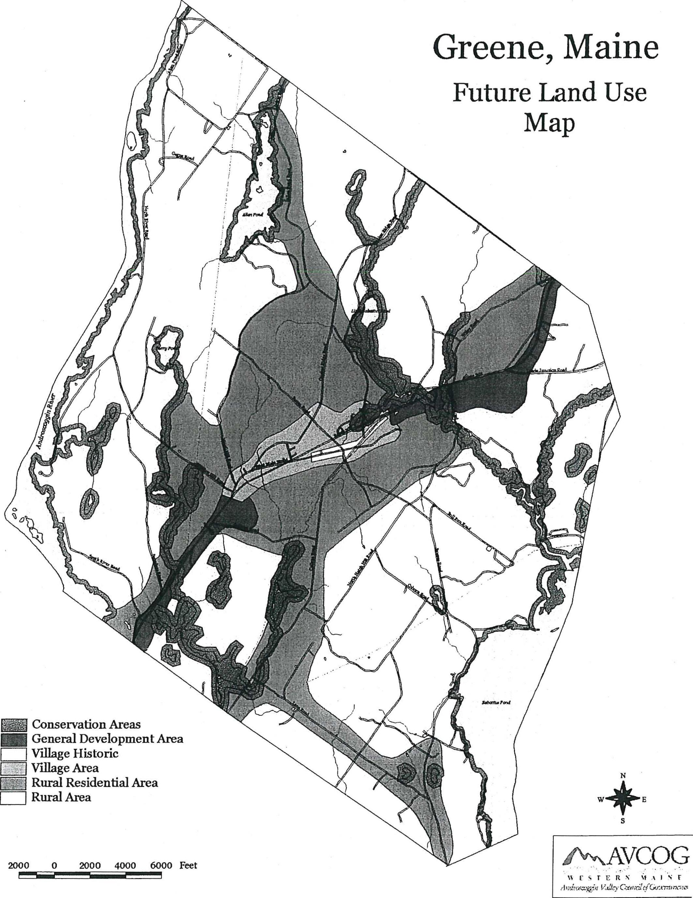
Greene, Maine
Future Land Use
Map
Conservation Areas
1.111 General Development Area
Village Historic Village Area
Rural Residential Area Rural Area
W+ E
hf\N\AVCOG
2000 0 200 0 4000 6000 Feet
['STERN \F.%IN V

GREENE COMPREHENSIVE PLANNING PROGRAM
CAPITAL INVESTMENT PLAN
Introduction
Over the 10 year planning period roads, fire equipment, and other public facilities and equipment will require upgrading. Town development depends on renewing, expanding and improving systems that support development. To promote appropriate development and accommodate Greene's projected growth, to correct existing and emerging problems, to improve the quality of life for residents, to promote citizens' health, safety and welfare, and fulfill the policies and strategies of the comprehensive plan public improvements will be required.
Capital investments as contained in the Capital Investment Plan are expenditures greater than $10,000 that do not recur annually, have a useful life of greater than three years, and result in fixed assets. They include new or expanded physical facilities, rehabilitation or replacement of existing facilities, major pieces of equipment which are expensive and have a relatively long period of usefulness, the cost of engineering or architectural studies and services, and the acquisition of land for community facilities. Capital investments or improvements usually require the expenditure of public funds; town, state, federal or some combination thereof. Funding limitations will make it impossible to pay for or implement all needed major public improvements at any one time or even over a multi-year period. The recommended Capital Improvement Program will be the process whereby the needs identified here will be formalized and specific priorities and implementation periods targeted.
Listed below are the significant capital investments which are expected over the next ten years identified during the comprehensive planning process. Individual items represent necessary equipment replacement/upgrading, facility improvements and investments necessitated by projected growth.

29

IDENTIFIED CAPITAL INVESTMENT NEEDS
2000-2009
, ITEM :  . , . | ',YEAR | PRIORITY, | ESTIMATED  . . 'COST , - | PRO13ABLE  , ,  , FUNDING  SOURCE
Highway Reconstruction/Paving | 2000 | HIGH | $186,300.00 | CR/RF
Highway Garage Addition | 2000 | HIGH | $20,000.00 | CR/RF
Land Acquisition Abutting Existing Fire Station | 2000 | HIGH | $20,000.00 | CR
Highway Reconstruction/Paving | 2001 | HIGH | $169,200.00 | CR/RF
Sprague Mill Bridge Reconstruction | 2001 | MED | $? | CRJRF/G
Loader(Highway) | 2001 | HIGH | $105,000.00 | CR/ RF
Fire Truck Pumper/Tanker | 2001 | HIGH | $300,000.00 | CR/RF
Highway Reconstruction/Paving | 2002 | MED | $170,600.00 | CR/RF
Pickup Truck(Highway) | 2002 | HIGH | $25,000.00 | CR/RF
Addition to Library | 2002 | HIGH | $250,000.00 | CR/B/D
Highway Reconstruction/Paving | 2003 | HIGH | $173,200.00 | CR/RF
Fire Truck Pumper/Tanker | 2003 | HIGH | $325,000.00 | CR/RF/B
Highway Reconstruction/Paving | 2004 | HIGH | $153,000.00 | CR/RF
Highway Reconstruction/Paving | 2005 | HIGH | $227,600.00 | CR/RF
Highway Reconstruction/Paving | 2006 | MED | $164,000.00 | CR/RF
Grader(Highway) | 2006 | HIGH | $80,000.00 | CRJRF
Highway Reconstruction/Paving | 2007 | MED | $120,000.00 | CR/RF
Town Office Addition | 2007 | MED | $213,000.00 | CR/RF/B
Sidewalk(Village) | 2008 | MED | $50,000.00 | CR/RF/G
Business Park Development | 2009 | MED | $400,000.00 | G/D/DF

NOTES:
CR: | Current Revenues | UF: | User Fees
B: | Bonding | G: | Grants
RF: | Reserve Funds | DF: | Developer Financing
TP: | Time Phased | LL: | Low Interest Loans
D: | Donations

:30

Capital Improvements Financing
Capital improvements, as they are prioritized and scheduled for implementation through Greene's multi-year Capital Improvement Program, require a funding source or means of financing. A variety of techniques for financing capital improvements exist and are outlined below. State laws usually govern which techniques are authorized and how they are to be carried out.
CURRENT REVENUES (Pay-As-You-Go)
The most fundamental and simplest means of paying for capital improvements is on a pay-as-you-go basis: funding capital improvements from current revenues. This has the advantage of avoiding bonding and its interest costs. Its disadvantage is that large scale capital improvements may require a similarly large amount of money to finance them. That would create an inordinate tax burden for the implementation period and extreme fluctuations in the tax rate. Spreading these costs over a longer period reduces such sudden impacts and rate swings.
BONDING
Borrowing against future taxes (general obligation bonds) or future service charges or fees (revenue bonds) to finance long-term public improvements is widely practiced and makes good sense from the standpoint of "paying-as-you-use." Bonding evens out the tax impact over time and allows the municipality to obtain vital improvements earlier in time than current revenue or reserve fund arrangements would permit. As a general rule, no improvement or equipment should be bonded beyond its service life and thus violate the pay-as-you-use rule. The chief disadvantage of bonding is the payment of interest on the borrowed money. The fact that purchasers of municipal bonds are usually exempt from payment of taxes on interest received causes the interest rate on such bonds to fall below market rates.
RESERVE FUND
A reserve fund is analogous to a family savings account for a future big ticket purchase (car, appliance, etc.). Reserve funds are often used to replace equipment with a known service life whose cost and date of replacement are fairly accurately known and can be planned for. The full replacement cost thus becomes available at the time when replacement is necessary without the necessity of bonding or suffering a sudden impact on the tax rate. Other advantages are that reserve funds may be invested to collect interest on their principal, thus reducing the tax revenue contribution required. Reserve funds, like bonding, even out the flow of revenues required for capital improvements.
TIME-PHASED PROJECTS
Some very large scale projects can be broken up into time-phased increments, and thus paid for over a period of several years through annual bonding or pay-as-you-go arrangements. This, again, avoids sudden tax increases.
3 1

MUNICIPAL ASSESSMENT AND USER FEES
Development fees, assessment and user charges, if appropriate and feasible, may also be applied by the municipality to recapture costs from direct beneficiaries or users of specific capital improvements. Assessments, for example, are commonly used to recapture street improvements for which fees, assessments and service charges are appropriate and may lend themselves to the use of revolving funds. Under this arrangement, the income so generated, after paying off the original improvements, is placed in a fund dedicated to financing future improvements of the same sort.
DEVELOPER FINANCING OF INFRASTRUCTURE
Shifting public sector costs to the private sector is becoming a more frequently used option. The infrastructure required for large scale developments becomes part of the developer's investment costs. If built to municipal specifications, the improvements may later be accepted by the municipality for maintenance.
GRANTS AND COST SHARING
A number of state and federal grant-in-aid programs exist to share the cost of certain categorical public improvements. Full advantage should be taken of these cost-sharing programs to maximize the benefits to the community, recapture an equitable share of locally generated taxes and secure vitally needed public improvements. Cost sharing grant programs exist in a wide variety of areas such as highways and streets, water quality, sewers, energy co-generation, parks, community development, conservation, school construction and bike paths.
LOW-INTEREST LOANS
In some cases, the federal and state governments have developed special low-interest loan programs to support certain categories of public improvements. These should be investigated as possible funding mechanisms for capital improvements falling within those categories.
Capital Investment Plan Implementation
To implement the Capital Investment Plan, the Town of Greene should develop a formal Capital Improvement Program.
The Capital Improvement Program provides a mechanism for estimating capital requirements; scheduling all projects over a fixed period with appropriate planning and implementation; budgeting high-priority projects and developing a project revenue policy for proposed improvements; coordinating the activities of various departments in meeting project schedules; monitoring and evaluating the progress of capital projects; and informing the public of projected capital improvements.

32

In its most basic form, the Capital Improvement Program is no more than a schedule listing capital improvements, in order of priority, together with cost estimates and the proposed method of financing. Each year, the Capital Improvement Program should be reviewed and updated to reflect changing community priorities, unexpected emergencies or events, unique opportunities, cost changes or alternate financing strategies. The Capital Improvement Program is comprised of three elements:
- inventory and facility maintenance plan;
- capital improvements budget (first year); and
- long-term CEP (5 years).

33

REGIONAL COORDINATION PROGRAM
Overview
The Town of Greene realizes that coordination and/or joint action is necessary to address a number of interlocal planning issues. Based upon the results of the inventory and analysis element of the Comprehensive Plan and the various policies contained in the plan, the following interlocal issues have been included in the Regional Coordination Program.
Interlocal Planning Issues
- Phosphorus which is exported to lakes and ponds from their entire watershed has a major impact on the quality of water in lakes and ponds. Greene contains portions of the watersheds of No Name Pond in Lewiston and Sabattus Pond, shared with Sabattus and Wales. In addition, portions of the Allen and Hooper Ponds' watersheds are located in Leeds.
- The Androscoggin River corridor and Gulf Island Pond are important natural and recreational resources. They are shared with the surrounding communities of Auburn, Leeds, Lewiston and Turner.
- Compatibility of land use and development patterns with bordering communities of Leeds, Lewiston, Monmouth, Sabattus and Wales.
- Regional approaches to economic development.
- Regional transportation systems.
- Continued rapid population growth in the three communities that comprise SAD#5 2 may lead to a need for school facility expansions.
Regional Coordination Goal
- To seek solutions to regional concerns and issues
Regional Coordination Policy
Pursuant to this goal and the interlocal planning issues the policies of the comprehensive plan are:
- To consider phosphorus export form development proposals in watersheds of lakes and ponds shared with other communities.
- To recognize the Androscoggin River Corridor and Gulf Island Pond as important regional natural and recreational resources.
34

- To coordinate with adjacent communities any futdre land use district designations and development on the borders of adjacent communities.
- To support regional programs to improve and expand the local and regional economy.
- To encourage improvements to the regional transportation system that are a benefit to the economy and for the safe movement of people and goods.
- To maintain a dialogue with the Towns of Leeds and Turner to monitor growth and assess its impact on school facilities.
Implementation Strategies
A. Short-Term Activities-To accomplish these goals and policies, the Greene community should undertake the following within one to two years of plan adoption.
- The town should continue to participate with regional groups such as the Regional Transportation Advisory Committee, neighboring communities and the Maine Department of Transportation to encourage the improvements of Route 202 and collector roads (Allen Pond and Sawyer Roads) necessitated by increased commuter traffic.
Responsibility: Selectmen/Town Manager
- Conservation easements or land purchase should be pursued for important open space areas along the Androscoggin River and Gulf Island Pond.
Responsibility: Conservation Commission/Androscoggin Land Trust
- The Planning Board, along with the planning boards of Leeds and Turner, should meet annually with the Superintendent of Schools to review new development trends and their impacts on school facilities.
Responsibility: Planning Board
- The Economic Development Committee should work with local, regional and state economic development organizations to retain and attract business.
Responsibility: Economic Development Committee
- Prior to designating any future land use districts adjacent to neighboring municipal borders a review of compatibility should be undertaken.
Responsibility: Planning Board /Ordinance Committee
B. Mid-Term Activities-To accomplish these goals and policies, the Greene community
should undertake the following within three to five years of plan adoption,
35

- 1. Common phosphorus export standards for development proposals should be
developed for the overall watersheds of Allen Pond, Hooper Pond, No Name Pond and Sabatt⁻us Pond.
Responsibility: Conservation Commission/Planning Board

36

•
•
0

0
•
•

